Springfield Presbyterian Church (USA)
7300 Spout Hill Road, Sykesville, MD 21784 410-795-6152

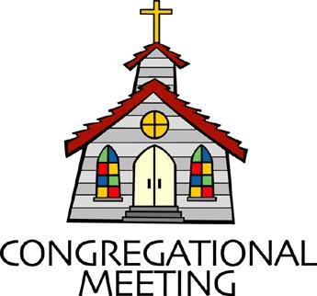
Youth Sunday - May 5, 2019 - 10:30 am

WELCOME VISITORS! We're glad you are here! Cards at the ends of each pew are for you to fill out and drop in the Offering Plate. Please let us know you are visiting, and join us for refreshments and fellowship following the service. The Sanctuary has an induction loop system to assist the hearing impaired. The system will also work on the telephone setting of hearing aids.

Springfield Presbyterian Church is rooted in the gospel of Jesus Christ, led by the Holy Spirit, and called to loving relationships through vibrant worship and service. Valuing all people, we are committed to developing disciples and fostering stewardship.
PREPARATION FOR THE WORD
(* those who are able are invited to stand)

PRELUDE This We Know By Vertical Worship

GATHERING OF THE PEOPLE

The Lord be with you! And also with you! (Greeting)

LIGHTING THE CHRIST CANDLE
Leader: Whenever we light this candle we proclaim:
People: Christ is the Light of the world and the center of our lives.

CALL TO WORSHIP
Leader: Who is the Lord? People: He is our map.
Leader: Who is the Lord? People: He is our path.
Leader: Who is the Lord? People: He is our guide.
Leader: Who is the Lord? People: He is our compass.
Leader: Who is the Lord? People: He is love.

* HYMN Depth of Mercy Can There Be
Depth of mercy! Can there be mercy still reserved for me?
Can my God His wrath forbear? Me, the chief of sinners, spare?

I have long withstood His grace: long provoked Him to His face;
Would not hearken to His calls; grieved Him by a thousand falls.

I my Master have denied, I afresh have crucified,
Oft profaned His hallowed name, put Him to an open shame.

There for me the Savior stands, shows His wounds and spreads His hands:
God is love! I know, I feel; Jesus weeps, but loves me still!

Now incline me to repent! Let me now my fall lament!
Now my foul revolt deplore! Weep, believe, and sin no more.

PRAYER OF CONFESSION
Oh Lord, we are human, like Saul, we stray from your word. We stop listening to your wisdom and give in to the path of pain and deceit. You have generously given us a road to our future, but we either cross other paths or follow others instead. We distract others from your word and lead them down an unrighteous path by going in the wrong direction. We are blind to: greed, tyranny, the changing climate, the oppressed, those who are discriminated against, the sick and the needs of others. We are blind in our own community to: homelessness, poverty, the effects of mental illness, those who lack confidence, those who are overworked and underpaid, those who face tragedy and are left without someone to care for them.

SILENT PRAYERS OF CONFESSION

RESPONSE Restore in Us, O God
Restore in us, O God, the splendor of your love;
Renew your image in our hearts, and all our sins remove.

WORDS OF ASSURANCE
Leader : We are human.
People : We sin.
Leader : He loves us
People : Unconditionally.
Leader : He saves us
People : Time and time again.
Leader : He guides us from the gates of hell.
People : Leads us in the direction of His word.
Leader : He protects us,
People : And He loves us.

* MUSICAL RESPONSE OF PRAISE Alleluia, Alleluia! Give Thanks
Alleluia, alleluia! Give thanks to the risen Lord.
Alleluia, alleluia! Give praise to His name.

* THE PEACE The peace of Christ be with you! And also with you!
(You may greet those around you.)

* RESPONSE Here I Am, Lord
Here I am, Lord, Is it I, Lord? I have heard you calling in the night.
I will go, Lord, if you lead me. I will hold your people in my heart.
THE PROCLAMATION OF THE WORD

PRAYER OF ILLUMINATION
Lord, we gather here today to celebrate your unconditional love and your helping guidance. Bring us together today to celebrate this journey, which you are bringing us on.

FIRST SCRIPTURE LESSON Acts 9:1-20
Meanwhile Saul, still breathing threats and murder against the disciples of the Lord, went to the high priest ²and asked him for letters to the synagogues at Damascus, so that if he found any who belonged to the Way, men or women, he might bring them bound to Jerusalem. ³Now as he was going along and approaching Damascus, suddenly a light from heaven flashed around him. ⁴He fell to the ground and heard a voice saying to him, ‘Saul, Saul, why do you persecute me?’ ⁵He asked, ‘Who are you, Lord?’ The reply came, ‘I am Jesus, whom you are persecuting. ⁶But get up and enter the city, and you will be told what you are to do.’ ⁷The men who were travelling with him stood speechless because they heard the voice but saw no one. ⁸Saul got up from the ground, and though his eyes were open, he could see nothing; so they led him by the hand and brought him into Damascus. ⁹For three days he was without sight, and neither ate nor drank. ¹⁰Now there was a disciple in Damascus named Ananias. The Lord said to him in a vision, ‘Ananias.’ He answered, ‘Here I am, Lord.’ ¹¹The Lord said to him, ‘Get up and go to the street called Straight, and at the house of Judas look for a man of Tarsus named Saul. At this moment he is praying, ¹²and he has seen in a vision a man named Ananias come in and lay his hands on him so that he might regain his sight.’ ¹³But Ananias answered, ‘Lord, I have heard from many about this man, how much evil he has done to your saints in Jerusalem; ¹⁴and here he has authority from the chief priests to bind all who invoke your name.’ ¹⁵But the Lord said to him, ‘Go, for he is an instrument whom I have chosen to bring my name before Gentiles and kings and before the people of Israel; ¹⁶I myself will show him how much he must suffer for the sake of my name.’ ¹⁷So Ananias went and entered the house. He laid his hands on Saul and said, ‘Brother Saul, the Lord Jesus, who appeared to you on your way here, has sent me so that you may regain your sight and be filled with the Holy Spirit.’ ¹⁸And immediately something like scales fell from his eyes, and his sight was restored. Then he got up and was baptized, ¹⁹and after taking some food, he regained his strength. For several days he was with the disciples in Damascus, ²⁰and immediately he began to proclaim Jesus in the synagogues, saying, ‘He is the Son of God.’

SECOND SCRIPTURE LESSON John 21:1-19
After these things Jesus showed himself again to the disciples by the Sea of Tiberias; and he showed himself in this way. ²Gathered there together were Simon Peter, Thomas called the Twin, Nathanael of Cana in Galilee, the sons of Zebedee, and two others of his disciples. ³Simon Peter said to them, ‘I am going fishing.’ They said to him, ‘We will go with you.’ They went out and got into the boat, but that night they caught nothing. ⁴Just after daybreak, Jesus stood on the beach; but the disciples did not know that it was Jesus. ⁵Jesus said to them, ‘Children, you have no fish, have you?’ They answered him, ‘No.’ ⁶He said to them, ‘Cast the net to the right side of the boat, and you will find some.’ So they cast it, and now they were not able to haul it in because there were so many fish. ⁷That disciple whom Jesus loved said to Peter, ‘It is the Lord!’ When Simon Peter heard that it was the Lord, he put on some clothes, for he was naked, and jumped into the lake. ⁸But the other disciples came in the boat, dragging the net full of fish, for they were not far from the land, only about a hundred yards off.
9 When they had gone ashore, they saw a charcoal fire there, with fish on it, and bread. ¹⁰Jesus said to them, ‘Bring some of the fish that you have just caught.’ ¹¹So Simon Peter went aboard and hauled the net ashore, full of large fish, a hundred and fifty-three of them; and though there were so many, the net was not torn. ¹²Jesus said to them, ‘Come and have breakfast.’ Now none of the disciples dared to ask him, ‘Who are you?’ because they knew it was the Lord. ¹³Jesus came and took the bread and gave it to them, and did the same with the fish. ¹⁴This was now the third time that Jesus appeared to the disciples after he was raised from the dead. ¹⁵When they had finished breakfast, Jesus said to Simon Peter, ‘Simon son of John, do you love me more than these?’ He said to him, ‘Yes, Lord; you know that I love you.’ Jesus said to him, ‘Feed my lambs.’ ¹⁶A second time he said to him, ‘Simon son of John, do you love me?’ He said to him, ‘Yes, Lord; you know that I love you.’ Jesus said to him, ‘Tend my sheep.’ ¹⁷He said to him the third time, ‘Simon son of John, do you love me?’ Peter felt hurt because he said to him the third time, ‘Do you love me?’ And he said to him, ‘Lord, you know everything; you know that I love you.’ Jesus said to him, ‘Feed my sheep. ¹⁸Very truly, I tell you, when you were younger, you used to fasten your own belt and to go wherever you wished. But when you grow old, you will stretch out your hands, and someone else will fasten a belt around you and take you where you do not wish to go.’ ¹⁹(He said this to indicate the kind of death by which he would glorify God.) After this he said to him, ‘Follow me.’

Leader: Hear what the Spirit is saying to the Church.
All: Thanks be to God.

TIME WITH YOUNG PEOPLE

SERMON God is Love (video)

THE RESPONSE TO THE WORD

* HYMN
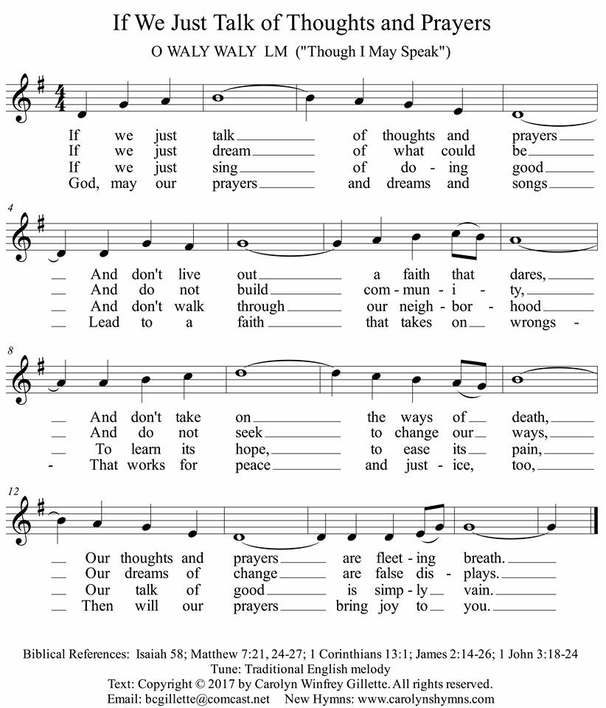
THE COMMUNION OF THE PEOPLE

INVITATION

THE GREAT PRAYER OF THANKSGIVING
Leader: The Lord be with you.
People: And also with you.
Leader: Lift up your hearts.
People: We lift them up to the Lord.
Leader: Let us give thanks to the Lord our God.
People: It is right to give our thanks and praise.
[The Pastor continues… “…who forever sing to the glory of your name.”]

IN PRAISE OF GOD Tune #552
Holy, holy, holy, Lord, God of Power and might.
Heaven and earth are full of your glory, Hosanna in the highest!
Blessed is He who comes in the name of the Lord.
Hosanna in the highest, hosanna in the highest.
[The Pastor continues… “…proclaim the One crucified and risen...”]

IN PRAISE OF CHRIST Tune #553
Christ has died; Christ is risen; Christ will come again.
Christ has died; Christ is risen; Christ will come again.

PASTORAL PRAYER AND THE LORD’S PRAYER
Amazing God, help those who are in need of your love and those who are going in the wrong direction. Oh God, be there for others who are sinning in your name and don’t know they have sinned. Keep us mindful of different cultures and their sufferings. We pray for those in the world who are victims of: greed, tyranny and the effects of climate change. The world is full of the oppressed, the sick and those who are discriminated against. We pray for those in our own community who are: homeless and in poverty, suffering from the effects of mental illness, lacking confidence, overworked and underpaid, facing tragedy and are left without someone to care for them. We pray for those who don’t even know they need God’s help.

WORDS OF INSTITUTION

SHARING OF THE MEAL

PRAYER OF DEDICATION (Unison)
Dear God, take us out to live as changed people because we have shared the living bread and cannot remain the same. Ask much of us, expect much from us, enable much by us, encourage many through us. So, Lord, may we live to your glory, both as inhabitants of the earth, and citizens of the commonwealth of Heaven. Through Christ, with Christ, in Christ, in the
unity of the Holy Spirit, all glory and honor are yours, almighty God, now and forever. Amen.

PRESENTATION OF TITHES AND OFFERINGS
OFFERTORY Come to the Table
* SONG OF THANKS God, We Honor You
God, we honor you. God, we trust in you. God, we worship and adore you. Take what we bring, offered to you. Teach us to show your abundant blessings. Alleluia, alleluia, alleluia, amen.
* PRAYER OF DEDICATION
We graciously accept these gifts given in God’s name. We accept these gifts and may we use them to guide others down your path.

* HYMN Here I Am, Lord #69

I, the Lord of sea and sky, I have heard my people cry,
All who dwell in deepest sin, my hand will save.
I who made the stars of night, I will make their darkness bright.
Who will bear my light to them? Whom shall I send?

Refrain:
Here I am, Lord. Is it I, Lord? I have heard you calling in the night.
I will go, Lord, if you lead me. I will hold your people in my heart.

I, the Lord of snow and rain, I have borne my people’s pain.
I have wept for love of them, they turn away.
I will break their hearts of stone, give them hearts for love alone.
I will speak my word to them. Whom shall I send? [Refrain]

I, the Lord of wind and flame, I will tend the poor and lame.
I will set a feast for them, my hand will save.
Finest bread I will provide, till their hearts be satisfied.
I will give my life to them. Whom shall I send? [Refrain]

* CHARGE AND BENEDICTION
Like Saul we sin and we make mistakes, but God leads us back to our holy path. So let us go out to be different people and live by His word.

* UNISON AMEN

POSTLUDE This Is Amazing Grace By Phil Wickham

Assisting in Worship: We appreciate those who serve:

Today 5/5 Next Week 5/12
Sunday Opener Bob Rogers Barbara Cornell
Greeters & Ushers Steve & Donna Don Vasbinder &
Mazer Charlie Sperling
Lay Leader Youth Sunday Diana Steppling
Sunday School Connie Robinson Connie Robinson
Fellowship Linda Caviglia Barbara Nickell

Communion Servers Today:
1. Mark Kearney 4. Linda Caviglia
2. Kathy Russ 5. Connie Robinson
3. Tony Caviglia

Church Attendance: April 21 (Easter) – 90 April 28 - 42

Church Cleaning: May 17, 18 or 19 – The Oates Family

Happy Birthday! May 10 – Kathy Russ

Sunday May 12 Lectionary
Acts 9:36-43; Psalm 23; Revelation 7:9-17; John 10:22-30
Announcements

Youth Sunday is TODAY! Come and see how amazing our youth are. They planned today’s worship while on the annual Ocean City retreat.

Summer Worship Hours: For the next two weeks, we are asking the congregation to vote on whether or not we should move Worship to 9:30 for the summer or keep it at 10:30 am. Please pick up a ballot with your choice and drop it in the offering plate. Please vote only once.

Spring Plant Sale: Between May 1 and May 21, buy your spring plants at Buppert’s and they will donate 15% of your purchase price back to Springfield! Pick up a flyer in the Narthex and share it with your family and friends!

C.I.A. (Community In Action) will meet TOMORROW from 4:30-6 pm at the Manse. Pizza and drinks provided. Friends are welcome and encouraged to attend! C.I.A is a group open to all religious and non-religious people as a means of providing the community with acts of kindness. We will be doing different activities throughout the school year to help people in our community who are in need. Come and be a part of giving back to our community!

Blessing Bags are in the Narthex. Please feel free to pick up a few. Handing one out to someone in need gives you a very real way to meet their immediate needs by providing them with some basic supplies.

Weekly Announcements: If you have an announcement to include with next week’s bulletin, please call the Office at 410-795-6152 or email to spc.office@verizon.net by Wednesday each week.

Prayers & Thanksgivings

~ Prayers of comfort and strength for Ron Holmes and family on the passing of Ron’s Mom on April 30.
~ Prayers for Catonsville Presbyterian from our Ministry Group.

The Congregational Care team wants to know what YOU or someone you know needs...a visit...a call...a meal. Please contact Diana Steppling or Connie Robinson.

Today:
Sunday May 5 – Youth Sunday
10:30 am Worship & Sunday School
11:30 am Fellowship

This Week:
Monday May 6
4:30 pm C.I.A. Meeting (Manse)
Wednesday May 8
6:30 pm Bell Choir Practice
7:45 pm Adult Choir Practice

Looking Ahead:
Sunday May 12 – Mother’s Day
10:30 am Worship & Sunday School
11:30 am Fellowship
6:30 pm Youth Movie Night
Monday May 13
7:00 pm HeadHuggers (Manse)
Tuesday May 14
10:30 am Prayer Group (Manse)
7:00 pm ESCAPE Lunch Packing (Manse)
Wednesday May 15
6:30 pm Bell Choir Practice
7:45 pm Adult Choir Practice
Friday May 17
7:00 pm Family Game Night (Fellowship Room)

Office Hours: Tuesday, Wednesday, Friday 9:00 am - 3:00 pm

Springfield Presbyterian Church

10:30 am Worship & Sunday School
11:30 am Fellowship
Website: www.springfield-church.org Church Office: 410-795-6152
Like us on Facebook: www.facebook.com/SpringfieldPresbyterianChurch
Pastor: Rev. Becca Crate
Email: springfieldpastor@gmail.com
Clerk of Session: Sharon Pappas
Minister of Music: Linda Caviglia
Accompanist: Aaron Thacker Organist: Jennifer Wise
Youth Group Coordinators: Charles & Deb Sperling
Sunday School Coordinator: Connie Robinson
Administrative Assistant: Donna Mazer
e-mail: spc.office@verizon.net

