(Large Print)

Springfield Presbyterian Church (USA)
7300 Spout Hill Road, Sykesville, MD 21784 410-795-6152

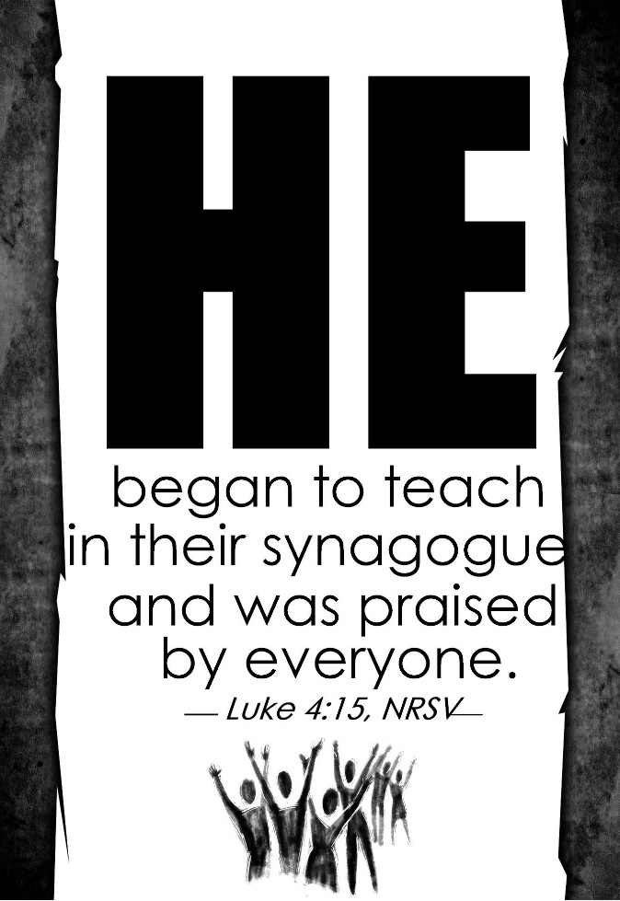

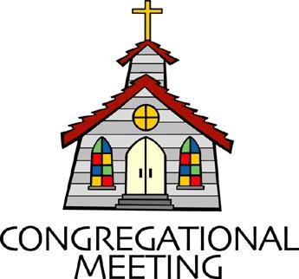
January 30, 2022 - 10:30 am

WELCOME VISITORS! We're glad you are here! Cards at the ends of each pew are for you to fill out and drop in the Offering Plate. Please let us know you are visiting, and join us for refreshments and fellowship following the service. The Sanctuary has an induction loop system to assist the hearing impaired. The system will also work on the telephone setting of hearing aids.

Springfield Presbyterian Church is rooted in the gospel of Jesus Christ, led by the Holy Spirit, and called to loving relationships through vibrant worship and service. Valuing all people, we are committed to developing disciples and fostering stewardship.
PREPARATION FOR THE WORD
(* those who are able are invited to stand)

PRELUDE

GATHERING OF THE PEOPLE

The Lord be with you! And also with you! (Greeting)

LIGHTING THE CHRIST CANDLE
Leader: Whenever we light this candle we proclaim:
People: Christ is the Light of the world and the center of our lives.

CALL TO WORSHIP [Psalm 71:1-6]
Leader: In you, O Lord, I take refuge; let me never be put to shame.
People: In your righteousness deliver me and rescue me; incline your ear to me and save me.
Leader: Be to me a rock of refuge, a strong fortress, to save me, for you are my rock and my fortress.
People: Rescue me, O God, from the hand of the wicked, from the grasp of the unjust and cruel.
Leader: For you, O Lord, are my hope, my trust, O Lord, from my youth.
People: Upon you I have leaned from my birth; it was you who took me from my mother’s womb. My praise is continually of you.

* HYMN Here in This Place (Gather Us In) #401

Here in the place the new light is streaming; now is the darkness vanished away; see in this space our fears and our dreamings brought here to you in the light of this day.
Gather us in, the lost and forsaken; gather us in, the blind and the lame; call to us now, and we shall awaken; we shall arise at the sound of our name.

We are the young, our lives are a mystery. We are the old who yearn for your face. We have been sung throughout all of history, called to be light in the whole human race.
Gather us in, the rich and the haughty; gather us in, the proud and the strong; give us a heart, so meek and so lowly; give us the courage to enter the song.

Here we will take the wine and the water; here we will take the bread of new birth. Here you shall call your sons and your daughters, call us anew to be salt for the earth.
Give us to drink the wine of compassion; give us to eat the bread that is you; nourish us well, and teach us to fashion live that are holy and hearts that are true.

Not in the dark of buildings confining, not in some heaven, light years away: here in this place the new light is shining; now is the kingdom, and now is the day.
Gather us in and hold us forever; gather us in and make us your own; gather us in, all peoples together, fire of love in our flesh and our bone.

CALL TO CONFESSION
Leader: We are a people born of water and of the Spirit. We have made promises to be Christ’s faithful disciples, and to show His love to our life’s end. Although we fail to fulfill those baptismal vows, God’s faithful love endures forever. Confident of God’s grace, let us now confess our sin and the sin of this world.

PRAYER OF CONFESSION
Merciful God, we confess that we have not loved you with our whole heart. We have failed to be an obedient church. We have not done your will, we have broken your law, we have rebelled against your love. We have not loved our neighbors, and we have

refused to hear the cry of the needy. Forgive us, we pray. Free us for joyful obedience through Jesus Christ our Lord. Amen.

SILENT PRAYERS OF CONFESSION

RESPONSE Spirit of the Living God Tune #288
Spirit of the living God, fall afresh on me.
Spirit of the living God, fall afresh on me.
Melt me; mold me; fill me; use me.
Spirit of the living God, fall afresh on me.

WORDS OF ASSURANCE [Romans 5:5]
Leader: Hear the good news! Hope does not disappoint us, for God’s love has been poured into our hearts through the Holy Spirit given to us in baptism.
People: Believe in this good news and give thanks: In Jesus Christ, we are forgiven! Thanks be to God! Amen!

* MUSICAL RESPONSE OF PRAISE Glory Be to the Father Tune #581
Glory be to the Father, and to the Son, and to the Holy Ghost;
As it was in the beginning, is now, and ever shall be,
World, without end. Amen, amen.

* THE PEACE The peace of Christ be with you! And also with you!
(You may greet those around you.)

* RESPONSE Here I Am, Lord
Here I am, Lord, Is it I, Lord? I have heard you calling in the night.
I will go, Lord, if you lead me. I will hold your people in my heart.

THE PROCLAMATION OF THE WORD

PRAYER OF ILLUMINATION
Guide us, O God, by your Word and Spirit, that in your light we may see light, in your truth find freedom, and in your will discover your peace; through Jesus Christ our Lord. Amen.

FIRST SCRIPTURE LESSON Psalm 19
¹ The heavens are telling the glory of God; and the firmament proclaims his handiwork. ² Day to day pours forth speech, and night to night declares knowledge. ³ There is no speech, nor are there words; their voice is not heard; ⁴ yet their voice goes out through all the earth, and their words to the end of the world. In the heavens he has set a tent for the sun, ⁵ which comes out like a bridegroom from his wedding canopy, and like a strong man runs its course with joy. ⁶ Its rising is from the end of the heavens, and its circuit to the end of them; and nothing is hidden from its heat. ⁷ The law of the Lord is perfect, reviving the soul;
the decrees of the Lord are sure, making wise the simple; ⁸ the precepts of the Lord are right, rejoicing the heart; the commandment of the Lord is clear, enlightening the eyes; ⁹ the fear of the Lord is pure, enduring for ever; the ordinances of the Lord are true and righteous altogether.
¹⁰ More to be desired are they than gold, even much fine gold; sweeter also than honey, and drippings of the honeycomb. ¹¹ Moreover by them is your servant warned; in keeping them there is great reward.
¹² But who can detect their errors? Clear me from hidden faults.
¹³ Keep back your servant also from the insolent; do not let them have dominion over me. Then I shall be blameless, and innocent of great transgression. ¹⁴ Let the words of my mouth and the meditation of my heart be acceptable to you, O Lord, my rock and my redeemer.

SECOND SCRIPTURE LESSON Luke 4:14-21
Then Jesus, filled with the power of the Spirit, returned to Galilee, and a report about him spread through all the surrounding country. ¹⁵He began to teach in their synagogues and was praised by everyone.
¹⁶When he came to Nazareth, where he had been brought up, he went to the synagogue on the sabbath day, as was his custom. He stood up to read, ¹⁷and the scroll of the prophet Isaiah was given to him. He unrolled the scroll and found the place where it was written: ¹⁸ ‘The Spirit of the Lord is upon me, because he has anointed me to bring good news to the poor. He has sent me to proclaim release to the captives and recovery of sight to the blind, to let the oppressed go free,
¹⁹to proclaim the year of the Lord’s favor.’ ²⁰And he rolled up the scroll, gave it back to the attendant, and sat down. The eyes of all in the synagogue were fixed on him. ²¹Then he began to say to them, ‘Today this scripture has been fulfilled in your hearing.’

Leader: Hear what the Spirit is saying to the Church.
All: Thanks be to God.

SERMON The Proclamation of the Good News Rev. Becca Crate-Price

THE RESPONSE TO THE WORD

* HYMN O for a Thousand Tongues to Sing #610

O for a thousand tongues to sing my dear Redeemer’s praise,
The glories of my God and King, the triumphs of God’s grace!

The name of Jesus charms our fears, and bids our sorrows cease,
Sings music in the sinner’s ears, brings life, and health and peace.

Christ speaks, and listening to his voice new life the dead receive,
The mournful waken to rejoice, the poor in heart believe.

My gracious Master and my God, assist me to proclaim,
To spread through all the earth abroad the honors of thy name.

To God all glory, praise and love be now and ever given
By saints below and saints above, the church in earth and heaven.

PASTORAL PRAYER AND THE LORD’S PRAYER

OFFERTORY

* HYMN In Christ There Is No East or West #318

In Christ there is no east or west, in him no south or north,
But one great fellowship of love throughout the whole wide earth.

In Christ shall true hearts everywhere their high communion find;
His service is the golden cord close-binding humankind.

Join hands, disciples of the faith, whate’er your face may be.
All children of the living God are surely kin to me.

In Christ now meet both east and west; in him meet south and north.
All Christly souls are one in him throughout the whole wide earth.

* CHARGE AND BENEDICTION
Leader: We hear the Word proclaimed,
People: A Word that promises freedom.
Leader: Freedom in all shapes and kinds,
People: For God’s people to live abundantly.
Leader: Let us be emboldened with the good news,
People: To share it wherever we go.

* UNISON AMEN POSTLUDE

Sunday February 6, 2022 Lectionary
Isaiah 6:1-8 (9-13); Psalm 138; I Corinthians 15:1-11; Luke 5:1-11

Assisting in Worship: We appreciate those who serve:

Today 1/30 Next Week 2/6
Sunday Opener Barbara Cornell Beth Oates
Greeter Beth Oates Sharon Pappas
Lay Leader Tim Oates Christy Yeager

Happy Birthday! February 1 – Steve & Donna Mazer

Announcements

Congregational Meeting: There will be a Congregational Meeting on Sunday, February 13 immediately following Worship. The purpose of the meeting is to approve the 2022 budget and review the 2021 Annual Report.

Upcoming Concert: Mark your calendars for our upcoming concert on February 13, featuring Candice Mowbray and Danny Webber performing classical and jazz guitar. Due to the continuing COVID pandemic, all attendees will be required to wear a mask throughout the concert, and we will not have our normal reception following the concert. Hope to see you there!

Fellowship Reminder: Following the Worship service, we will gather downstairs for fellowship, but will not have food and will continue to wear our masks. We, as a Session, have made this decision out of an abundance of caution and the desire to keep our family of Christ safe and healthy.
Congregational Care / Mission & Outreach: Do you know of a member or friend of our church family who is ill, needs prayers, would like call, a visit or a card, or might benefit from meal train? If so, please contact the Church Office (410-795-6152), Cathy Marsh (410-549-6916) or Diana Steppling (862-266-2242).

Inclement Weather: If we feel the need to cancel Worship, there will be a message on the Church answering machine, as well as on Facebook. You may also receive an email with that information.

Today:
Sunday January 30
10:30 am Worship
11:30 am Fellowship

This Week:
Wednesday February 2
6:15 – 7:15 pm Bell Choir Practice
7:30 – 8:45 pm Adult Choir Practice

Looking Ahead:
Sunday February 6
10:30 am Worship
11:30 am Fellowship
Wednesday February 9
6:15 – 7:15 pm Bell Choir Practice
7:30 – 8:45 pm Adult Choir Practice

Office Hours: Tuesday, Wednesday & Friday
Springfield Presbyterian Church

10:30 am Worship
11:30 am Fellowship
Website: www.springfield-church.org Church Office: 410-795-6152
Like us on Facebook: www.facebook.com/SpringfieldPresbyterianChurch
Pastor: Rev. Becca Crate-Price
Email: springfieldpastor@gmail.com
Clerk of Session: Sharon Pappas
Minister of Music: Linda Caviglia
Accompanist/Organist: Aaron Thacker
Youth Group Coordinators: Charles & Deb Sperling
Sunday School Coordinator: Connie Robinson
Administrative Assistant: Donna Mazer e-mail: spc.office@verizon.net

