(Large Print)

Springfield Presbyterian Church (USA)
7300 Spout Hill Road, Sykesville, MD 21784 410-795-6152

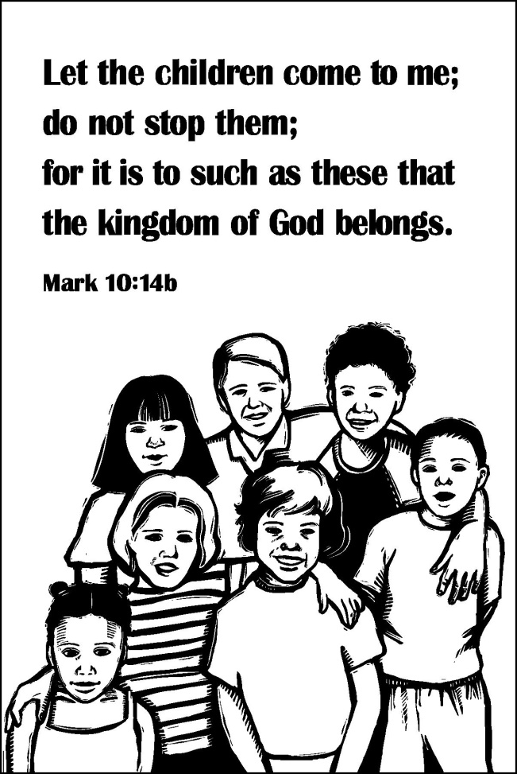

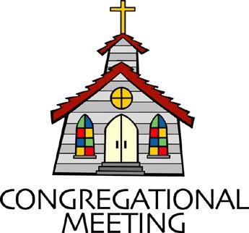
October 7, 2018 - 10:30 am

WELCOME VISITORS! We're glad you are here! Cards at the ends of each pew are for you to fill out and drop in the Offering Plate. Please let us know you are visiting, and join us for refreshments and fellowship following the service. The Sanctuary has an induction loop system to assist the hearing impaired. The system will also work on the telephone setting of hearing aids. A head set is available upon request.

Springfield Presbyterian Church is rooted in the gospel of Jesus Christ, led by the Holy Spirit, and called to loving relationships through vibrant worship and service. Valuing all people, we are committed to developing disciples and fostering stewardship.

PREPARATION FOR THE WORD
(* those who are able are invited to stand)

Please prepare for worship by listening to the music of the Prelude.

PRELUDE

GATHERING OF THE PEOPLE

The Lord be with you! And also with you! (Greeting)

LIGHTING THE CHRIST CANDLE
Leader: Whenever we light this candle we proclaim:
People: Christ is the Light of the world and the center of our lives.

CALL TO WORSHIP [Interpretation of Psalm 26 NRSV]
Leader: We wash our hands in innocence, and go around your altar, O Lord.
People: We sing aloud a song of thanksgiving, telling of all your wondrous deeds.
Leader: O Lord, we love the house in which you dwell, and the place where your glory abides.
People: Do not sweep us away with sinners, nor our lives with the bloodthirsty.
Leader: But as for us, we will walk in integrity;
People: We ask that you redeem us and be gracious to us.
Leader: Put our feet on level ground,
People: And in this great congregation, we bless you and worship you, O Lord.

* HYMN What A Friend We Have in Jesus

What a friend we have in Jesus, all our sins and griefs to bear!
What a privilege to carry, everything to God in prayer!
O what peace we often forfeit, O what need-les pain we bear.
All because we do not carry, everything to God in prayer!

Have we trials and temptations? Is there trouble anywhere?
We should never be discouraged: Take it to the Lord in prayer!
Can we find a friend so faithful, who will all our sorrows share?
Jesus knows our every weakness; take it to the Lord in prayer!

Are we weak and heavy laden, cumbered with a load of care?
Precious Savior, still our refuge - take it to the Lord in prayer!
Do thy friends despise, forsake thee? Take it to the Lord in prayer!
In His arms He’ll take and shield thee, Thou wilt find a solace there.

PRAYER OF CONFESSION
Holy and merciful God, in your presence we confess our failure to be what you created us to be. You alone know how often we have sinned in wandering from your ways, in wasting your gifts, in forgetting your love. By your loving mercy, help us to live in your light and abide in your ways, for the sake of Jesus Christ our Savior. Amen.

SILENT PRAYERS OF CONFESSION

RESPONSE Have Mercy on Us, Living Lord Tune #195
Have mercy on us, living Lord, remember not our sin.
According to your steadfast love, come, cleanse us deep within.

WORDS OF ASSURANCE
Leader: Anyone who is in Christ is a new creation. The old life has gone, a new life has begun.

People: We are a forgiven people! Let us praise God and be at peace. Amen.

* MUSICAL RESPONSE OF PRAISE Let Us with a Gladsome Mind
Let us with a gladsome mind, praise the Lord who is so kind:
For God’s mercies shall endure, ever faithful, ever sure.

* THE PEACE The peace of Christ be with you! And also with you!
(You may greet those around you.)

* RESPONSE Here I Am, Lord
Here I am, Lord, Is it I, Lord? I have heard you calling in the night.
I will go, Lord, if you lead me. I will hold your people in my heart.

THE PROCLAMATION OF THE WORD

PRAYER OF ILLUMINATION
Lord, open our hearts and mind by the power of your Holy Spirit, that as the scriptures are read and your Word is proclaimed, we may hear with joy what you say to us today. Amen.
FIRST SCRIPTURE LESSON Psalm 8
¹ O Lord, our Sovereign, how majestic is your name in all the earth! You have set your glory above the heavens. ² Out of the mouths of babes and infants you have founded a bulwark because of your foes, to silence the enemy and the avenger. ³ When I look at your heavens, the work of your fingers, the moon and the stars that you have established;
⁴ what are human beings that you are mindful of them, mortals that you care for them? ⁵ Yet you have made them a little lower than God, and crowned them with glory and honor. ⁶ You have given them dominion over the works of your hands; you have put all things under their feet, ⁷ all sheep and oxen, and also the beasts of the field, ⁸ the birds of the air, and the fish of the sea, whatever passes along the paths of the seas. ⁹ O Lord, our Sovereign, how majestic is your name in all the earth!

SECOND SCRIPTURE LESSON Mark 10:2-16
²Some Pharisees came, and to test him they asked, ‘Is it lawful for a man to divorce his wife?’ ³He answered them, ‘What did Moses command you?’ ⁴They said, ‘Moses allowed a man to write a certificate of dismissal and to divorce her.’ ⁵But Jesus said to them, ‘Because of your hardness of heart he wrote this commandment for you. ⁶But from the beginning of creation, “God made them male and female.” ⁷“For this reason a man shall leave his father and mother and be joined to his wife, ⁸and the two shall become one flesh.” So they are no longer two, but one flesh. ⁹Therefore what God has joined together, let no one separate.’ ¹⁰Then in the house the disciples asked him again about this matter. ¹¹He said to them, ‘Whoever divorces his wife and marries another commits adultery against her; ¹²and if she divorces her husband and marries another, she commits adultery.’ ¹³People were bringing little children to him in order that he might touch them; and the disciples spoke sternly to them. ¹⁴But when Jesus saw this, he was indignant and said to them, ‘Let the little children come to me; do not stop them; for it is to such as these that the kingdom of God belongs. ¹⁵Truly I tell you, whoever does not receive the kingdom of God as a little child will never enter it.’ ¹⁶And he took them up in his arms, laid his hands on them, and blessed them.

Leader: Hear what the Spirit is saying to the Church.
All: Thanks be to God.

TIME WITH YOUNG PEOPLE

SERMON The Blended Family of Christ Rev. Becca Crate

THE RESPONSE TO THE WORD

* HYMN Lord, Listen to Your Children Praying
Lord, listen to your children praying, Lord, send your Spirit in this place;
Lord, listen to your children praying, Send us love, send us power, send us grace.

THE SACRAMENT OF HOLY COMMUNION

INVITATION

THE GREAT PRAYER OF THANKSGIVING
Leader: The Lord be with you.
People: And also with you.
Leader: Lift up your hearts.
People: We lift them up to the Lord.
Leader: Let us give thanks to the Lord our God.
People: It is right to give our thanks and praise.

[The Pastor continues… “…who forever sing to the glory of your name.”]

IN PRAISE OF GOD Tune #581
Holy, holy, holy, Lord, God of Power and might.
Heaven and earth are full of your glory, Hosanna in the highest!
Blessed is He who comes in the name of the Lord.
Hosanna in the highest, hosanna in the highest.

[The Pastor continues… “and all creation might be restored.”]

IN PRAISE OF CHRIST Tune #582
Dying, you destroyed our death; rising, you restored our life.
Lord Jesus, come in glory.

PASTORAL PRAYER AND THE LORD’S PRAYER
“For this I pray to God.” / “For this I give thanks to God.”
Congregational Response: “Hear our prayer, O God.”

WORDS OF INSTITUTION

SHARING OF THE MEAL

PRAYER OF DEDICATION (Unison)
Dear God, take us out to live as changed people because we have shared the living bread and cannot remain the same. Ask much of us, expect much from us, enable much by us, encourage many through us. So, Lord, may we live to your glory, both as inhabitants of the earth, and citizens of the commonwealth of Heaven. Through Christ, with Christ, in Christ, in the unity of the Holy Spirit, all glory and honor are yours, almighty God, now and forever. Amen.

PRESENTATION OF TITHES AND OFFERINGS
OFFERTORY The Voice of God
* SONG OF THANKS My Gratitude Now Accept, O God STF #2044 All that is living belongs to you; all that I am in your hands kept. From the abundance of your hand, gifts from the heart accept.
* PRAYER OF DEDICATION

* HYMN Do Not Turn Away the Children
By Carolyn Winfrey Gillette

(sung to the tune of God, Whose Giving Knows No Ending #422)

“Do not turn away the children; let them come to me instead.
For to them belongs the kingdom. Make them welcome!" Christ, you said.

As we hear your words of blessing that you spoke when they drew near,
Can we hear your love addressing needs of children we see here?

Do not turn your back on children who know violence, pain and war.
Give them justice, food and welcome, make their homes and lives secure.
Don't neglect the world of children who have AIDS and HIV,
For to them belongs the kingdom. Give them health care that they need.

Do not tell the nation's children, "schools are what we can't afford.”
Give them all good education; teach them well, both rich and poor.
Do not hurry past the children longing for your love this day;
For to them belongs the kingdom; give them time, don't turn away.

Do not miss the faith of children who have questions deep inside,
For to them belongs the kingdom wonder with them, be their guide.
Jesus, as we hear your blessing for those ones you welcomed in,
May our deeds reflect your caring as we welcome them again!

* CHARGE AND BENEDICTION
Leader: Let your Kingdom come,
People: So that earth looks a little more like heaven.
Leader: Let your Kingdom come,
People: So that diversity, in all its beauty, is glorified.
Leader: Let your Kingdom come,
People: So that we may be people of love, glorifying you each and every day.

* UNISON AMEN POSTLUDE

Sunday October 14 Lectionary
Job 23:1-9, 16-17; Psalm 22:1-15; Hebrews 4:12-16; Mark 10:17-31

Assisting in Worship: We appreciate those who serve:

Today 10/7 Next Week 10/14
Sunday Opener Bob Rogers Ron Holmes
Greeters & Ushers Amy Vasbinder & Sharon Pappas &
Elizabeth Meirowitz Jim Wise
Lay Leader Bob Steppling Elizabeth Meirowitz
Sunday School Connie Robinson Connie Robinson
Fellowship Linda Caviglia

Communion Servers Today:
1. Barbara Cornell 4. Kathy Russ
2. Tim Doyle 5. Beth Oates
3. Sharon Pappas

Church Attendance: September 23 - 44 September 30 - 47

Church Cleaning: October 19, 20 or 21 - The Oates Family

Happy Birthday! October 12 - Jim Nickell
October 13 - Joy Barwick
October 13 - Ron Holmes

Announcements

World Communion Sunday: The first Sunday in October is designated as World Communion Sunday each year. TODAY we celebrate communion with churches around the world in all different cultures and traditions. To help us remember that we are a small part of a worldwide celebration, we have a variety of breads to offer, representing the many and varied places in the world, all worshiping the same God!

Dakota Presbytery: On October 21, Chrystie Adams, the Chair of the Baltimore Dakota Steering Committee will be making a presentation about the unique relationship between Baltimore Presbytery and the Dakota Presbytery. The Dakota Presbytery is comprised of all Native American congregations representing the Eastern Sioux (Dakota) and the Western Sioux (Lakota) Nations. Chrystie will have slides and be available to answer any questions arising from her presentation during fellowship.

Needed: New volunteers for Ushers/Greeters for the following dates: March 10, 2019, April 28, 2019, May 19, 2019, August 4, 2019, Oct. 6, 2019, Dec. 24, 2019 (8 pm service). If you are able to serve any or all of these dates, please contact Kathy Russ at 410-795-2587 before the end of November. Many thanks!

Presbyterian Disaster Assistance: Presbyterian Disaster Assistance programs are responding to Hurricane Florence relief efforts and are still working in older areas like the California mudslides, Guatemala volcano, and many other events. See their website at https://pda.pcusa.org/situations/national/ for updates on their work. If you are able, make a note on your donation check and it will be sent along to PDA. There is a line item in our Church budget for PDA and congregational donations will be added to that.

Weekly Announcements: If you have an announcement to include with next week’s bulletin, please call the Office at 410-795-6152 or email to spc.office@verizon.net by Wednesday each week.

Prayers & Thanksgivings

~ Prayers of strength and healing for Leah Halvorson’s brother, Carl, whose cancer has become very aggressive.
~ “Prayers of thanksgiving to all of the Springfield Church members who have said prayers and helped in many ways with my Dad.”
~ Becky LaBrosse
~ Prayers of strength and healing for Charlie Sperling’s mom and dad and Deb’s dad who are all facing health issues.
~ Prayers of strength and comfort for Joy Barwick and her grandson, Dylan, while Dylan’s medical problems are addressed.
~ Prayers for Brenda McClung’s mom, Liz Old, as she transitions to memory care at Copper Ridge. Also prayers for Alex McClung’s mom, Sandy, who is struggling with memory issues. She is at Broadmead in Hunt Valley and will be transitioning from independent living to assisted living in the next few months.
~ Prayers of healing for Dr. Elwood LaBrosse, permanently moved to Room 222 in the Fairhaven Health Unit. He would love to have visitors!
~ Prayers for Mt. Paran Presbyterian from our Ministry Group.

The Congregational Care team wants to know what YOU or someone you know needs...a visit...a call...a meal. Please contact Kay Freas or Connie Robinson.

Today:
Sunday October 7
9:00 am Red Sea Parting Practice
10:30 am Worship & Sunday School
11:30 am Fellowship
6:30 pm Youth Movie Night (Manse)

This Week:
Monday October 8
7:00 pm Headhuggers (Manse)
Tuesday October 9
1:30 am Prayer Group (Manse)
7:00 pm ESCAPE Lunch Packing (Manse)
Wednesday October 10
6:30 pm Bell Choir Practice
7:45 pm Adult Choir Practice
Thursday October 11
7:00 pm Session Meeting (Manse)

Looking Ahead:
Sunday October 14
10:30 am Worship & Sunday School
11:30 am Fellowship
3:00 pm Concert - Beatrice Gilbert, Lyric Soprano
Monday October 15
9:30 am Feed My Sheep (Wesley Freedom)
4:30 pm C.I.A. Meeting (Manse)
Wednesday October 17
6:30 pm Bell Choir Practice
7:45 pm Adult Choir Practice
Friday October 19
7:00 pm Game Night (Fellowship Room)

Office Hours: Tuesday, Wednesday, Friday 9:00 am - 3:00 pm
Springfield Presbyterian Church

10:30 am Worship & Sunday School
11:30 am Fellowship
Website: www.springfield-church.org Church Office: 410-795-6152
Like us on Facebook: www.facebook.com/SpringfieldPresbyterianChurch
Pastor: Rev. Becca Crate
Email: springfieldpastor@gmail.com
Clerk of Session: Sharon Pappas
Minister of Music: Linda Caviglia
Accompanist: Aaron Thacker Organist: Jennifer Wise
Youth Group Coordinators: Charles & Deb Sperling
Sunday School Coordinator: Connie Robinson
Administrative Assistant: Donna Mazer
e-mail: spc.office@verizon.net

