(Large Print)

Springfield Presbyterian Church (USA)
7300 Spout Hill Road, Sykesville, MD 21784 410-795-6152

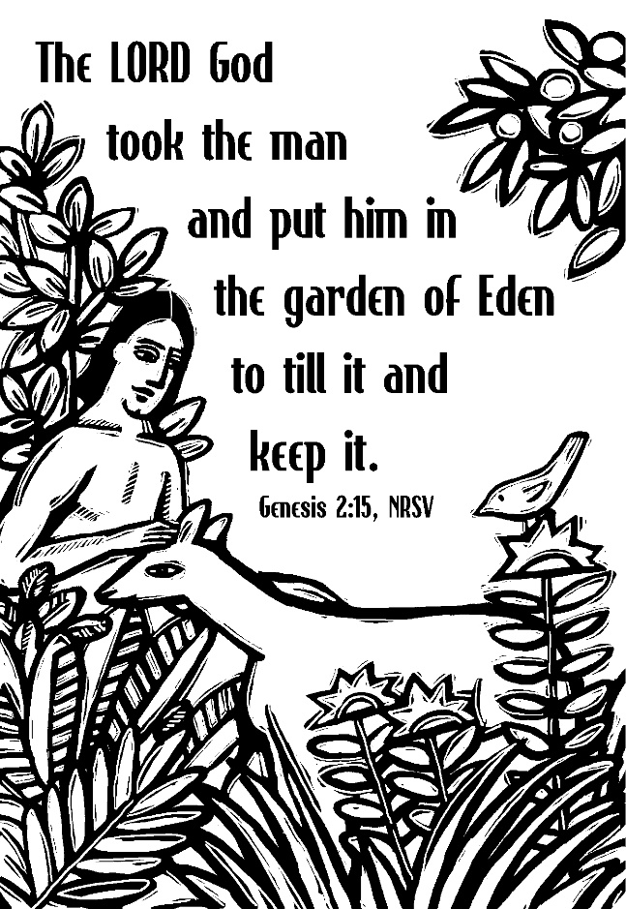

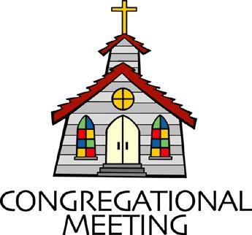
September 11, 2022 - 10:30 am

WELCOME VISITORS!
We're glad you are here! Cards at the ends of each pew are for you to fill out and drop in the Offering Plate. Please let us know you are visiting, and join us for refreshments and fellowship following the service. The Sanctuary has an induction loop system to assist the hearing impaired. The system will also work on the telephone setting of hearing aids.

Springfield Presbyterian Church is rooted in the gospel of Jesus Christ, led by the Holy Spirit, and called to loving relationships through vibrant worship and service. Valuing all people, we are committed to developing disciples and fostering stewardship.
PREPARATION FOR THE WORD
(* those who are able are invited to stand)

PRELUDE

GATHERING OF THE PEOPLE

The Lord be with you! And also with you! (Greeting)

LIGHTING THE CHRIST CANDLE
Leader: Whenever we light this candle we proclaim:
People: Christ is the Light of the world and the center of our lives.

CALL TO WORSHIP
Leader: We are from north and south.
People: We are from tiny apartments and expansive homes.
Leader: We are from this area and from others far away.
People: We are from big families and dinners made from one.
Leader: We are from stages of grief and stages of love.
People: We are from hot summers and cold winters.
Leader: We are from kitchens with passed down recipes, and front porches with old, familiar swings.
People: We are from the dust of the earth and the stars of the sky.
Leader: We are from many places, but today we are here.
People: Today we are together.
ALL: Holy God, gather us in.

* HYMN Here in This Place (Gather Us In) GTG #401
Here in the place the new light is streaming; now is the darkness vanished away; see in this space our fears and our dreamings brought here to you in the light of this day.
Gather us in, the lost and forsaken; gather us in, the blind and the lame; call to us now, and we shall awaken; we shall arise at the sound of our name.

We are the young, our lives are a mystery. We are the old who yearn for your face. We have been sung throughout all of history, called to be light in the whole human race.
Gather us in, the rich and the haughty; gather us in, the proud and the strong; give us a heart, so meek and so lowly; give us the courage to enter the song.

Here we will take the wine and the water; here we will take the bread of new birth. Here you shall call your sons and your daughters, call us anew to be salt for the earth.
Give us to drink the wine of compassion; give us to eat the bread that is you; nourish us well, and teach us to fashion live that are holy and hearts that are true.

Not in the dark of buildings confining, not in some heaven, light years away: here in this place the new light is shining; now is the kingdom, and now is the day.
Gather us in and hold us forever; gather us in and make us your own; gather us in, all peoples together, fire of love in our flesh and our bone.

CALL TO CONFESSION
Leader: If we were to call the prayer of confession by another name, maybe we would call it a moment for truth telling – a moment to pause, to reflect, to be honest about the places we want to grow and the way we need God’s help. There is power in honesty, so pray with me. We worship a loving and gracious God.

PRAYER OF CONFESSION
Gracious God, we know that when people heard that Jesus was from Nazareth, they asked, “Can anything good come from Nazareth?” We confess, God of beginnings, we have asked the same questions. Can anything good from that side of town? From a school with poor test scores? From a criminal history? From a history of addiction? From a faith with doubt? From a church with faults? Holy God, forgive us for doubting that you are in all things at all times. Open our eyes to see your goodness, not as something that resides here or there, but as the expansive grace that it is. When the question is asked, “Can anything good come from there?”, let us respond, “Yes. Always yes.” Amen.

SILENT PRAYERS OF CONFESSION

RESPONSE Lord Jesus Think on Me Tune #417
Lord Jesus, think on me, and purge away my sin.
From earth-born passions set me free, and make me pure within.

WORDS OF ASSURANCE
Leader: If you ever ask yourself, “Can anything good come from this messy and human life of mine?” Remember this: God is always whispering, “Yes.” You were created in the image of God. Your origin story is one of goodness and love from the very beginning. So hear and believe the good news of the gospel:
People: God is here. God is at work among us. We are forgiven. Thanks be to God for a love like that. Amen.

* MUSICAL RESPONSE OF PRAISE Glory to God Tune #583
Glory to God, glory to God, glory in the highest!
Glory to God, glory to God, alleluia, alleluia!

* THE PEACE The peace of Christ be with you! And also with you!
(You may greet those around you.)

* RESPONSE Here I Am, Lord
Here I am, Lord, Is it I, Lord? I have heard you calling in the night.
I will go, Lord, if you lead me. I will hold your people in my heart.
THE PROCLAMATION OF THE WORD

PRAYER OF ILLUMINATION
Holy God, we don’t always know how to pray, but you find us anyway. We don’t always know how to listen, but you enter in all the same. We don’t always know how to believe, but you surround us with beauty and love. Where we come from there are so many distractions. Where we come from there is so much noise. Find us. Hold us. Be in these words. Help us hear. Amen.

FIRST SCRIPTURE LESSON Genesis 2:4b-17
In the day that the Lord God made the earth and the heavens, ⁵when no plant of the field was yet in the earth and no herb of the field had yet sprung up—for the Lord God had not caused it to rain upon the earth, and there was no one to till the ground; ⁶but a stream would rise from the earth, and water the whole face of the ground— ⁷then the Lord God formed man from the dust of the ground, and breathed into his nostrils the breath of life; and the man became a living being. ⁸And the Lord God planted a garden in Eden, in the east; and there he put the man whom he had formed. ⁹Out of the ground the Lord God made to grow every tree that is pleasant to the sight and good for food, the tree of life also in the midst of the garden, and the tree of the knowledge of good and evil. ¹⁰A river flows out of Eden to water the garden, and from there it divides and becomes four branches. ¹¹The name of the first is Pishon; it is the one that flows around the whole land of Havilah, where there is gold; ¹²and the gold of that land is good; bdellium and onyx stone are there. ¹³The name of the second river is Gihon; it is the one that flows around the whole land of Cush. ¹⁴The name of the third river is Tigris, which flows east of Assyria. And the fourth river is the Euphrates. ¹⁵The Lord God took the man and put him in the garden of Eden to till it and keep it. ¹⁶And the Lord God commanded the man, ‘You may freely eat of every tree of the garden; ¹⁷but of the tree of the knowledge of good and evil you shall not eat, for in the day that you eat of it you shall die.’

SECOND SCRIPTURE LESSON Genesis 2:18-25
¹⁸Then the Lord God said, ‘It is not good that the man should be alone; I will make him a helper as his partner.’ ¹⁹So out of the ground the Lord God formed every animal of the field and every bird of the air, and brought them to the man to see what he would call them; and whatever the man called each living creature, that was its name. ²⁰The man gave names to all cattle, and to the birds of the air, and to every animal of the field; but for the man there was not found a helper as his partner. ²¹So the Lord God caused a deep sleep to fall upon the man, and he slept; then he took one of his ribs and closed up its place with flesh. ²²And the rib that the Lord God had taken from the man he made into a woman and brought her to the man. ²³Then the man said,
‘This at last is bone of my bones and flesh of my flesh; this one shall be called Woman, for out of Man this one was taken.’ ²⁴Therefore a man leaves his father and his mother and clings to his wife, and they become one flesh. ²⁵And the man and his wife were both naked, and were not ashamed.

Leader: Hear what the Spirit is saying to the Church.
All: Thanks be to God.

SERMON A New Birth Certificate Rev. Becca Crate-Price

THE RESPONSE TO THE WORD

* HYMN God of Great and God of Small GTG #19

God of great and God of small, God of one and God of all,
God of weak and God of strong, God to whom all things belong,

Refrain:
Alleluia, alleluia, praise be to your name.

God of land and sky and sea, God of life and destiny,
God of never-ending power, yet beside me every hour [Refrain]

God of silence, God of sound, God by whom the lost are found, God of day and darkest night, God whose love turns wrong to right [Refrain]

God of heaven and God of earth, God of death and God of birth, God of now and days before, God who reigns forever more [Refrain]

PASTORAL PRAYER AND THE LORD’S PRAYER

OFFERTORY With One Heart By Mark Patterson
SONG OF THANKS Praise God, from Whom All Blessings Flow #606
Praise God, from whom all blessing flow; praise him, all creatures here below; Praise him above, ye heavenly host; praise Father, Son and Holy Ghost. Amen.
PRAYER OF DEDICATION

* HYMN For the Beauty of the Earth GTG #14

For the beauty of the earth, for the glory of the skies,
For the love which from our birth over and around us lies:

Refrain:
Lord of all, to thee we raise this our hymn of grateful praise.

For the wonder of each hour of the day and of the night,
Hill and vale, and tree and flower, sun and moon, and stars of light: [Refrain]

For the joy of ear and eye, for the heart and mind’s delight,
For the mystic harmony linking sense to sound and sight: [Refrain]

For the joy of human love, brother, sister, parent, child,
Friends on earth, and friends above, for all gentle thoughts and mild: [Refrain]

For thyself, best gift divine to the world so freely given;
For that great, great love of thine, peace on earth and joy in heaven: [Refrain]

* CHARGE AND BENEDICTION
Leader: As you leave this place, may God grant us,
People: The curiosity to counter assumptions,
Leader: The vulnerability to befriend,
People: The bravery to speak your truth,
Leader: The wisdom to listen,
People: The strength to ask for help,
Leader: The resiliency to choose love, even when it’s hard,
People: And the awareness of the Holy Spirit always beside us.
Leader: In the name of our Great God, who is Love itself, may you go in peace.

* UNISON AMEN

POSTLUDE

Sunday, September 18, 2022 Lectionary
Amos 8:4-7; Psalm 113; 1 Timothy 2:1-7; Luke 16:1-13
Assisting in Worship: We appreciate those who serve:

Today 9/11 Next Week 9/18
Sunday Opener Ron Holmes Bob Rogers
Ushers/Greeters Sharon Pappas Don Vasbiner
Bob Rogers Elizabeth Meirowitz
Lay Leader Don Vasbinder Diana Steppling

Happy Anniversary! September 12 – Becca & Bryan Price

Happy Birthday! September 13 – Mark Kearney
September 14 – Linda Caviglia

Announcements

“I want to thank the congregation for all the blessings of love and support during Jim's illness and after his death. The continuous flow of cards, texts, emails, visits, phone calls, food, and gifts have been so encouraging and comforting. I am so grateful for all of you and your care and compassion beside us through this journey.”
~ Love & Prayers, Barb Nickell and Family

Headhuggers: The first meeting of the Headhuggers will be on Monday, September 12 at 7:00 pm at the Manse. See Amy Vasbinder for more information.

Presbytones Bell Choir: Bell Choir will begin rehearsing on September 14 from 6:15 to 7:15 pm, with Choir to follow from 7:30 to 8:45 pm.

Sunday School is back! We will be offering Sunday School beginning on September 18, and on the 1st and 3rd Sundays of each month thereafter. See Pastor Becca for details…

SAVE THE DATE! We are planning a church picnic, rain or shine (indoors or out) after worship Sunday, September 18! Do plan to come. We will have “7556 Bistro” on Sykesville's Main Street cater several dishes: Mac'n'cheese, a green salad, broccoli bacon slaw, and German potato salad, and we'll offer fried chicken and lunchmeat and cheese with rolls. If you REALLY want to bring something to share, maybe you have a favorite dessert! We need a good estimate of how many people to expect so please sign up at church or RSVP to barbaracornell4@gmail.com.

Fall Fellowship Time: The weather is changing! Time to make our plans for Fellowship through the fall. We'd love to have your help providing and serving the goodies we share as we visit after worship. If you have not hosted Fellowship, we can pair you with someone who knows the routine (and where we hide the toothpicks!).
If you don't want to host, we would be happy to have you sign up to bring something in. We always have a supply of crackers and cookies in the kitchen, but our table often includes fruit, cheese and baked goods. Let us know on the sign-up sheet in the kitchen or email me what you'd like to bring. Thanks so much!
Barbaracornell@gmail.com or 240-308-0035

Christian Education: Our Time and Talents survey shows folks are interested in an adult bible study program, and Alex McClung is interested in leading a study group. We imagine meeting 2x/month before church, but content, format, and timing are all TBD. Please contact Alex with your suggestions, interests, and best times: akmcclungiii@gmail.com.

Mask Update: Due to the uptick in COVID-19 cases, the Session has decided to strongly encourage masking and social distancing. Though it is not a mandate, we seek to love one another by keeping each other as safe as possible. Thank you for your help in this endeavor.

Pastor-Parish Committee: The Pastor-Parish Committee invites you to share your concerns, suggestions, and gratitude. We have a form in the Narthex and a lock-box that we will open weekly and we ask that you share your name and be specific. We look forward to reading your comments so that we can continue to grow into the body of Christ.

Springfield Membership: Are you interested in finding out more about our faith community and becoming a member? We would love to answer any questions you have. Please contact Pastor Becca at springfieldpastor@gmail.com for more information.

Congregational Care / Mission & Outreach (CoCaMO): Do you know of a member or friend of our church family who is ill, needs prayers, would like call, a visit or a card, or might benefit from meal train? If so, please contact the Church Office (410-795-6152), Cathy Marsh (410-549-6916) or Diana Steppling (862-266-2242).

Prayers & Thanksgivings
~ Prayers for Sue Holmes’ mom, Betty Martlew, who fell and broke her hip and underwent surgery this week.
~ Prayers for Cynthia Smith and her family on the passing of her Mom on September 1.
~ Prayers for speedy recovery for Craig Robinson who is healing from gallbladder surgery.

Today:
Sunday September 11
10:30 am Worship
11:30 am Fellowship
12:00 noon Pastor-Parish Committee Meeting

This Week:
Monday September 12
7:00 pm Headhuggers (Manse)
Tuesday September 13
7:00 pm CoCaMO Meeting (Manse)
Wednesday September 14
6:15 – 7:15 pm Bell Choir Practice
7:30 – 8:45 pm Adult Choir Practice

Looking Ahead:
Sunday September 18
10:30 am Worship & Sunday School
11:30 am Picnic
Wednesday September 21
6:15 – 7:15 pm Bell Choir Practice
7:30 – 8:45 pm Adult Choir Practice

Office Hours: Tuesday, Wednesday & Friday
Springfield Presbyterian Church

10:30 am Worship & Sunday School
11:30 am Fellowship
Website: www.springfield-church.org Church Office: 410-795-6152
Like us on Facebook: www.facebook.com/SpringfieldPresbyterianChurch
Pastor: Rev. Becca Crate-Price
Email: springfieldpastor@gmail.com
Clerk of Session: Sharon Pappas
Minister of Music: Linda Caviglia
Accompanist/Organist: Aaron Thacker
Youth Group Coordinator: Dylan Vasbinder
Administrative Assistant: Donna Mazer e-mail: spc.office@verizon.net

