(Large Print)

Springfield Presbyterian Church (USA)
7300 Spout Hill Road, Sykesville, MD 21784 410-795-6152

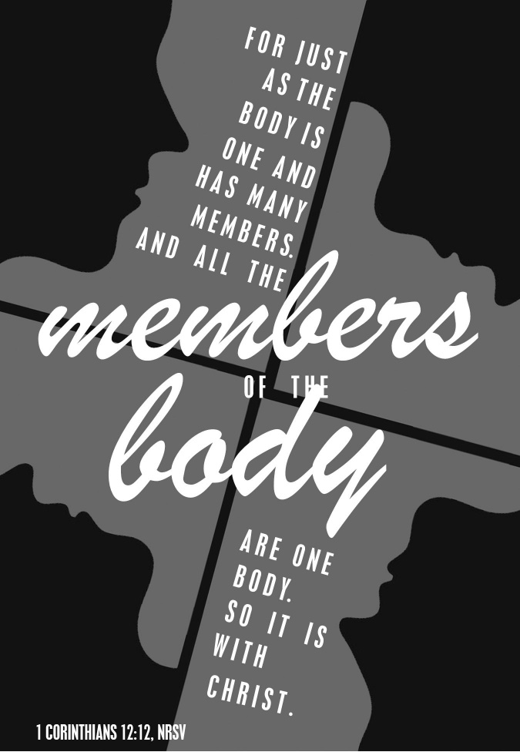

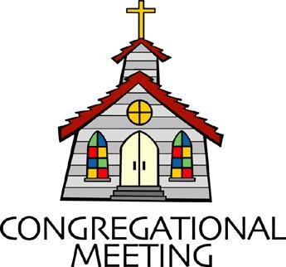
June 12, 2022 - 10:30 am

WELCOME VISITORS! We're glad you are here! Cards at the ends of each pew are for you to fill out and drop in the Offering Plate. Please let us know you are visiting, and join us for refreshments and fellowship following the service. The Sanctuary has an induction loop system to assist the hearing impaired. The system will also work on the telephone setting of hearing aids.

Springfield Presbyterian Church is rooted in the gospel of Jesus Christ, led by the Holy Spirit, and called to loving relationships through vibrant worship and service. Valuing all people, we are committed to developing disciples and fostering stewardship.
PREPARATION FOR THE WORD
(* those who are able are invited to stand)
PRELUDE

GATHERING OF THE PEOPLE

The Lord be with you! And also with you! (Greeting)

LIGHTING THE CHRIST CANDLE
Leader: Whenever we light this candle we proclaim:
People: Christ is the Light of the world and the center of our lives.

CALL TO WORSHIP
Leader: When two or three are gathered,
People: We prepare our hearts to worship God.
Leader: We give thanks for mornings like this,
People: When we look around in our pews and see love surround us.
Leader: We find that love in our family; the family of Springfield who are a family in Christ.
People: And with joy, today, we add to our beautiful and ever-growing family.
Leader: We give thanks to God for this gift,
People: And we do so with our thanksgiving and praise as we worship the one who led us here. Amen.

* HYMN God Welcomes All GTG #399
God welcomes all, strangers and friends;
God’s love is strong and it never ends.

CALL TO CONFESSION
Leader: We live in a busy and fast world where it is far too easy to forget the gifts that God has bestowed upon us and one another. We forget the fact that we are each part of this body of Christ, each valuable, and each equal part of it. We know, O God, that you call us to more, to see your power working within us and around us more clearly, so we come to seek forgiveness together as we pray:

PRAYER OF CONFESSION
Generous God, there are many gifts in the body of Christ, but we are soon to dismiss them. We can find ourselves not investing our time in learning about one another, seeing one another’s gifts, or appreciating the gifts that God has granted us. Renew us with better vision, one that helps us see more clearly all that the Spirit is doing in and through ourselves and one another. We know that only through these gifts we can do the work set before us for your Kingdom. Forgive us, O God, as we align ourselves in the work of the Church. Amen.

SILENT PRAYERS OF CONFESSION

RESPONSE The Woman Hiding in the Crowd Tune #178
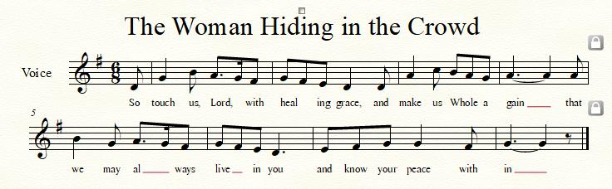

WORDS OF ASSURANCE
Leader: Whenever we come before God, with humble hearts and open minds, God calls us back into fellowship with love.
People: Thanks be to God whose forgiveness is beyond measure! Alleluia and amen!

* MUSICAL RESPONSE OF PRAISE O My Soul, Bless Your Redeemer
Bless your Maker, all you creatures, ever under God’s control,
All throughout God’s vast dominion; bless the Lord of all, my soul!

* THE PEACE The peace of Christ be with you! And also with you!
(You may greet those around you.)

* RESPONSE Here I Am, Lord
Here I am, Lord, Is it I, Lord? I have heard you calling in the night.
I will go, Lord, if you lead me. I will hold your people in my heart.

THE PROCLAMATION OF THE WORD

PRAYER OF ILLUMINATION
God of Mercy and Wonder, you promised never to break your covenant with us. Amid all the changing words of our generation, speak your eternal word that does not change. Then may we respond to your gracious promises with faithful and obedient lives; through our Lord Jesus Christ. Amen.

FIRST SCRIPTURE LESSON 1 Corinthians 12:12-27
¹²For just as the body is one and has many members, and all the members of the body, though many, are one body, so it is with Christ. ¹³For in the one Spirit we were all baptized into one body—Jews or Greeks, slaves or free—and we were all made to drink of one Spirit.
¹⁴Indeed, the body does not consist of one member but of many. ¹⁵If the foot were to say, ‘Because I am not a hand, I do not belong to the body’, that would not make it any less a part of the body. ¹⁶And if the ear were to say, ‘Because I am not an eye, I do not belong to the body’, that would not make it any less a part of the body. ¹⁷If the whole body were an eye, where would the hearing be? If the whole body were hearing, where would the sense of smell be? ¹⁸But as it is, God arranged the members in the body, each one of them, as he chose. ¹⁹If all were a single member, where would the body be? ²⁰As it is, there are many members, yet one body. ²¹The eye cannot say to the hand, ‘I have no need of you’, nor again the head to the feet, ‘I have no need of you.’ ²²On the contrary, the members of the body that seem to be weaker are indispensable, ²³and those members of the body that we think less honorable we clothe with greater honor, and our less respectable members are treated with greater respect; ²⁴whereas our more respectable members do not need this. But God has so arranged the body, giving the greater honor to the inferior member, ²⁵that there may be no dissension within the body, but the members may have the same care for one another. ²⁶If one member suffers, all suffer together with it; if one member is honored, all rejoice together with it.
²⁷Now you are the body of Christ and individually members of it.

SECOND SCRIPTURE LESSON Ephesians 2:19-22; 4:11-16
¹⁹So then you are no longer strangers and aliens, but you are citizens with the saints and also members of the household of God, ²⁰built upon the foundation of the apostles and prophets, with Christ Jesus himself as the cornerstone. ²¹In him the whole structure is joined together and grows into a holy temple in the Lord; ²²in whom you also are built together spiritually into a dwelling-place for God. ¹¹The gifts he gave were that some would be apostles, some prophets, some evangelists, some pastors and teachers, ¹²to equip the saints for the work of ministry, for building up the body of Christ, ¹³until all of us come to the unity of the faith and of the knowledge of the Son of God, to maturity, to the measure of the full stature of Christ. ¹⁴We must no longer be children, tossed to and fro and blown about by every wind of doctrine, by people’s trickery, by their craftiness in deceitful scheming. ¹⁵But speaking the truth in love, we must grow up in every way into him who is the head, into Christ, ¹⁶from whom the whole body, joined and knitted together by every ligament with which it is equipped, as each part is working properly, promotes the body’s growth in building itself up in love.

Leader: Hear what the Spirit is saying to the Church.
All: Thanks be to God.

SERMON Welcome to the Family Rev. Becca Crate-Price

THE RESPONSE TO THE WORD

* HYMN In Christ There Is No East or West GTG #318

In Christ there is no east or west, in him no south or north,
But one great fellowship of love throughout the whole wide earth.

In Christ shall true hearts everywhere their high communion find;
His service is the golden cord closebinding humankind.

Join hands, disciples of the faith, whate’er your face may be.
All children of the living God are surely kin to me.

In Christ now meet both east and west; in him meet south and north.
All Christly souls are one in him throughout the whole wide earth.

THE RECEPTION OF NEW MEMBERS
Presentation
Leader: There is one body and one Spirit, just as you were called to the one hope of your calling.
People: One Lord, one faith, one baptism, one God and Father of all, who is above all and through all and in all.

Profession of Faith
Leader: As members of the body of Christ, let us reaffirm the faith into which we were baptized:
People: I believe in God, the Father almighty, Maker of heaven and earth, and in Jesus Christ his only Son, our Lord; who was conceived by the Holy Ghost, born of the Virgin Mary, suffered under Pontius Pilate, was crucified, dead, and buried; he descended into hell; the third day he rose again from the dead; he ascended into heaven, and sitteth on the right hand of God the Father Almighty; from thence he shall come to judge the quick and the dead. I believe in the Holy Ghost; the holy catholic church; the communion of saints; the forgiveness of sins; the resurrection of the body; and the life everlasting. Amen.

Leader: Barbara, Hubert, Christy, and Bobby, we have professed our faith as one body. Will you be a faithful member of this congregation, share in its worship and mission through your prayers and gifts, your study and service, and so fulfill your calling to be a disciple of Jesus Christ?
New Members: We will, with God’s help.

Leader: Remember your baptism and be thankful, and know that the Holy Spirit is at work within you.
New Members: Thanks be to God.

Welcome
Leader: Welcome to this ministry that we share in Jesus Christ. The peace of Christ be with you.
People: And also with you.

PASTORAL PRAYER AND THE LORD’S PRAYER

OFFERTORY Celebrate the Joy by Joseph M. Martin
SONG OF THANKS As Those of Old Their Firstfruits Brought #712
In gratitude and humble trust we bring our best today, to serve your cause and share your love with all along life’s way. O God who gave yourself to us in Jesus Christ your Son, help us to give ourselves each day until life’s work is done.
PRAYER OF DEDICATION

* HYMN Give Thanks, O Christian People GTG #644

Give thanks, O Christian people, for workers of our day
Who heed the call to service and make it their life’s way
To go to feed the hungry, to tend to those in need,
To work for equal justice, till all God’s folk are freed.

Give thanks, O Christian people, for leaders of our years
Who live to share with others our joy when Christ appears,
To teach the ones who seek light, to guide the faltering feet,
To lead the followers forward our living Lord to meet.

Give thanks, O Christian people, for all who love the Lord,
Who live each day believing in God’s eternal Word:
To share Christ’s love in living, to witness with each deed,
To use the talents given to plant the gospel seed.

Give thanks, O Christian people, for life in fellowship
With all who trust our Savior their serving to equip:
To ease another’s burdens, to cope in joy and stress,
To magnify God’s message and Christ’s great love confess.

* CHARGE AND BENEDICTION
Leader: With joy and thanksgiving,
People: We give God thanks for life together.
Leader: And from this place,
People: We will seek to be ambassadors for Christ.
Leader: In the way we act, speak, and share in life,
People: May all know the love of Christ through us.

* UNISON AMEN

POSTLUDE

Sunday June 19, 2022 Lectionary
Isaiah 65:1-9; Psalm 22:19-28; Galatians 3:23-29; Luke 8:26-39

Assisting in Worship: We appreciate those who serve:

Today 6/12 Next Week 6/19
Sunday Opener Beth Oates Ron Holmes
Ushers/Greeters Leah & Henry Steve & Donna Halvorson Mazer
Lay Leader Christy Yeager Max Carroll

Happy Anniversary! June 14 – Tim & Esther Doyle

Happy Birthday! June 13 – Noella Izaguirre
June 17 – Alex McClung

Announcements

The final concert for our 2021-2022 concert series is TODAY at 3:00 pm, featuring Rebecca Hall and Ken Anderson, otherwise known as Hungrytown. The duo has earned a reputation for quality and authenticity in their songwriting. Lyricist Rebecca Hall is credited with compositions “that sound as timeless as any traditional songs” (Norther Sky, UK) while producer/multi-instrumentalist/husband Ken Anderson is lauded for his “remarkable affinity for instrumental embellishment” (No Depression) and for crafting Hungrytown’s “gorgeous vocal harmonies” (Folk and Roots, UK) (info taken from www.https://Hungrytown.net/bio ). We are excited to have them back in our series (they were also part of our 2015-2016 series).

Masking while indoors is strongly encouraged. We plan to have a reception (outdoors, weather permitting) following the concert with some great food! Please come and join us for a fun, musical afternoon!

Mask Update: Due to the uptick in COVID-19 cases, the Session has decided to strongly encourage masking and social distancing. Though it is not a mandate, we seek to love one another by keeping each other as safe as possible. Thank you for your help in this endeavor.

Pastor-Parish Committee: The Pastor-Parish Committee invites you to share your concerns, suggestions, and gratitude. We have a form in the Narthex and a lock-box that we will open weekly and we ask that you share your name and be specific. We look forward to reading your comments so that we can continue to grow into the body of Christ.

Sunday School is back! On the 1st and 3rd Sundays of the month, we will be offering Sunday School! See Pastor Becca for details…

Springfield Membership: Are you interested in finding out more about our faith community and becoming a member? We would love to answer any questions you have. Please contact Pastor Becca at springfieldpastor@gmail.com for more information.

Congregational Care / Mission & Outreach: Do you know of a member or friend of our church family who is ill, needs prayers, would like call, a visit or a card, or might benefit from meal train? If so, please contact the Church Office (410-795-6152), Cathy Marsh (410-549-6916) or Diana Steppling (862-266-2242).

Fellowship Help Needed: If you are interested in helping with Fellowship, please contact Barbara Cornell (240-308-0035). A sign-up sheet will also be available.

Today:
Sunday June 12 – Trinity Sunday – New Members
10:30 am Worship
11:30 am Fellowship
3:00 pm Concert (Sanctuary)

Looking Ahead:
Sunday June 19 – Happy Father’s Day!
10:30 am Worship
11:30 am Fellowship

Office Hours: Tuesday, Wednesday & Friday
Springfield Presbyterian Church

10:30 am Worship
11:30 am Fellowship
Website: www.springfield-church.org Church Office: 410-795-6152
Like us on Facebook: www.facebook.com/SpringfieldPresbyterianChurch
Pastor: Rev. Becca Crate-Price
Email: springfieldpastor@gmail.com
Clerk of Session: Sharon Pappas
Minister of Music: Linda Caviglia
Accompanist/Organist: Aaron Thacker
Youth Group Coordinator: Dylan Vasbinder
Administrative Assistant: Donna Mazer e-mail: spc.office@verizon.net

