(Large Print)

Springfield Presbyterian Church (USA)
7300 Spout Hill Road, Sykesville, MD 21784 410-795-6152

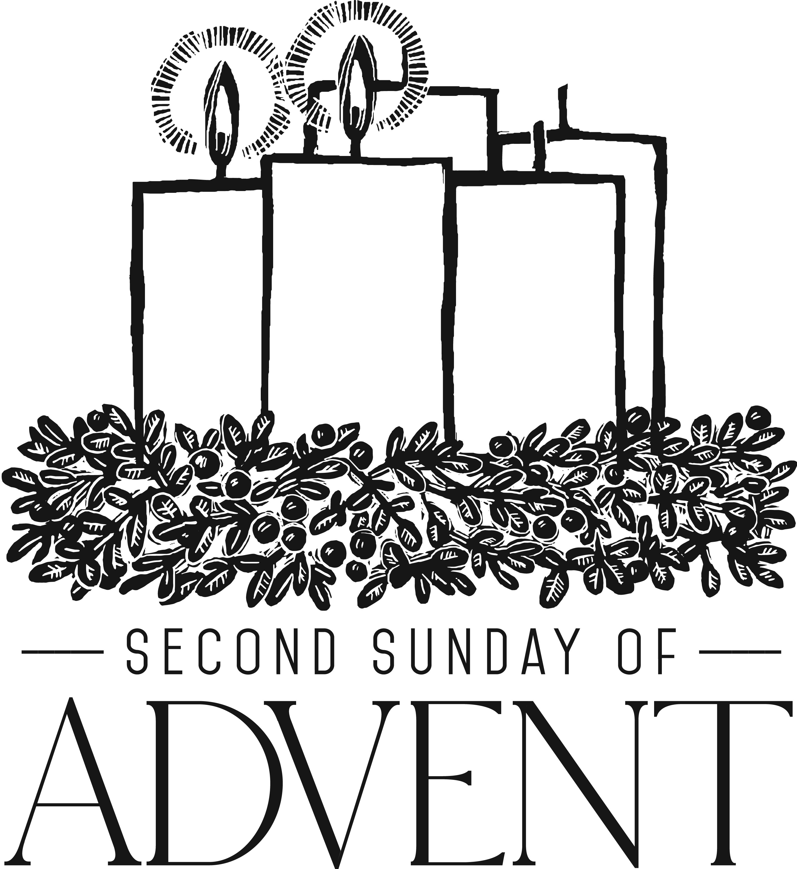

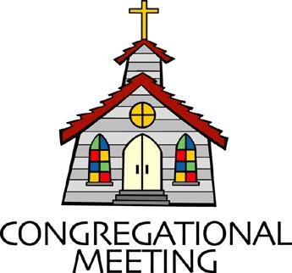
December 9, 2018 - 10:30 am

WELCOME VISITORS! We're glad you are here! Cards at the ends of each pew are for you to fill out and drop in the Offering Plate. Please let us know you are visiting, and join us for refreshments and fellowship following the service. The Sanctuary has an induction loop system to assist the hearing impaired. The system will also work on the telephone setting of hearing aids.

Springfield Presbyterian Church is rooted in the gospel of Jesus Christ, led by the Holy Spirit, and called to loving relationships through vibrant worship and service. Valuing all people, we are committed to developing disciples and fostering stewardship.
PREPARATION FOR THE WORD
(* those who are able are invited to stand)

Please prepare for worship by listening to the music of the Prelude.

PRELUDE

GATHERING OF THE PEOPLE

The Lord be with you! And also with you! (Greeting)

ADVENT CANDLE LIGHTING
Advent Reading - Week 2 Peace [Isaiah 9:6b-7a]
The Prophets promised that the coming Messiah would bring the presence and peace of God: “His name will be called Wonderful Counselor, Mighty God, Everlasting Father, Prince of Peace. Of the increase of His government and of peace there will be no end.” [Latin hymn, 12th c.: translated by John M. Neale 1851]

Lighting of the Candle
O Come, desires of nations, bind all people in one heart and one mind; bid envy, strife, and quarrels cease; fill the whole world with heaven’s peace.

Congregation joins choir in singing: Light the Candle
Light the candle of PEACE today, the Giver of peace is here!
Welcome the peace we fight and cry for, but only Christ can give.
Flicker and flame and glow - with peace, light up the world around you.
Flicker and flame and glow - with peace, light up the world around you.

CALL TO WORSHIP [Adapted from Malachi 3:1-4]
Leader: The Lord is sending a messenger to prepare the way before us!
People: Let us prepare for our Lord!
Leader: He will be the one of the covenant, one in which we will delight!
People: Let us prepare for our Lord!
Leader: He will refine and purify us, renewing us all!
People: Let us prepare for our Lord!
Leader: The one we seek is coming!
People: Let us prepare for our Lord!

* HYMN Prepare the Way of the Lord
Prepare the way of the Lord. Prepare the way of the Lord,
And all people will see the salvation of our God.

PRAYER OF CONFESSION
Generous God, we sit in a time of waiting; a time of waiting for the Christ child to be born, a time to recognize that birth, and to see that birth and new life take place in us. Yet, O God, we are impatient. From the beginning of time, from Isaiah’s words, to the words we will hear from the Gospels – we wait, we wait, we wait, for Christ to come and for the world to be made whole again. As we wait, we forget that something new is taking place in us, every year and every day – you are recreating, refining, and renewing who we are to bring your message of hope, peace, joy, love, and life into this world. When we get frustrated in waiting, forgive us; when we doubt your promise, renew us; and when we become unmoved to the powerful event of Christ being born, challenge us. Please forgive us, we plea, O Christ. Amen.

SILENT PRAYERS OF CONFESSION

RESPONSE O Little Town of Bethlehem (verse 3)
How silently, how silently, the wondrous gift is given!
So God imparts to human hearts the blessings of His heaven.
No ear may hear His coming, but in this world of sin,
Where meek souls will receive Him, the dear Christ enters in.

WORDS OF ASSURANCE [Based off of John 3:17]
Leader: Believe the good news! God did not send Christ into the world to condemn the world, but to save the world through Him.
People: We are forgiven! Thanks be to our merciful and loving God! Amen!

* MUSICAL RESPONSE OF PRAISE Angels, from the Realms of Glory
All creation, join in praising God the Father, Spirit, Son,
Ever more your voices raising to the eternal Three in One:
Come and worship, come and worship, worship Christ the newborn King!

* THE PEACE The peace of Christ be with you! And also with you!
(You may greet those around you.)

* RESPONSE Here I Am, Lord
Here I am, Lord, Is it I, Lord? I have heard you calling in the night.
I will go, Lord, if you lead me. I will hold your people in my heart.

THE PROCLAMATION OF THE WORD

PRAYER OF ILLUMINATION
Dear God, prepare our hearts, O God, to accept your Word. Silence in us any voices but your own, so that we may hear your Word and also do it, through Christ our Lord. Amen.

FIRST SCRIPTURE LESSON Luke 3:1-6
In the fifteenth year of the reign of Emperor Tiberius, when Pontius Pilate was governor of Judea, and Herod was ruler of Galilee, and his brother Philip ruler of the region of Ituraea and Trachonitis, and Lysanias ruler of Abilene, ²during the high-priesthood of Annas and Caiaphas, the word of God came to John son of Zechariah in the wilderness. ³He went into all the region around the Jordan, proclaiming

a baptism of repentance for the forgiveness of sins, ⁴as it is written in the book of the words of the prophet Isaiah, ‘The voice of one crying out in the wilderness: “Prepare the way of the Lord, make his paths straight. ⁵ Every valley shall be filled, and every mountain and hill shall be made low, and the crooked shall be made straight, and the rough ways made smooth; ⁶and all flesh shall see the salvation of God.” ’

SECOND SCRIPTURE LESSON Philippians 1:3-11
³I thank my God every time I remember you, ⁴constantly praying with joy in every one of my prayers for all of you, ⁵because of your sharing in the gospel from the first day until now. ⁶I am confident of this, that the one who began a good work among you will bring it to completion by the day of Jesus Christ. ⁷It is right for me to think this way about all of you, because you hold me in your heart, for all of you share in God’s grace with me, both in my imprisonment and in the defense and confirmation of the gospel. ⁸For God is my witness, how I long for all of you with the compassion of Christ Jesus. ⁹And this is my prayer, that your love may overflow more and more with knowledge and full insight ¹⁰to help you to determine what is best, so that on the day of Christ you may be pure and blameless, ¹¹having produced the harvest of righteousness that comes through Jesus Christ for the glory and praise of God.

Leader: Hear what the Spirit is saying to the Church.
All: Thanks be to God.

TIME WITH YOUNG PEOPLE

SERMON From the Valleys to the Mountains Rev. Becca Crate

THE RESPONSE TO THE WORD

* HYMN Wait for the Lord
Wait for the Lord, whose day is near.
Wait for the Lord; be strong; take heart!

PASTORAL PRAYER AND THE LORD’S PRAYER
“For this I pray to God.” / “For this I give thanks to God.”
Congregational Response: “Hear our prayer, O God.”

PRESENTATION OF TITHES AND OFFERINGS
OFFERTORY Come Messiah, Come by Bailey/Mayo
* SONG OF THANKS As with Gladness Men of Old
As they offered gifts most rare, at the manger rude and bare;
So may we with holy joy, pure, and free from sin’s alloy.
All our costliest treasures bring, Christ, to Thee, our heavenly King.
* PRAYER OF DEDICATION

* HYMN People, Look East

People, look east. The time is near of the crowning of the year.
Make your house fair as you are able; trim the hearth and set the table. People, look east: Love, the Guest, is on the way.

Furrows, be glad. Though earth is bare, one more seed is planted there. Give up your strength the seed to nourish, that in course the flower may flourish. People, look east: Love, the Rose, is on the way.

Birds, though you long have ceased to build, guard the nest that must be filled. Even the hour when wings are frozen, God for fledging time has chosen. People, look east: Love, the Bird, is on the way.

Stars, keep the watch. When night is dim, one more light the bowl shall brim, shining beyond the frosty weather, bright as sun and moon together. People, look east: Love, the Star, is on the way.

Angels, announce with shouts of mirth, Christ who brings new life to earth. Set every peak and valley humming with the word, the Lord is coming. People, look east: Love, the Lord, is on the way.

* CHARGE AND BENEDICTION

* UNISON AMEN

POSTLUDE [All are invited to stay and listen, but feel free to leave after the Unison Amen if you prefer.]

Assisting in Worship: We appreciate those who serve:

Today 12/9 Next Week 12/16
Sunday Opener Ron Holmes Bob Rogers
Greeters & Ushers Jim Wise & Sharon Pappas &
Connie Robinson Don Vasbinder
Lay Leader Tim Oates Diana Steppling
Sunday School Connie Robinson Connie Robinson
Fellowship Barbara Nickell Need Volunteer

Church Attendance: November 25 - 38 December 2 - 58

Church Cleaning: Dec. 14, 15 or 16 - Belle Vasbinder &
Barbara Nickell
Sunday December 16 Lectionary
Zephaniah 3:14-20; Isaiah 12:2-6; Philippians 4:4-7; Luke 3:7-18
Happy Birthday! December 14 - Dylan Vasbinder
December 15 - Grant Stinson

Happy Anniversary! December 14 - Tony & Linda Caviglia

Announcements

The Glory to God Hymnals are here! Through discernment of the Worship Committee and Session, we opted to use memorial fund money to purchase these wonderful new assets to our musical ministry. As you may recall, the blue hymnals had book plates, where you could donate money as a means of memorializing or honoring someone. The same will be offered for these books. The cost per book was 18 dollars, so the suggested donation is around that number, but any donation will be graciously received. Further into the new year, we will commemorate and list all contributors in a bulletin and bless the new hymnals.

Something is different in the Sanctuary: You might notice something a bit different in the Sanctuary this morning: Our new sound system! It was through Peggy Robbins’ profound donation upon her passing that we are able to have the beautiful acoustics of this space amplified. An AV/Screen will also be installed and upon completion of the project, we will dedicate these new worship tools in her name through a blessing and plaque.

Advent Craft Fair/SERRV Sale: Our Advent Craft Fair/SERRV Sale will be TODAY after Worship - food, cotton candy, crafts, music, memories, and a special Christmas photo booth! Once again the Mission Committee has arranged for a consignment SERRV sale. Shop SERRV's unique, handcrafted, fair trade items from around the world. Fill your home and kitchen with authentic decor, handmade dishware and stunning handcrafted baskets. Adorn yourself with gorgeous fair trade

jewelry, scarves and bags. Indulge in delicious chocolate and fair trade gourmet coffee. Give special fair trade gifts that will impact so many lives. Items sold through SERRV will help to fight poverty and build the communities of impoverished artisans and farmers. These artisans and farmers live in challenging circumstances and work diligently to provide for themselves and their families. SERRV items will also be available on December 23 after Worship.

C.I.A. (Community In Action): C.I.A. is a group open to all religious and non-religious people as a means of providing the community with acts of kindness. We will be doing different activities throughout the school year to help people in our community who are in need. Our next meeting will be TOMORROW from 4:30 to 6:00 pm at the Manse. Pizza and drinks provided! We will be preparing for the Family Shelter Christmas party - we will wrap gifts, put together stockings and other holiday goodies.

ESCAPE Lunch Packing: There is a sign-up sheet in the Fellowship Room to help with ESCAPE lunch packing on Tuesday, December 11 at 7:00 pm in the Manse, or to bring supplies. Please join us!

Holy Cow’ Conversations Assessment: LAST CHANCE! If you haven’t already done so, please complete the assessment on line (there are also pen and paper questionnaires available) to get a better sense of where the Spirit is leading us. We are looking forward to hearing your voice and kicking off the new year with the assessment in hand. It’s exciting to see where the Spirit will take us!

Gift Tree: The Christmas tree in the Narthex has gift tags for residents at Springfield Hospital. Please bring in unwrapped gifts to place under the tree by December 15. If you have any questions, please see Connie Robinson.

Weekly Announcements: If you have an announcement to include with next week’s bulletin, please call the Office at 410-795-6152 or email to spc.office@verizon.net by Wednesday each week.

Prayers & Thanksgivings

~ Prayers for Hope Presbyterian from our Ministry Group.

The Congregational Care team wants to know what YOU or someone you know needs...a visit...a call...a meal. Please contact Diana Steppling or Connie Robinson.

Today:
Sunday December 9 - Second Sunday of Advent
9:00 am Red Sea Parting Practice
10:30 am Worship & Sunday School
11:30 am Fellowship
3:00 pm Concert - Iron Ridge Band (Bluegrass)
6:30 pm Youth Movie Night (Manse)

This Week:
Monday December 10
4:30 pm C.I.A. Meeting (Manse)
7:00 pm Headhuggers (Manse)
Tuesday December 11
10:30 am Prayer Group (Manse)
6:30 pm Bell Choir Practice
7:00 pm Adult Choir Practice
7:00 pm ESCAPE Lunch Packing (Manse)
Thursday December 13
7:00 pm Session Meeting (Manse)
Saturday December 15
1:00 pm Family Shelter Party (Westminster)

Looking Ahead:
Sunday December 16
9:00 am Red Sea Parting Practice
10:30 am Worship & Sunday School
11:30 am Fellowship
Monday December 17
9:30 am Feed My Sheep (Wesley Freedom)
4:30 pm C.I.A. Christmas Party (Manse)

Office Hours: Tuesday, Wednesday, Friday 9:00 am - 3:00 pm
Springfield Presbyterian Church

10:30 am Worship & Sunday School
11:30 am Fellowship
Website: www.springfield-church.org Church Office: 410-795-6152
Like us on Facebook: www.facebook.com/SpringfieldPresbyterianChurch
Pastor: Rev. Becca Crate
Email: springfieldpastor@gmail.com
Clerk of Session: Sharon Pappas
Minister of Music: Linda Caviglia
Accompanist: Aaron Thacker Organist: Jennifer Wise
Youth Group Coordinators: Charles & Deb Sperling
Sunday School Coordinator: Connie Robinson
Administrative Assistant: Donna Mazer
e-mail: spc.office@verizon.net

