(Large Print)

Springfield Presbyterian Church (USA)
7300 Spout Hill Road, Sykesville, MD 21784 410-795-6152

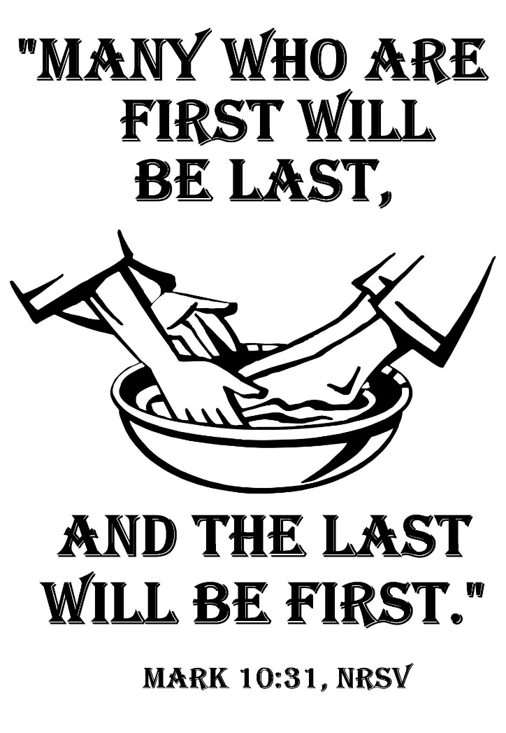

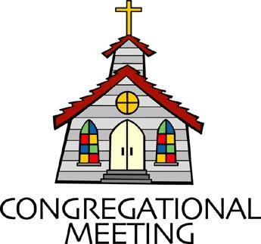
October 10, 2021 - 10:30 am

WELCOME VISITORS! We're glad you are here! Cards at the ends of each pew are for you to fill out and drop in the Offering Plate. Please let us know you are visiting, and join us for refreshments and fellowship following the service. The Sanctuary has an induction loop system to assist the hearing impaired. The system will also work on the telephone setting of hearing aids.

Springfield Presbyterian Church is rooted in the gospel of Jesus Christ, led by the Holy Spirit, and called to loving relationships through vibrant worship and service. Valuing all people, we are committed to developing disciples and fostering stewardship.
PREPARATION FOR THE WORD
(* those who are able are invited to stand)

PRELUDE

GATHERING OF THE PEOPLE

The Lord be with you! And also with you! (Greeting)

LIGHTING THE CHRIST CANDLE
Leader: Whenever we light this candle we proclaim:
People: Christ is the Light of the world and the center of our lives.

CALL TO WORSHIP [Psalm 130]
Leader: Out of the depths I cry to you, O Lord.
People: Lord, hear my voice! Let your ears be attentive to the voice of my supplications!
Leader: If you, O Lord, should mark iniquities, Lord, who could stand?
People: But there is forgiveness with you, so that you may be revered.
Leader: I wait for the Lord, my soul waits, and in His word I hope;
People: My soul waits for the Lord more than those who watch for the morning.
Leader: O Israel, hope in the Lord! For with the Lord there is steadfast love, and with Him is great power to redeem.
People: It is He who will redeem Israel from all its iniquities.

* HYMN Lord, You Have Come to the Lakeshore #721

Lord, you have come to the lakeshore looking neither for wealthy nor wise ones; you only asked me to follow humbly.

Refrain: O Lord, with your eyes you have searched me, and while smiling have spoken my name; now my boat’s left on the shoreline behind me. By your side I will seek other seas.

You know so well my possessions; my boat carries no gold and no weapons; you will find there my nets and labor. [Refrain]

You need my hands, full of caring, through my labors to give others rest and constant love that keeps on loving. [Refrain]

You, who have fished other oceans, ever longed for by souls who are waiting, my loving friend, as thus you call me. [Refrain]

PRAYER OF CONFESSION
Generous God, you urge us to live in a state of humility, one where our lives reflect your own. You tell us, “The first will be last and the last will be first” but we find it difficult to live in a world where we give our all. We seek the kingdom, sometimes we even believe we deserve it, but you remind us again and again that it is your salvation alone that brings us into your presence. Forgive us when our egos become larger, and we forget whose we are and where we come from. Renew us as we restore ourselves to being people whose default is humility and a love that stands for all. Amen.

SILENT PRAYERS OF CONFESSION

RESPONSE Hear My Prayer, O God Tune #782
Hear my prayer, O God, and listen to my plea;
Faithful, righteous One, give ear and answer me.

WORDS OF ASSURANCE [Romans 8:34; 2 Corinthians 5:17]
Leader: Hear the Good News! Who is in a position to condemn? Only Christ, and Christ died for us, Christ rose for us, Christ reigns in power for us, Christ prays for us.
People: Anyone who is in Christ is a new creation. The old life has gone; a new life has begun. Let us know that we are forgiven and now let us be at peace. Amen.

* MUSICAL RESPONSE OF PRAISE O My Soul, Bless Your Redeemer
Bless your Maker, all you creatures, ever under God’s control,
All throughout God’s vast dominion; bless the Lord of all, my soul!

* THE PEACE The peace of Christ be with you! And also with you!
(You may greet those around you.)

* RESPONSE Here I Am, Lord
Here I am, Lord, Is it I, Lord? I have heard you calling in the night.
I will go, Lord, if you lead me. I will hold your people in my heart.

THE PROCLAMATION OF THE WORD

PRAYER OF ILLUMINATION
O Lord our God, your Word is a lamp to our feet and a light to our path. Give us grace to receive your truth in faith and love, that we may be obedient to your will and live always for your glory; through Jesus Christ our Savior. Amen.

FIRST SCRIPTURE LESSON Psalm 22:1-15
¹ My God, my God, why have you forsaken me? Why are you so far from helping me, from the words of my groaning? ² O my God, I cry by day, but you do not answer; and by night, but find no rest. ³ Yet you are holy, enthroned on the praises of Israel. ⁴ In you our ancestors trusted; they trusted, and you delivered them. ⁵ To you they cried, and were saved; in you they trusted, and were not put to shame. ⁶ But I am a worm, and not human; scorned by others, and despised by the people.
⁷ All who see me mock at me; they make mouths at me, they shake their heads; ⁸ ‘Commit your cause to the Lord; let him deliver— let him rescue the one in whom he delights!’ ⁹ Yet it was you who took me from the womb; you kept me safe on my mother’s breast. ¹⁰ On you I was cast from my birth, and since my mother bore me you have been my God. ¹¹ Do not be far from me, for trouble is near and there is no one to help. ¹² Many bulls encircle me, strong bulls of Bashan surround me; ¹³ they open wide their mouths at me, like a ravening and roaring lion. ¹⁴ I am poured out like water, and all my bones are out of joint;
my heart is like wax; it is melted within my breast; ¹⁵ my mouth is dried up like a potsherd, and my tongue sticks to my jaws; you lay me in the dust of death.

SECOND SCRIPTURE LESSON Mark 10:17-31
¹⁷As he was setting out on a journey, a man ran up and knelt before him, and asked him, ‘Good Teacher, what must I do to inherit eternal life?’ ¹⁸Jesus said to him, ‘Why do you call me good? No one is good but God alone. ¹⁹You know the commandments: “You shall not murder; You shall not commit adultery; You shall not steal; You shall not bear false witness; You shall not defraud; Honor your father and mother.” ’ ²⁰He said to him, ‘Teacher, I have kept all these since my youth.’ ²¹Jesus, looking at him, loved him and said, ‘You lack one thing; go, sell what you own, and give the money to the poor, and you will have treasure in heaven; then come, follow me.’ ²²When he heard this, he was shocked and went away grieving, for he had many possessions. ²³Then Jesus looked around and said to his disciples, ‘How hard it will be for those who have wealth to enter the kingdom of God!’ ²⁴And the disciples were perplexed at these words. But Jesus said to them again, ‘Children, how hard it is to enter the kingdom of God! ²⁵It is easier for a camel to go through the eye of a needle than for someone who is rich to enter the kingdom of God.’ ²⁶They were greatly astounded and said to one another, ‘Then who can be saved?’ ²⁷Jesus looked at them and said, ‘For mortals it is impossible, but not for God; for God all things are possible.’ ²⁸Peter began to say to him, ‘Look, we have left everything and followed you.’ ²⁹Jesus said, ‘Truly I tell you, there is no one who has left house or brothers or sisters or mother or father or children or fields, for my sake and for the sake of the good news, ³⁰who will not receive a hundredfold now in this age—houses, brothers and sisters, mothers and children, and fields, with persecutions—and in the age to come eternal life. ³¹But many who are first will be last, and the last will be first.’
Leader: Hear what the Spirit is saying to the Church.
All: Thanks be to God.

SERMON The Tension of Humility Rev. Becca Crate-Price

THE RESPONSE TO THE WORD

* HYMN Will You Come and Follow Me #726

Will you come and follow me if I but call your name?
Will you go where you don’t know and never be the same?
Will you let my love be shown, will you let my name be known,
Will you let my life be grown in you and you in me?

Will you leave yourself behind if I but call your name?
Will you care for cruel and kind and never be the same?
Will you risk the hostile stare should your life attract or scare?
Will you let me answer prayer in you and you in me?

Will you let the blinded see if I but call your name?
Will you set the prisoners free and never be the same?
Will you kiss the leper clean, and do such as this unseen,
And admit to what I mean in you and you in me?

Will you love the “you” you hide if I but call your name?
Will you quell the fear inside and never be the same?
Will you use the faith you’ve found to reshape the world around,
Through my sight and touch and sound in you and you in me?

Lord, your summons echoes true when you but call my name.
Let me turn and follow you and never be the same.
In your company I’ll go where your love and footsteps show.
Thus I’ll move and live and grow in you and you in me.

PASTORAL PRAYER AND THE LORD’S PRAYER

PRESENTATION OF TITHES AND OFFERINGS
* PRAYER OF DEDICATION

* HYMN Take My Life #697

Take my life and let it be consecrated, Lord, to thee;
Take my moments and my days; let them flow in ceaseless praise;
Let them flow in ceaseless praise.

Take my hands and let them move at the impulse of thy love;
Take my feet and let them be swift and beautiful for thee,
Swift and beautiful for thee.

Take my voice and let me sing always, only, for my King;
Take my lips and let them be filled with messages from thee,
Filled with messages from thee.

Take my silver and my gold; not a mite would I withhold;
Take my intellect and use every power as thou shalt choose,
Every power as thou shalt choose.

Take my will and make it thine; it shall be no longer mine.
Take my heart, it is thine own; it shall be thy royal throne,
It shall be thy royal throne.

Take my love; my Lord, I pour at thy feet its treasure store;
Take myself and I will be ever, only, all for thee,
Ever, only, all for thee.

ANTHEM A Prayer for Humility By Mark Patterson

* CHARGE AND BENEDICTION
Leader: Lead us from this place,
People: And let us remember whose we are.
Leader: Let us be a humble people,
People: Who point to goodness of you in this world.
Leader: And let us set aside our egos,
People: To dwell in full communion with you.

* UNISON AMEN

POSTLUDE

Assisting in Worship: We appreciate those who serve:

Today 10/10 Next Week 10/17
Sunday Opener Ron Holmes Bob Rogers
Greeters & Ushers Sharon Pappas & Connie Gibbons &
Jim Wise Cathy Marsh
Lay Leader Bob Steppling Diana Steppling
Fellowship Need Volunteer Need Volunteer
Sunday October 17, 2021 Lectionary
Isaiah 53:4-12; Psalm 91:9-16; Hebrews 5:1-10; Mark 10:35-45

Happy Birthday! October 12 – Jim Nickell
October 13 – Joy Barwick
October 13 – Ron Holmes
October 15 – Jessica Lane
October 17 – Beth Oates

Happy Anniversary! October 15 – Barbara & Jim Nickell

Announcements

Special Offering: Peace and Global Witness is the third of our four special offerings and supports peacemaking and reconciliation ministries throughout the world. With this offering, each congregation is able to use one-quarter of the offering to support an organization of their choice. We want to assist with those needing some legal assistance. Legal Services Corporation, America's Partner for Equal Justice (LSC, tax-exempt organization) is the single largest funder of civil legal services in the country. They play a vital role in a public-private partnership focused on fulfilling America's pledge of equal justice for all. Since its founding more than four decades ago. LSC has been making a difference in the lives of low-income Americans by funding high-quality civil legal assistance to veterans, the elderly, victims of domestic abuse, tenants facing unlawful evictions, and others who cannot afford to pay for legal assistance.

Upcoming Concert: TODAY at 3:00 pm, we will feature John Bullard, classical banjo and Markus Compton, pianist in our Sanctuary, followed by fellowship (outdoors if possible). Bring your family and friends!

Congregational Care / Mission & Outreach: The Congregational Care/Mission & Outreach Committee would like your help. As we emerge from this pandemic, there is a greater than usual need to make every effort to connect with one another. Do you know of a member or friend of our church family who is ill, needs prayers, would like call, a visit or a card, or might benefit from meal train? If so, please contact the Church Office (410-795-6152), Cathy Marsh (410-549-6916) or Diana Steppling (862-266-2242).

Prayers & Thanksgivings

~ We would like to thank everyone for the cards, texts, emails, and phone calls that we continue to receive. They are very encouraging and help to get us through the difficult days. This is such a wonderful ministry. ~ With Love & Prayers, Barb & Jim Nickell

Today:
Sunday October 10
10:30 am Worship
11:30 am Fellowship
3:00 pm Concert

This Week:
Tuesday October 12
7:00 pm Congregational Care/Mission & Outreach Meeting
(Manse and also via Zoom)
Wednesday October 13
6:30 pm Bell Choir Practice
7:45 pm Adult Choir Practice
Thursday October 14
7:00 pm Session Meeting (Manse and also via Zoom)

Looking Ahead:
Sunday October 17
10:30 am Worship
11:30 am Fellowship

Office Hours: Tuesday, Wednesday & Friday
Springfield Presbyterian Church

10:30 am Worship
11:30 am Fellowship
Website: www.springfield-church.org Church Office: 410-795-6152
Like us on Facebook: www.facebook.com/SpringfieldPresbyterianChurch
Pastor: Rev. Becca Crate
Email: springfieldpastor@gmail.com
Clerk of Session: Sharon Pappas
Minister of Music: Linda Caviglia
Accompanist: Aaron Thacker Organist: Jennifer Wise
Youth Group Coordinators: Charles & Deb Sperling
Sunday School Coordinator: Connie Robinson
Administrative Assistant: Donna Mazer e-mail: spc.office@verizon.net

