(Large Print)

Springfield Presbyterian Church (USA)
7300 Spout Hill Road, Sykesville, MD 21784 410-795-6152

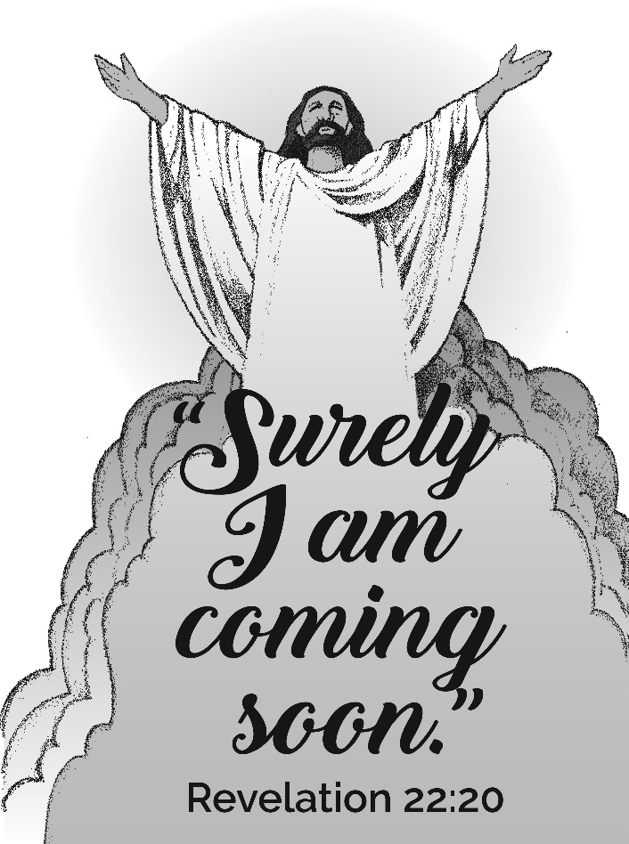

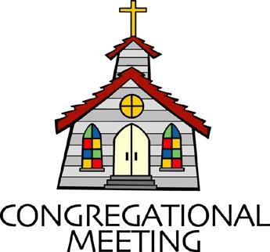
June 2, 2019 - 10:30 am

WELCOME VISITORS! We're glad you are here! Cards at the ends of each pew are for you to fill out and drop in the Offering Plate. Please let us know you are visiting, and join us for refreshments and fellowship following the service. The Sanctuary has an induction loop system to assist the hearing impaired. The system will also work on the telephone setting of hearing aids.

Springfield Presbyterian Church is rooted in the gospel of Jesus Christ, led by the Holy Spirit, and called to loving relationships through vibrant worship and service. Valuing all people, we are committed to developing disciples and fostering stewardship.
PREPARATION FOR THE WORD
(* those who are able are invited to stand)

PRELUDE

GATHERING OF THE PEOPLE

The Lord be with you! And also with you! (Greeting)

LIGHTING THE CHRIST CANDLE
Leader: Whenever we light this candle we proclaim:
People: Christ is the Light of the world and the center of our lives.

CALL TO WORSHIP
Leader: We lift up our eyes to the hills – where does our help come from?
People: Our help comes from the Lord, who made heaven and earth.
Leader: God will not let your foot be moved; God who keeps you will not slumber.
People: Our redeemer who keeps Israel with neither slumber nor sleep.
Leader: The Lord is our keeper; our shade at our right hand.
People: The sun shall not strike us by day, nor the moon by night.
Leader: The Lord will keep us from all evil; the Lord will keep our lives.
People: The Lord will keep our going out and our coming in from this time on and forevermore.
All: Let us all worship our faithful and loving God! Amen!

* HYMN Holy, Holy, Holy! Lord God Almighty!
Holy, holy, holy! Lord God Almighty!
Early in the morning our song shall rise to thee.
Holy, holy, holy! Merciful and mighty!
God in three persons, blessed Trinity!

Holy, holy, holy! All the saints adore thee,
Casting down their golden crowns around the glassy sea;
Cherubim and seraphim falling down before thee,
Who wert, and art, and evermore shalt be.

Holy, holy, holy! Though the darkness hide thee,
Though the eye of sinfulness thy glory may not see,
Only thou art holy; there is none beside thee,
Perfect in power, in love and purity.

Holy, holy, holy! Lord God Almighty!
All thy works shall praise thy name, in earth and sky and sea.
Holy, holy, holy! Merciful and mighty!
God in three persons, blessed Trinity!

PRAYER OF CONFESSION (Unison)
Generous God, we enter our mornings without recognizing the blessings before us: from the flowers of the field, the birds of the air, to the creation that surrounds us. We go along our days in monotony, grateful here and there, but unintentional about how we live. Yet you tell us that you are the Alpha and Omega, the beginning and the end, and you call us to come and be active in your good work. Forgive us when we do not sense the urgency of that call, and renew a right spirit within us to serve you with our whole heart. Amen.

SILENT PRAYERS OF CONFESSION

RESPONSE Remember Not, O God
O Lord, our Savior, help, and glorify your name;
Deliver us from all our sins and take away our shame.

WORDS OF ASSURANCE [Psalm 103:17]
Leader: The mercy of the Lord is from everlasting to everlasting.
People: We declare, in the name of Jesus Christ, we are forgiven! Thanks be to God! Amen!

* MUSICAL RESPONSE OF PRAISE Great Is Thy Faithfulness
Great is thy faithfulness! Great is thy faithfulness! Morning by morning new mercies I see. All I have needed thy hand hath provided. Great is thy faithfulness Lord unto me.

* THE PEACE The peace of Christ be with you! And also with you!
(You may greet those around you.)
* RESPONSE Here I Am, Lord
Here I am, Lord, Is it I, Lord? I have heard you calling in the night.
I will go, Lord, if you lead me. I will hold your people in my heart.

THE PROCLAMATION OF THE WORD

PRAYER OF ILLUMINATION
Lord, open our hearts and minds by the power of your Holy Spirit, that as the scriptures are read and your Word is proclaimed, we may hear with joy what you say to us today. Amen.

FIRST SCRIPTURE LESSON Psalm 97
¹ The Lord is king! Let the earth rejoice; let the many coastlands be glad! ² Clouds and thick darkness are all around him; righteousness and justice are the foundation of his throne. ³ Fire goes before him, and consumes his adversaries on every side. ⁴ His lightnings light up the world; the earth sees and trembles. ⁵ The mountains melt like wax before the Lord, before the Lord of all the earth. ⁶ The heavens proclaim his righteousness; and all the peoples behold his glory. ⁷ All worshippers of images are put to shame, those who make their boast in worthless idols; all gods bow down before him. ⁸ Zion hears and is glad,

and the towns of Judah rejoice, because of your judgements, O God.
⁹ For you, O Lord, are most high over all the earth; you are exalted far above all gods. ¹⁰ The Lord loves those who hate evil; he guards the lives of his faithful; he rescues them from the hand of the wicked.
¹¹ Light dawns for the righteous, and joy for the upright in heart.
¹² Rejoice in the Lord, O you righteous, and give thanks to his holy name!

SECOND SCRIPTURE LESSON Revelation 22:12-14, 16-17, 20-21
¹²‘See, I am coming soon; my reward is with me, to repay according to everyone’s work. ¹³I am the Alpha and the Omega, the first and the last, the beginning and the end.’ ¹⁴Blessed are those who wash their robes, so that they will have the right to the tree of life and may enter the city by the gates. ¹⁶‘It is I, Jesus, who sent my angel to you with this testimony for the churches. I am the root and the descendant of David, the bright morning star.’ ¹⁷The Spirit and the bride say, ‘Come.’ And let everyone who hears say, ‘Come.’ And let everyone who is thirsty come.
Let anyone who wishes take the water of life as a gift. ²⁰The one who testifies to these things says, ‘Surely I am coming soon.’ Amen. Come, Lord Jesus! ²¹The grace of the Lord Jesus be with all the saints. Amen.

Leader: Hear what the Spirit is saying to the Church.
All: Thanks be to God.

TIME WITH YOUNG PEOPLE

SERMON Come and Wait Rev. Becca Crate

THE RESPONSE TO THE WORD

* HYMN Take My Life
Take my life and let it be consecrated, Lord, to thee;
Take my moments and my days; let them flow in ceaseless praise;
Let them flow in ceaseless praise.

Take my hands and let them move at the impulse of thy love;
Take my feet and let them be swift and beautiful for thee,
Swift and beautiful for thee.

Take my voice and let me sing always, only, for my King;
Take my lips and let them be filled with messages from thee,
Filled with messages from thee.

Take my silver and my gold; not a mite would I withhold;
Take my intellect and use every power as thou shalt choose,
Every power as thou shalt choose.

Take my will and make it thine; it shall be no longer mine.
Take my heart, it is thine own; it shall be thy royal throne,
It shall be thy royal throne.

Take my love; my Lord, I pour at thy feet its treasure store;
Take myself and I will be ever, only, all for thee, ever, only, all for thee.

ORDINATION AND INSTALLATION

Sentences of Scripture [1 Cor. 12:4-7; 27]

Leader: There are varieties of gifts, but it is the same Spirit who gives them.
People: There are different ways of serving God, but it is the same Lord who is served.

Leader: God works through each person in a unique way, but it is God’s purpose that is accomplished.
People: To each is given a gift of the Spirit to be used for the common good.
Leader: Together we are the body of Christ, and individually members of it.

Statement on Ordination

Statement on Ordaining Ruling Elders

Statement on Installing Ruling Elders

Profession of Faith

Thanksgiving for Baptism

Constitutional Questions
Do you trust in the Lord Jesus Christ your Savior, acknowledge Him Lord of all and Head of the Church, and through Him believe in one God: Father, Son, and Holy Spirit? I do.

Do you accept the Scriptures of the Old and New Testaments to be, by the Holy Spirit, the unique and authoritative witness to Jesus Christ in the church universal, and God’s Word to you? I do.

Do you sincerely receive and adopt the essential tenets of the Reformed faith as expressed in the confessions of our church as authentic and reliable expositions of what Scripture leads us to believe and do, and will you be instructed and led by those confessions as you lead the people of God? I do and I will.

Will you fulfil your ministry in obedience to Jesus Christ, under the authority of Scripture, and be continually guided by our Confessions?
I will.
Will you be governed by our church’s polity, and will you abide by its discipline? Will you be a friend among your colleagues in ministry, working with them, subject to the ordering of God’s Word and Spirit?
I will.

Will you in your own life seek to follow the Lord Jesus Christ, love your neighbors, and work for the reconciliation of the world? I will.

Do you promise to further the peace, unity, and purity of the church?
I do.

Will you pray for and seek to serve the people with energy, intelligence, imagination, and love? I will.

Will you be a faithful ruling elder, watching over the people, providing for their worship, nurture, and service? Will you share in government and discipline, serving in councils of the church, and in your ministry will you try to show the love and justice of Jesus Christ? I will.

Questions for the Congregation
Do we, the members of the church, accept Julie and Don as ruling elders, chosen by God through the voice of this congregation to lead us in the way of Jesus Christ? If so, please say, ‘we do’.

Do we agree to pray for them, to encourage them, to respect their decisions, and to follow as they guide us, serving Jesus Christ, who alone is Head of the Church? If so, please say, ‘we do’.

Prayer of Ordination & Installation

Declaration of Ordination & Installation

Welcome

Charge to the Ordained & Installed

Charge to the Congregation
THE COMMUNION OF THE PEOPLE

INVITATION

THE GREAT PRAYER OF THANKSGIVING
Leader: The Lord be with you.
People: And also with you.
Leader: Lift up your hearts.
People: We lift them up to the Lord.
Leader: Let us give thanks to the Lord our God.
People: It is right to give our thanks and praise.
[The Pastor continues… “…who forever sing to the glory of your name.”]

IN PRAISE OF GOD Tune #552
Holy, holy, holy, Lord, God of Power and might.
Heaven and earth are full of your glory, Hosanna in the highest!
Blessed is He who comes in the name of the Lord.
Hosanna in the highest, hosanna in the highest.
[The Pastor continues… “…proclaim the One crucified and risen...”]

IN PRAISE OF CHRIST Tune #553
Christ has died; Christ is risen; Christ will come again.
Christ has died; Christ is risen; Christ will come again.

PASTORAL PRAYER AND THE LORD’S PRAYER
“For this I pray to God.” / “For this I give thanks to God.”
Congregational Response: “Hear our prayer, O God.”

WORDS OF INSTITUTION

SHARING OF THE MEAL

PRAYER OF DEDICATION (Unison)
Dear God, take us out to live as changed people because we have shared the living bread and cannot remain the same. Ask much of us, expect much from us, enable much by us, encourage many through us. So, Lord, may we live to your glory, both as inhabitants of the earth, and citizens of the commonwealth of Heaven. Through Christ, with Christ, in Christ, in the unity of the Holy Spirit, all glory and honor are yours, almighty God, now and forever. Amen.

PRESENTATION OF TITHES AND OFFERINGS
OFFERTORY Here I Am Lord by Schutte/Sherman
* SONG OF THANKS As Those of Old Their Firstfruits Brought
In gratitude and humble trust we bring our best today,
To serve your cause and share your love with all along life’s way.
O God who gave yourself to us in Jesus Christ your Son,
Help us to give ourselves each day until life’s work is done.
* PRAYER OF DEDICATION

* HYMN O for a Thousand Tongues to Sing
O for a thousand tongues to sing my dear Redeemer’s praise,
The glories of my God and King, the triumphs of God’s grace!

The name of Jesus charms our fears, and bids our sorrows cease,
Sings music in the sinner’s ears, brings life, and health and peace.

Christ speaks, and listening to his voice new life the dead receive,
The mournful waken to rejoice, the poor in heart believe.

My gracious Master and my God, assist me to proclaim,
To spread through all the earth abroad the honors of thy name.

To God all glory, praise and love be now and ever given
By saints below and saints above, the church in earth and heaven.

* CHARGE AND BENEDICTION
Leader: You tell us to come,
People: To come and be with you.
Leader: You tell us to come,
People: To serve you with our whole heart.
Leader: You tell us to come,
People: So we await with joy and jubilation and with servant hearts your coming into this world. Amen.

* BENEDICTION RESPONSE Servant, Go Forth by Mark Patterson

POSTLUDE

Assisting in Worship: We appreciate those who serve:

Today 5/26 Next Week 6/2
Sunday Opener Jennifer Wise Ron Holmes
Greeters & Ushers Jim Wise & Sharon Pappas &
Amy Vasbinder Jim Wise
Lay Leader Linda Black Diana Steppling
Sunday School Connie Robinson Connie Robinson
Fellowship Sandy Newsome Connie Gibbons &
Cathy Marsh

Communion Servers Today:
1. Ron Holmes 4. Jim Wise
2. Sue Holmes 5. Diana Steppling
3. Sharon Pappas
Sunday June 9 Lectionary
Acts :1-21 or Genesis 11:1-9; Psalm 104:24-34, 35b; Romans 8:14-17 or Acts 2:1-21; John 14:8-17 (25-27)

Church Attendance: May 19 - 35 May 26 - 20

Church Cleaning: June 14, 15 or 16 – Sharon Pappas & Sandy N.

Happy Birthday! June 3 – Esther Doyle

Announcements

Ordination and Installation: Today we join together to ordain and install Julie Ballard and Don Vasbinder to the office of Elder, serving the Springfield Church family for the next two years along with Elizabeth Meirowitz, Beth Oates and Diana Steppling, and Sue Holmes who has accepted a second term. Please continue to hold our Church and its leaders in your prayers for wisdom and guidance. We gratefully acknowledge the gifts and service of Tony Caviglia and Mark Kearney who have served two terms.

C.I.A. (Community In Action) will meet will meet for the last time (until the Fall) on Monday, June 3 from 4:30-6 pm at the Manse. Pizza and drinks provided. Friends are welcome and encouraged to attend! Come and be a part of giving back to our community! Watch for details next week for C.I.A. Week coming June 23-27!

Pentecost Offering: Pentecost Offering, one of four PC(USA) yearly offerings, is to be received TODAY and June 9. The Pentecost Offering unites us in a church-wide effort to support young people by inspiring them to share their faith, ideas, and unique gifts with the church and the world and to build a life of faith. For this offering congregations retain 40% for local programs focused on children at risk and development of youth and young adults; 25% Presbyterian Mission sends to programs supporting young adults in fellowship, worship and service throughout the world; 25% goes to guiding youth in their walk; 10% goes to child advocacy protecting and educating our children and youth in mind, body and spirit. Springfield’s Mission Team agreed to again send our portion to Mission of Mercy, a traveling medical van, serving western Carroll and Frederick counties to provide health care to those children not receiving health care.

Last Day of Sunday School will be June 9, followed by Teacher Appreciation, college and high school graduate recognition and our Ice Cream Social.

Interested in trying out bell ringing? Linda Caviglia is planning to have introductory bell sessions on 3 Sundays over the summer - July 21, August 4, and August 18, time to be announced. There is a signup sheet on the bulletin board in the Narthex if you are interested (Fall 2019 going into 4th grade and up).

Summer Music for Worship: If you'd like to share some of your musical talents (all levels of accomplishment) over the summer while the choir and bell choir take a rest, we'd love to have you participate. There is a sign-up sheet in the Narthex for each Sunday over the summer. Please talk with Linda Caviglia about your thoughts/plans if you need Aaron to accompany you, or would like some other "backup" music.

Blessing Bags are in the Narthex. Please feel free to pick up a few. Handing one out to someone in need gives you a very real way to meet their immediate needs by providing them with some basic supplies.

Weekly Announcements: If you have an announcement to include with next week’s bulletin, please call the Office at 410-795-6152 or email to spc.office@verizon.net by Wednesday each week.
Prayers & Thanksgivings

~ Continued prayers of healing for Kathy Russ.
~ Prayers for First of Howard County from our Ministry Group.

The Congregational Care team wants to know what YOU or someone you know needs...a visit...a call...a meal. Please contact Diana Steppling or Connie Robinson.

Today:
Sunday June 2
10:30 am Worship & Sunday School
11:30 am Fellowship
12:00 noon Scotland Trip Planning Meeting (Sanctuary)

This Week:
Monday June 3
4:30 pm C.I.A. Meeting (Manse)
Wednesday June 5
6:30 pm Adult Choir Practice (Linda Caviglia’s House)
Thursday June 6
7:00 pm Session Meeting (Fellowship Room)

Looking Ahead:
Sunday June 9 – Day of Pentecost
10:30 am Worship & Last Day of Sunday School
11:30 am Ice Cream Social
Teacher Appreciation/Graduate Recognition
3:00 pm Concert – Trio St. Bernard
6:30 pm Youth Movie Night (Manse)

Office Hours: Tuesday, Wednesday, Friday 9:00 am - 3:00 pm

Springfield Presbyterian Church

10:30 am Worship & Sunday School
11:30 am Fellowship
Website: www.springfield-church.org Church Office: 410-795-6152
Like us on Facebook: www.facebook.com/SpringfieldPresbyterianChurch
Pastor: Rev. Becca Crate
Email: springfieldpastor@gmail.com
Clerk of Session: Sharon Pappas
Minister of Music: Linda Caviglia
Accompanist: Aaron Thacker Organist: Jennifer Wise
Youth Group Coordinators: Charles & Deb Sperling
Sunday School Coordinator: Connie Robinson
Administrative Assistant: Donna Mazer
e-mail: spc.office@verizon.net

