(Large Print)

Springfield Presbyterian Church (USA)
7300 Spout Hill Road, Sykesville, MD 21784 410-795-6152

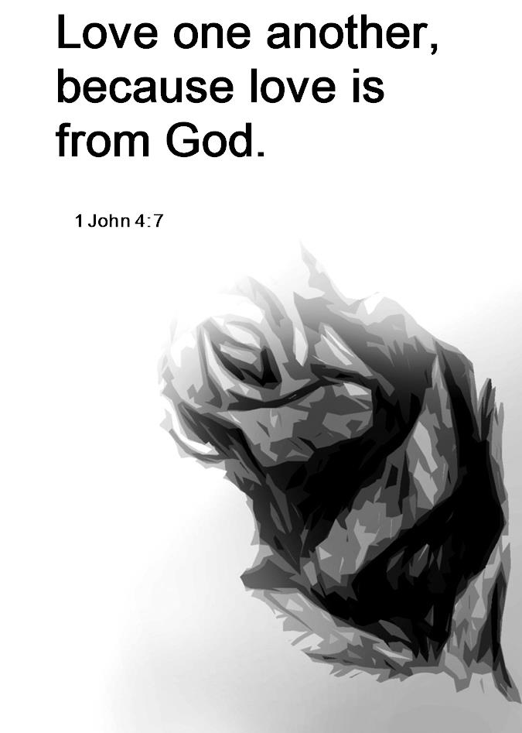

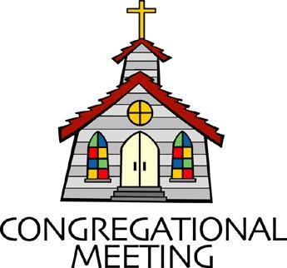
June 26, 2022 - 10:30 am

WELCOME VISITORS!
We're glad you are here! Cards at the ends of each pew are for you to fill out and drop in the Offering Plate. Please let us know you are visiting, and join us for refreshments and fellowship following the service. The Sanctuary has an induction loop system to assist the hearing impaired. The system will also work on the telephone setting of hearing aids.

Springfield Presbyterian Church is rooted in the gospel of Jesus Christ, led by the Holy Spirit, and called to loving relationships through vibrant worship and service. Valuing all people, we are committed to developing disciples and fostering stewardship.
PREPARATION FOR THE WORD
(* those who are able are invited to stand)
PRELUDE

GATHERING OF THE PEOPLE

The Lord be with you! And also with you! (Greeting)

LIGHTING THE CHRIST CANDLE
Leader: Whenever we light this candle we proclaim:
People: Christ is the Light of the world and the center of our lives.

CALL TO WORSHIP
Leader: Today we paint our world red,
People: Celebrating the flames of the Spirit that reigns in Pentecost.
Leader: Today we paint our world orange,
People: Enjoying the warmth that the color brings.
Leader: Today we paint our world yellow,
People: Basking in the sunshine of God’s Creation.
Leader: Today we paint our world green,
People: Feeling the renewal and growth it represents.
Leader: Today we paint our world blue,
People: Remembering the waters of Baptism.
Leader: Today we paint our world purple,
People: The color that speaks to the royalty and reign of Christ our King.
Leader: Today we recognize all the color this life brings,
People: Today we praise our God for the rainbow of life before us, within us, and around us. Amen.

* HYMN God Welcomes All GTG #399
God welcomes all, strangers and friends;
God’s love is strong and it never ends.

CALL TO CONFESSION
Throughout our history, the church has remained silent on matters of great importance in our human existence and the worth and dignity of all people. Sometimes the church has not been silent but has upheld values that are not of Christ and we have hurt people deeply in those actions. We can ask for forgiveness from those we have hurt and promise to be a church that is welcoming and loving, even when culture tells us otherwise. Let us seek to realign with the values of Christ as we come together to admit our sin:

PRAYER OF CONFESSION
Generous and Loving God, we look at our history as your living Church and we realize that in our ancestors and the generations among us, we have caused harm to our neighbor. When we belittle someone or believe we have the higher moral ground, we forget your call to humility and love. We ask for your divine forgiveness as we seek to fall in line with all that you teach us. Restore us again to your Kingdom, one that celebrates diversity and inclusion of all of your great creation. Amen.

SILENT PRAYERS OF CONFESSION

RESPONSE The Woman Hiding in the Crowd Tune #178
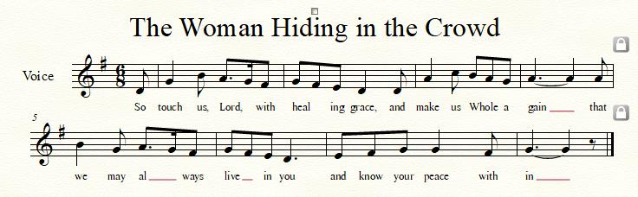

WORDS OF ASSURANCE
Leader: When we recognize our past, atone for our sin, and seek to change our behavior, God lovingly and joyfully forgives us.
People: Thanks be to God who renews and restores us once again. Amen!

* MUSICAL RESPONSE OF PRAISE O My Soul, Bless Your Redeemer
Bless your Maker, all you creatures, ever under God’s control,
All throughout God’s vast dominion; bless the Lord of all, my soul!

* THE PEACE The peace of Christ be with you! And also with you!
(You may greet those around you.)

* RESPONSE Here I Am, Lord
Here I am, Lord, Is it I, Lord? I have heard you calling in the night.
I will go, Lord, if you lead me. I will hold your people in my heart.

THE PROCLAMATION OF THE WORD

PRAYER OF ILLUMINATION
Generous God, in the illumination of your Word, we recognize your love for us and our love for you. Help us, as we hear these Scriptures read aloud, to let the Spirit come among us and envelope us in love. Help us to hear the Word more clearly and sense where love calls us today. Help us be a living witness to these words as we seek to live out the will of your Kingdom. Amen.

FIRST SCRIPTURE LESSON Psalm 139
¹ O Lord, you have searched me and known me. ² You know when I sit down and when I rise up; you discern my thoughts from far away. ³ You search out my path and my lying down, and are acquainted with all my ways. ⁴ Even before a word is on my tongue, O Lord, you know it completely. ⁵ You hem me in, behind and before, and lay your hand upon me. ⁶ Such knowledge is too wonderful for me; it is so high that I cannot attain it. ⁷ Where can I go from your spirit? Or where can I flee from your presence? ⁸ If I ascend to heaven, you are there; if I make my bed in Sheol, you are there. ⁹ If I take the wings of the morning and settle at the farthest limits of the sea, ¹⁰ even there your hand shall lead me, and your right hand shall hold me fast. ¹¹ If I say, ‘Surely the darkness shall cover me, and the light around me become night’,
¹² even the darkness is not dark to you; the night is as bright as the day, for darkness is as light to you. ¹³ For it was you who formed my inward parts; you knit me together in my mother’s womb. ¹⁴ I praise you, for I am fearfully and wonderfully made. Wonderful are your works; that I know very well. ¹⁵ My frame was not hidden from you, when I was being made in secret, intricately woven in the depths of the earth.
¹⁶ Your eyes beheld my unformed substance. In your book were written all the days that were formed for me, when none of them as yet existed.
¹⁷ How weighty to me are your thoughts, O God! How vast is the sum of them! ¹⁸ I try to count them—they are more than the sand; I come to the end—I am still with you. ¹⁹ O that you would kill the wicked, O God, and that the bloodthirsty would depart from me— ²⁰ those who speak of you maliciously, and lift themselves up against you for evil! ²¹ Do I not hate those who hate you, O Lord? And do I not loathe those who rise up against you? ²² I hate them with perfect hatred; I count them my enemies. ²³ Search me, O God, and know my heart; test me and know my thoughts. ²⁴ See if there is any wicked way in me, and lead me in the way everlasting.

SECOND SCRIPTURE LESSON 1 John 4:7-21
⁷Beloved, let us love one another, because love is from God; everyone who loves is born of God and knows God. ⁸Whoever does not love does not know God, for God is love. ⁹God’s love was revealed among us in this way: God sent his only Son into the world so that we might live through him. ¹⁰In this is love, not that we loved God but that he loved us and sent his Son to be the atoning sacrifice for our sins. ¹¹Beloved, since God loved us so much, we also ought to love one another. ¹²No one has ever seen God; if we love one another, God lives in us, and his love is perfected in us. ¹³By this we know that we abide in him and he in us, because he has given us of his Spirit. ¹⁴And we have seen and do testify that the Father has sent his Son as the Savior of the world. ¹⁵God abides in those who confess that Jesus is the Son of God, and they abide in God. ¹⁶So we have known and believe the love that God has for us. God is love, and those who abide in love abide in God, and God abides in them. ¹⁷Love has been perfected among us in this: that we may have boldness on the day of judgement, because as he is, so are we in this world. ¹⁸There is no fear in love, but perfect love casts out fear; for fear has to do with punishment, and whoever fears has not reached perfection in love. ¹⁹We love because he first loved us. ²⁰Those who say, ‘I love God’, and hate their brothers or sisters, are liars; for those who do not love a brother or sister whom they have seen, cannot love God whom they have not seen. ²¹The commandment we have from him is this: those who love God must love their brothers and sisters also.

Leader: Hear what the Spirit is saying to the Church.
All: Thanks be to God.

SERMON Perfect Love Casts Out Fear Rev. Becca Crate-Price

THE RESPONSE TO THE WORD

* HYMN For Everyone Born GTG #769
For everyone born, a place at the table,
for everyone born, clean water and bread,
a shelter, a space, a safe place for growing,
for everyone born, a star overhead,

Refrain:
And God will delight when we are creators of justice and joy, compassion and peace: yes, God will delight when we are creators
of justice, justice and joy!

For woman and man, a place at the table,
revising the roles, deciding the share,
with wisdom and grace, dividing the power,
for woman and man, a system that's fair, [Refrain]

For young and for old, a place at the table,
a voice to be heard, a part in the song,
the hands of a child in hands that are wrinkled,
for young and for old, the right to belong, [Refrain]

For just and unjust, a place at the table,
abuser, abused, with need to forgive,
in anger, in hurt, a mindset of mercy,
for just and unjust, a new way to live, [Refrain]

For everyone born, a place at the table,
to live without fear, and simply to be,
to work, to speak out, to witness and worship,
for everyone born, the right to be free, [Refrain]

PASTORAL PRAYER AND THE LORD’S PRAYER

OFFERTORY
SONG OF THANKS As Those of Old Their Firstfruits Brought #712
In gratitude and humble trust we bring our best today, to serve your cause and share your love with all along life’s way. O God who gave yourself to us in Jesus Christ your Son, help us to give ourselves each day until life’s work is done.
PRAYER OF DEDICATION

* HYMN There is Room in God’s Great Welcome
There is room in God's great welcome; See! The doors are open wide!
Here on earth as in God's heaven, hear the call to come inside!
There is so much room for difference — men and women, gay and straight.
In God's love, the rooms are countless, but there is no room for hate.

There is room in our good nation if we stand on justice-ground.
God has made a good creation; colors, cultures all abound.
Welcome, sister! Welcome, brother! All those yearning to breathe free!
There is room for one another but no room for bigotry.

There is room for understanding, for the outcast and the poor;
For the Christian, Jew and Muslim — there is room for these and more.
For the people on the fringes, for the ones with long career,
There is room for building bridges, but there is no room for fear.

There is room in faithful churches for the wounded and oppressed:
Women who've been told they're worthless, refugees who feel distressed,
Immigrants who fear the future, people scorned and pushed and shoved.
God, may we seek what you treasure: may we all make room for love.

Text: Copyright © 2016 by Carolyn Winfrey Gillette. All rights reserved.

* CHARGE AND BENEDICTION
Leader: Toleration is not enough,
People: True inclusion is our mission.
Leader: As people who cast out fear through love,
People: We show love unto others.
Leader: So that all may know,
People: God’s radical and abundant love for all people.

* UNISON AMEN
POSTLUDE
Sunday July 3, 2022 Lectionary
Isaiah 66:10-14; Psalm 66:1-9; Galatians 6:(1-6)7-16; Luke 10:1-11,16-20

Assisting in Worship: We appreciate those who serve:

Today 6/26 Next Week 7/3
Sunday Opener Bob Rogers Beth Oates
Ushers/Greeters Sharon Pappas Don Vasbinder
Tim Oates Elizabeth Meirowitz
Lay Leader Bob Steppling Tim Oates

Happy Birthday! June 28 – Margaret Carroll
June 30 – Diana Steppling

Happy Anniversary! June 27 – Barbara & Peter Cornell
June 29 – Linda & Larry Black
June 30 – Martha & Davis Streaker

Announcements

Lost & Found: If anyone lost a little pearl earring, please see Donna Mazer. It was found in the Noisy Offering bucket!

Mask Update: Due to the uptick in COVID-19 cases, the Session has decided to strongly encourage masking and social distancing. Though it is not a mandate, we seek to love one another by keeping each other as safe as possible. Thank you for your help in this endeavor.

Sunday School is back! On the 1st and 3rd Sundays of the month, we will be offering Sunday School! See Pastor Becca for details…
Pastor-Parish Committee: The Pastor-Parish Committee invites you to share your concerns, suggestions, and gratitude. We have a form in the Narthex and a lock-box that we will open weekly and we ask that you share your name and be specific. We look forward to reading your comments so that we can continue to grow into the body of Christ.

Springfield Membership: Are you interested in finding out more about our faith community and becoming a member? We would love to answer any questions you have. Please contact Pastor Becca at springfieldpastor@gmail.com for more information.

Congregational Care / Mission & Outreach: Do you know of a member or friend of our church family who is ill, needs prayers, would like call, a visit or a card, or might benefit from meal train? If so, please contact the Church Office (410-795-6152), Cathy Marsh (410-549-6916) or Diana Steppling (862-266-2242).

Fellowship Help Needed: If you are interested in helping with Fellowship, please contact Barbara Cornell (240-308-0035). A sign-up sheet will also be available.

Today:
Sunday June 26
10:30 am Worship
11:30 am Fellowship

Looking Ahead:
Sunday July 3
10:30 am Worship
11:30 am Fellowship
Thursday July 7
7:00 pm Session Meeting

Office Hours: Tuesday, Wednesday & Friday
Springfield Presbyterian Church

10:30 am Worship
11:30 am Fellowship
Website: www.springfield-church.org Church Office: 410-795-6152
Like us on Facebook: www.facebook.com/SpringfieldPresbyterianChurch
Pastor: Rev. Becca Crate-Price
Email: springfieldpastor@gmail.com
Clerk of Session: Sharon Pappas
Minister of Music: Linda Caviglia
Accompanist/Organist: Aaron Thacker
Youth Group Coordinator: Dylan Vasbinder
Administrative Assistant: Donna Mazer e-mail: spc.office@verizon.net

