(Large Print)

Springfield Presbyterian Church (USA)
7300 Spout Hill Road, Sykesville, MD 21784 410-795-6152

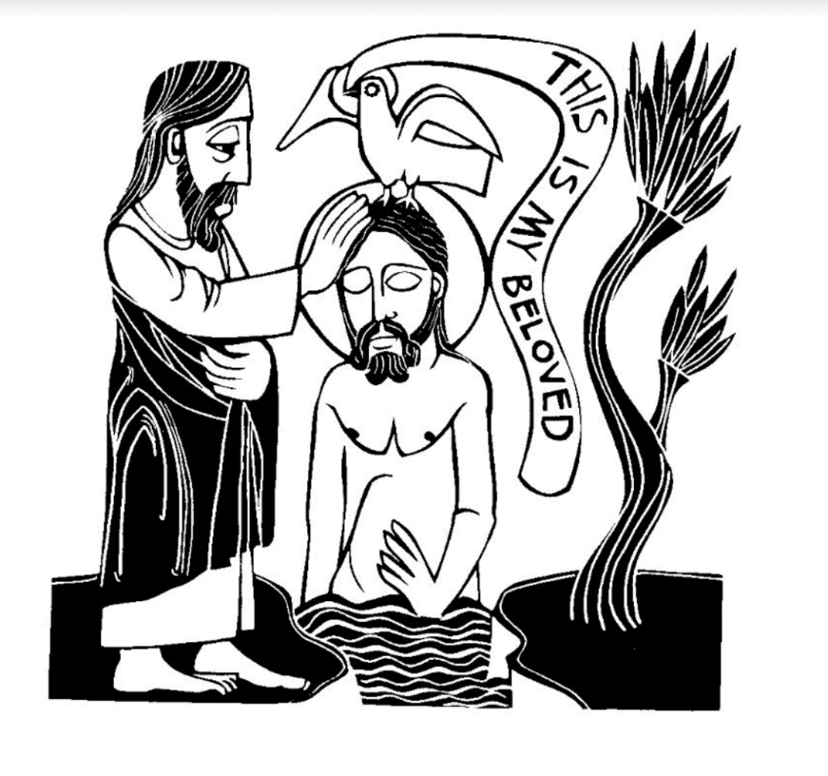
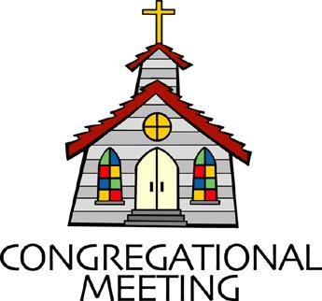
January 8, 2023 - 10:30 am

WELCOME VISITORS!
We're glad you are here! Cards at the ends of each pew are for you to fill out and drop in the Offering Plate. Please let us know you are visiting, and join us for refreshments and fellowship following the service. The Sanctuary has an induction loop system to assist the hearing impaired. The system will also work on the telephone setting of hearing aids.

Springfield Presbyterian Church is rooted in the gospel of Jesus Christ, led by the Holy Spirit, and called to loving relationships through vibrant worship and service. Valuing all people, we are committed to developing disciples and fostering stewardship.
PREPARATION FOR THE WORD
(* those who are able are invited to stand)

PRELUDE

GATHERING OF THE PEOPLE

The Lord be with you! And also with you! (Greeting)

LIGHTING THE CHRIST CANDLE
Leader: Whenever we light this candle we proclaim:
People: Christ is the Light of the world and the center of our lives.

CALL TO WORSHIP
Leader: God, some of us are discouraged and long for your embrace.
People: Wash us with your love.
Leader: Some of us are weary: weighed down by the desperation of this world.
People: Wash us with your hope.
Leader: Some of us are anxious and seek refuge from chaotic lives.
People: Wash us with your peace.
Leader: Some of us are restless, yearning for renewal or transformation.
People: Wash us with your grace.
Leader: However we come into your presence, pour out your Spirit upon us.
People: We come, remembering our baptism. Let us worship God!

* HYMN Come, Thou Fount of Every Blessing GTG #475

Come, thou Fount of every blessing; tune my heart to sing thy grace;
Streams of mercy, never ceasing, call for songs of loudest praise.
Teach me some melodious sonnet, sung by flaming tongues above;
Praise the mount! I’m fixed upon it, mount of God’s unchanging love!

Here I raise my Ebenezer; hither by thy help I’m come;
And I hope, by thy good pleasure, safely to arrive at home.
Jesus sought me when a stranger, wandering from the fold of God;
He, to rescue me from danger, interposed his precious blood.

O to grace how great a debtor daily I’m constrained to be!
Let that grace now, like a fetter, bind my wandering heart to thee.
Prone to wander, Lord, I feel it, prone to leave the God I love;
Here’s my heart; O take and seal it; seal it for thy courts above.

PRAYER OF CONFESSION
God of all glory, you look from heaven and see us as we are: not worthy to kneel at your feet, not ready to welcome your way. Forgive us, gracious God. In Christ, stoop down to save us. Loosen the ties that bind us to sing and set us free to love and serve you, In Jesus’ name. Amen.

SILENT PRAYERS OF CONFESSION

RESPONSE Just As I Am, Without One Plea Tune #442, v. 3
Just as I am, thou wilt receive, wilt welcome, pardon, cleanse, relieve;
Because thy promise I believe, O Lame of God, I come; I come.

WORDS OF ASSURANCE
Leader: To all who turn from sin in sorrow, to all who turn to God in hope, this is God’s Word of grace: we are accepted, we are forgiven, we are loved.
People: This gift we have from God.
Leader: I declare to you in the name of Jesus Christ, you and I have been forgiven.

* MUSICAL RESPONSE OF PRAISE
We Praise You, O God Tune #612, v. 1
We praise you, O God, our Redeemer, Creator;
In grateful devotion our tribute we bring.
We lay it before you; we kneel and adore you;
We bless your holy name; glad praises we sing.

* THE PEACE The peace of Christ be with you! And also with you!
(You may greet those around you.)

* RESPONSE Here I Am, Lord
Here I am, Lord, Is it I, Lord? I have heard you calling in the night.
I will go, Lord, if you lead me. I will hold your people in my heart.

THE PROCLAMATION OF THE WORD

FIRST SCRIPTURE LESSON Isaiah 42:1-9
Here is my servant, whom I uphold, my chosen, in whom my soul delights; I have put my spirit upon him; he will bring forth justice to the nations. ² He will not cry out or lift up his voice or make it heard in the street; ³ a bruised reed he will not break, and a dimly burning wick he will not quench; he will faithfully bring forth justice. ⁴ He will not grow faint or be crushed until he has established justice in the earth, and the coastlands wait for his teaching. ⁵ Thus says God, the Lord, who created the heavens and stretched them out, who spread out the earth and what comes from it, who gives breath to the people upon it and spirit to those who walk in it: ⁶ I am the Lord; I have called you in righteousness; I have taken you by the hand and kept you; I have given you as a covenant to the people, a light to the nations, ⁷ to open the eyes that are blind, to bring out the prisoners from the dungeon, from the prison those who sit in darkness. ⁸ I am the Lord; that is my name; my glory I give to no other, nor my praise to idols. ⁹ See, the former things have come to pass, and new things I now declare; before they spring forth, I tell you of them.
SECOND SCRIPTURE LESSON Matthew 3:13-17
¹³ Then Jesus came from Galilee to John at the Jordan, to be baptized by him. ¹⁴ John would have prevented him, saying, “I need to be baptized by you, and do you come to me?” ¹⁵ But Jesus answered him, “Let it be so now, for it is proper for us in this way to fulfill all righteousness.” Then he consented. ¹⁶ And when Jesus had been baptized, just as he came up from the water, suddenly the heavens were opened to him and he saw God’s Spirit descending like a dove and alighting on him. ¹⁷ And a voice from the heavens said, “This is my Son, the Beloved, with whom I am well pleased.”

SERMON Blessings First The Rev. Dr. Carl Wilton

THE RESPONSE TO THE WORD

* HYMN I Was There to Hear Your Borning Cry GTG #488

I was there to hear your borning cry; I’ll be there when you are old.
I rejoice the day you were baptized to see your life unfold.
I was there when you were but a child with a faith to suit you well;
In a blaze of light you wandered off to find where demons dwell.

When you heard the wonder of the Word, I was there to cheer you on.
You were raised to praise the living Lord to whom you now belong.
If you find someone to share your time and you join your hearts as one,
I’ll be there to make your verses rhyme from dusk till rising sun.

In the middle ages of your life, not too old, no longer young,
I’ll be there to guide you through the night, complete what I’ve begun.
When the evening gently closes in and you shut your weary eyes,
I’ll be there as I have always been with just one more surprise.

I was there to hear your borning cry; I’ll be there when you are old.
I rejoiced the day you were baptized to see your life unfold.
COMMUNION

OFFERTORY
* SONG OF THANKS Take My Life Tune #697 v.4
Take my silver and my gold; not a mite would I withhold;
Take my intellect and use every power as though shalt choose,
Every power as though shalt choose.
* PRAYER OF DEDICATION

* HYMN In Christ Called to Baptize GTG #297
In Christ called to baptize, we witness to grace and gather
A people from each land and race.
In deep, flowing waters, we share in Christ’s death,
Then, rising to new life, give thanks with each breath.

In Christ called to banquet, one table we share,
A haven of welcome, a circle of care.
Although we are many, we share in one bread.
One cup of thanksgiving proclaims Christ, our head.

In Christ called to witness, by grace we will preach
The lifegiving gospel; God’s love we will teach.
By grace may our living give proof to our praise
In costly compassion reflecting Christ’s ways.

Unite us, anoint us, O Spirit of love,
For you are within us, around us, above.
Equip us for service with gifts you bestow.
In Christ is our calling. In Christ may we grow.

* CHARGE AND BENEDICTION
Leader: May the peace that passes understanding surround you with calm assurance. May the wisdom that overcomes doubt guide you to an answer. May the hope that transcends every fear strengthen you in spirit. May the love that lives in spite of loss keep you safe in its powerful embrace. Be blessed today!
People: We go forth now to be a blessing.
Leader: May the grace of our Lord Jesus Christ, the love of God, and the communion of the Holy Spirit be with you all.
People: Amen.

* UNISON AMEN

POSTLUDE

ANNOUNCEMENTS

We joyfully welcome our preacher this morning, the Rev. Dr. Carlos “Carl” Wilton, Ph.D., a retired minister member of the Presbytery of Baltimore. He has served as pastor in Hawley, Pennsylvania; in Bedminster, New Jersey, and in Point Pleasant Beach, New Jersey (at Pastor Becca’s home church). He has also served as Director of Admissions and Assistant Dean at the University of Dubuque Theological Seminary, as an adjunct professor at Princeton and New Brunswick Theological Seminaries, and as stated clerk of two different presbyteries.

CoCaMo will meet this week on Tuesday at 7 pm. Please see Diana Steppling for more information.

Pastor Becca will be at Duke Divinity School for her intensive week of studies. She will return to the office next week. (Go Duke!)

Office Hours: Tuesday, Wednesday, and Friday, 10:00 am - 3:00 pm
Springfield Presbyterian Church

10:30 am Worship
11:30 am Fellowship
Website: www.springfield-church.org Church Office: 410-795-6152
Like us on Facebook: www.facebook.com/SpringfieldPresbyterianChurch
Pastor: Rev. Becca Price
Email: springfieldpastor@gmail.com
Clerk of Session: Sharon Pappas
Minister of Music: Linda Caviglia
Accompanist/Organist: Aaron Thacker
Youth Group Director: Dylan Vasbinder
Administrative Assistant: Donna Mazer e-mail: spc.office@verizon.net

