PREPARATION FOR THE WORD

(* those who are able are invited to stand)

PRELUDE

GATHERING OF THE PEOPLE The Lord be with you! And also with you!
(Greeting and Announcements)

LIGHTING THE CHRIST CANDLE
Leader: Whenever we light this candle we proclaim:
People: Christ is the Light of the world and the center of our lives.

CALL TO WORSHIP
Leader: Come and raise your voice!
People: For Christ the King is here!
Leader: Lend your ears,
People: For the melodies to swirl.
Leader: Sing with hope, joy, peace, and love,
People: For now all these abide.
Leader: We join in prayer and praise,
People: In celebration and worship of the Prince of Peace!

PRAYER OF CONFESSION
Generous God, as we lift our voices, we recognize that we have used our voices in both positive and negative ways. Sometimes we have used our voice to cause harm, to be unkind, to choose words that do not convey love. Please forgive us and help us to use our voices for your glory: to sing your praises, to offer prayers, and to show your love. Renew us, restore us, and refine us, today and always. Amen.

SILENT PRAYERS OF CONFESSION

WORDS OF ASSURANCE
Leader: When we speak aloud our faults and failures, God hears us with loving and open arms.
People: We are forgiven, loved, and freed – free to sing our praises to our generous God!

* THE PEACE The peace of Christ be with you! And also with you!

* RESPONSE Here I Am, Lord
Here I am, Lord, Is it I, Lord? I have heard you calling in the night.
I will go, Lord, if you lead me. I will hold your people in my heart.

THE PROCLAMATION OF THE WORD

SCRIPTURE LESSON Psalm 95:1-7 OT page 520

THE HYMN SING
During worship today, we will join in a 15-20 minute hymn sing. We will sing selected verses from hymns that you choose from our Glory to God hymnal. Have your hymn number/title ready and raise your hand!

REFLECTION A Musical Tale Rev. Becca Crate

PASTORAL PRAYER AND THE LORD’S PRAYER
“For this I pray to God.” / “For this I give thanks to God.”
Congregational Response: “Hear our prayer, O God.”

OFFERING PLATES can be found in the Narthex and we greatly appreciate any gift you may offer to show forth hope, peace, joy and love in Christ to our community and to our world.

* BENEDICTION

* UNISON AMEN

POSTLUDE

Springfield Presbyterian Church (USA)
7300 Spout Hill Road, Sykesville, MD 21784 410-795-6152

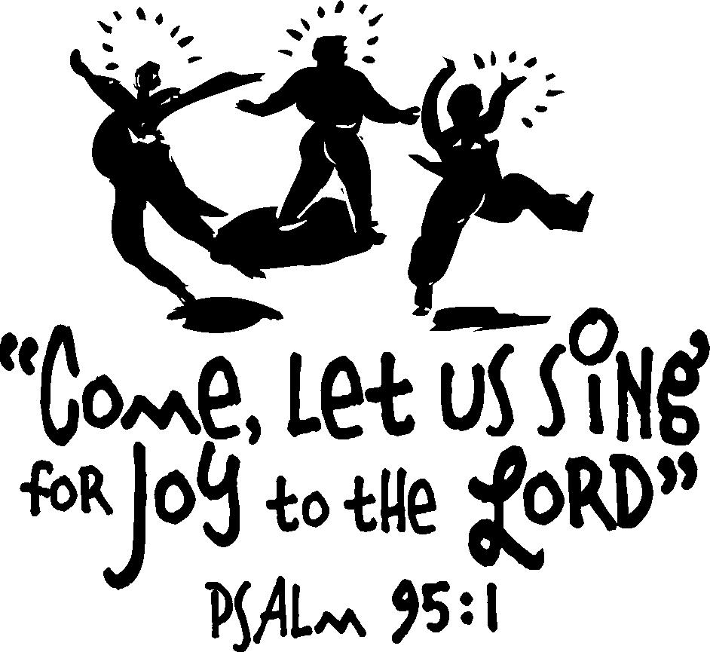

December 29, 2019 - 10:30 am

WELCOME VISITORS!
We're glad you are here! Cards at the ends of each pew are for you to fill out and drop in the Offering Plate. Please let us know you are visiting and join us for refreshments and fellowship following the service. The Sanctuary has an induction loop system to assist the hearing impaired. The system will also work on the telephone setting of hearing aids.

Springfield Presbyterian Church is rooted in the gospel of Jesus Christ, led by the Holy Spirit, and called to loving relationships through vibrant worship and service. Valuing all people, we are committed to developing disciples and fostering stewardship.

