(Large Print)

Springfield Presbyterian Church (USA)
7300 Spout Hill Road, Sykesville, MD 21784 410-795-6152

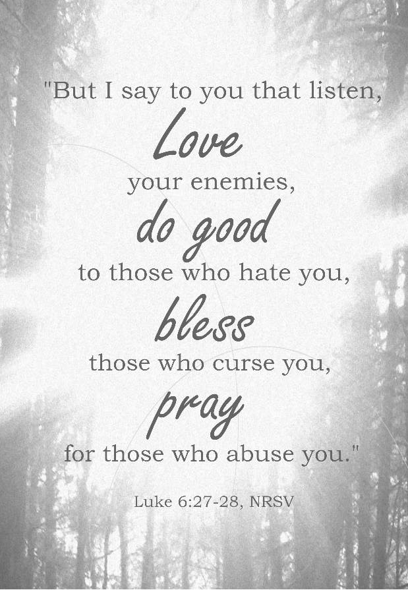

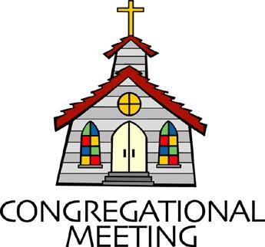
February 20, 2022 - 10:30 am

WELCOME VISITORS! We're glad you are here! Cards at the ends of each pew are for you to fill out and drop in the Offering Plate. Please let us know you are visiting, and join us for refreshments and fellowship following the service. The Sanctuary has an induction loop system to assist the hearing impaired. The system will also work on the telephone setting of hearing aids.

Springfield Presbyterian Church is rooted in the gospel of Jesus Christ, led by the Holy Spirit, and called to loving relationships through vibrant worship and service. Valuing all people, we are committed to developing disciples and fostering stewardship.
PREPARATION FOR THE WORD
(* those who are able are invited to stand)
PRELUDE

GATHERING OF THE PEOPLE

The Lord be with you! And also with you! (Greeting)

LIGHTING THE CHRIST CANDLE
Leader: Whenever we light this candle we proclaim:
People: Christ is the Light of the world and the center of our lives.

CALL TO WORSHIP [Psalm 37:1-11]
Leader: Do not fret because of the wicked; do not be envious of wrongdoers,
People: For they will soon fade like the grass, and wither like the green herb.
Leader: Trust in the Lord and do good; so you will live in the land and enjoy security.
People: Take delight in the Lord, and He will give you the desires of your heart.
Leader: Commit your way to the Lord; trust in Him and He will act.
People: He will make your vindication shine like the light and the justice of your cause like the noonday.
Leader: Be still before the Lord, and wait patiently for Him; do not fret over those who prosper in their way, over those who carry out evil devices.
People: Refrain from anger, and forsake wrath. Do not fret – it leads only to evil.
Leader: For the wicked shall be cut off, but those who wait for the Lord shall inherit the land.
People: Yet a little while, and the wicked will be no more; though you look diligently for their place, they will not be there.
Leader: But the meek shall inherit the land and delight themselves in abundant prosperity.
ALL: Let us worship our faithful and loving God.

* HYMN Let Us Build a House #301
Let us build a house where love can swell and all can safely live,
A place where saints and children tell how hears learn to forgive.
Built of hopes and dreams and visions, rock of faith and vault of grace; Here the love of Christ shall end divisions:

Refrain:
All are welcome; all are welcome; all are welcome in this place.

Let us build a house where prophets speak, and words are strong and true,
Where all God’s children dare to seek to dream God’s reign anew.
Here the cross shall stand as witness and as symbol of God’s grace;
Here as one we claim the faithful of Jesus: [Refrain]

Let us build a house where love is found in water, wine, and wheat;
A banquet hall on holy ground where peace and justice meet.
Here the love of God, through Jesus, is revealed in time and space;
As we share in Christ the feat that frees us: [Refrain]

Let us build a house where hands will reach beyond the wood and stone to heal and strengthen, serve and teach, and live the Word they’ve known.
Here the outcast and the stranger bear the image of God’s face;
Let us bring an end to fear and danger: [Refrain]

Let us build a house where all are named, their songs and visions heard, and loved and treasured, taught and claimed as words within the Word. Built of tears and cries and laughter, prayers of faith and songs of grace; let this house proclaim from floor to rafter: [Refrain]
CALL TO CONFESSION
Leader: God has given us guidance in this life – to love our enemies, to do good to those who hate us, to bless those who curse us, but it is hard to do. We are human, and in our humanity, we will continue to fall short of this rule of life. Yet God’s invitation remains that when we faithfully come and confess our sins, God’s love will overwhelm us. Trusting in that knowledge, let us come together to admit our sin.

PRAYER OF CONFESSION
Generous God, you tell us to love those who are against us, but everything within us tells us to retaliate. You ask us to forgive, but God, when the pain is so deep, it feels impossible. While we want to be selfless when we give, we still admit that we expect something in return. We have fallen short – short of the wholehearted life. As we confess, we pray be in alignment with your way of life. We pray that you forgive us and restore us, to begin again and faithfully live for you. Amen.

SILENT PRAYERS OF CONFESSION

RESPONSE Come and Fill Our Hearts Tune #466
Come and fill our hearts with your peace. You alone, O Lord, are holy.
Come and fill our hearts with your peace. Alleluia!

WORDS OF ASSURANCE
Leader: We know that when we come before the cross, when we admit our sin, that God’s grace will intercede.
People: Let us find joy in knowing that we are a forgiven people who can begin anew. Thanks be to God! Amen!

* MUSICAL RESPONSE OF PRAISE Now Thank We All Our God
All praise and thanks to God, who reigns in highest heaven,
To Father and to Son and Spirit now be given.
The one eternal God, whom heaven and earth adore,
The God who was, and is, and shall be ever more.

* THE PEACE The peace of Christ be with you! And also with you!
(You may greet those around you.)

* RESPONSE Here I Am, Lord
Here I am, Lord, Is it I, Lord? I have heard you calling in the night.
I will go, Lord, if you lead me. I will hold your people in my heart.

THE PROCLAMATION OF THE WORD

PRAYER OF ILLUMINATION
Holy God, help us shut out all distractions and focus on the Word that is spoken. Let our minds and hearts be opened to the words that we hear and let those words change how we live, act, and love. Amen.

FIRST SCRIPTURE LESSON Psalm 103
¹ Bless the Lord, O my soul, and all that is within me, bless his holy name. ² Bless the Lord, O my soul, and do not forget all his benefits—
³ who forgives all your iniquity, who heals all your diseases, ⁴ who redeems your life from the Pit, who crowns you with steadfast love and mercy, ⁵ who satisfies you with good as long as you live so that your youth is renewed like the eagle’s. ⁶ The Lord works vindication and justice for all who are oppressed. ⁷ He made known his ways to Moses, his acts to the people of Israel. ⁸ The Lord is merciful and gracious, slow to anger and abounding in steadfast love. ⁹ He will not always accuse, nor will he keep his anger for ever. ¹⁰ He does not deal with us according to our sins, nor repay us according to our iniquities. ¹¹ For as the heavens are high above the earth, so great is his steadfast love towards those who fear him; ¹² as far as the east is from the west, so far he removes our transgressions from us. ¹³ As a father has compassion for his children, so the Lord has compassion for those who fear him.
¹⁴ For he knows how we were made; he remembers that we are dust.
¹⁵ As for mortals, their days are like grass; they flourish like a flower of the field; ¹⁶ for the wind passes over it, and it is gone, and its place knows it no more. ¹⁷ But the steadfast love of the Lord is from everlasting to everlasting on those who fear him, and his righteousness to children’s children, ¹⁸ to those who keep his covenant and remember to do his commandments. ¹⁹ The Lord has established his throne in the heavens, and his kingdom rules over all. ²⁰ Bless the Lord, O you his angels, you mighty ones who do his bidding, obedient to his spoken word. ²¹ Bless the Lord, all his hosts, his ministers that do his will.
²² Bless the Lord, all his works, in all places of his dominion. Bless the Lord, O my soul.

SECOND SCRIPTURE LESSON Luke 6:27-38
²⁷ ‘But I say to you that listen, Love your enemies, do good to those who hate you, ²⁸bless those who curse you, pray for those who abuse you. ²⁹If anyone strikes you on the cheek, offer the other also; and from anyone who takes away your coat do not withhold even your shirt. ³⁰Give to everyone who begs from you; and if anyone takes away your goods, do not ask for them again. ³¹Do to others as you would have them do to you. ³² ‘If you love those who love you, what credit is that to you? For even sinners love those who love them. ³³If you do good to those who do good to you, what credit is that to you? For even sinners do the same. ³⁴If you lend to those from whom you hope to receive, what credit is that to you? Even sinners lend to sinners, to receive as much again. ³⁵But love your enemies, do good, and lend, expecting nothing in return. Your reward will be great, and you will be children of the Most High; for he is kind to the ungrateful and the wicked. ³⁶Be merciful, just as your Father is merciful. ³⁷ ‘Do not judge, and you will not be judged; do not condemn, and you will not be condemned. Forgive, and you will be forgiven; ³⁸give, and it will be given to you. A good measure, pressed down, shaken together, running over, will be put into your lap; for the measure you give will be the measure you get back.’

Leader: Hear what the Spirit is saying to the Church.
All: Thanks be to God.

SERMON A Rule of Life Rev. Becca Crate-Price

THE RESPONSE TO THE WORD

* HYMN Though I May Speak #693

Though I may speak with bravest fire,
And have the gift to all inspire,
And have not love, my words are vain,
As sounding brass, and hopeless gain.

Though I may give all I possess,
And striving so my love profess,
But not be given by love within,
The profit soon turns strangely thin.

Come, Spirit, come, our hearts control;
Our spirits long to be made whole.
Let inward love guide every deed;
By this we worship, and are freed.

PASTORAL PRAYER AND THE LORD’S PRAYER

ANTHEM Let Us Love One Another

* HYMN Help Us Accept Each Other #754

Help us accept each other as Christ accepted us;
Teach us as sister, brother, each person to embrace.
Be present, Lord, among us and bring us to believe
We are ourselves accepted, and meant to love and live.

Teach us, O Lord, your lessons, as in our daily life
We struggle to be human and search for hope and faith.
Teach us to care for people, for all, not just for some,
To love them as we find them, or as they may become.

Let your acceptance change us, so that we may be moved
In living situations to do the truth in love;
To practice your acceptance until we know by heart
The table of forgiveness, and laughter's healing art.

Lord, for today's encounters with all who are in need,
Who hunger for acceptance, for justice and for bread,
We need new eyes for seeing, new hands for holding on:
Renew us with your Spirit; Lord, free us; make us one!

* CHARGE AND BENEDICTION
Leader: Let us go from this place,
People: Willing to forgive, seeking to love.
Leader: Let us go from this place,
People: Showing kindness, expecting nothing in return.
Leader: Let us go from this place,
People: So may our lives be an example of God’s grace. Amen.

* UNISON AMEN

POSTLUDE

Sunday February 27, 2022 Lectionary
Exodus 34:29-35; Psalm 99; 2 Corinthians 3:12-4:2; Luke 9:28-37 (37-43a)

Assisting in Worship: We appreciate those who serve:

Today 2/20 Next Week 2/27
Sunday Opener Bob Rogers Barbara Cornell
Greeter Steve Mazer Donna Mazer
Lay Leader Kathy Russ Elizabeth Meirowitz

Announcements

Easter Flowers: It is time to order your Easter flowers! Attached is a flyer for your use. Orders need to be in to the Office no later than TODAY please!

Springfield Membership: Are you interested in finding out more about our faith community and becoming a member? We would love to answer any questions you have. Please contact Pastor Becca at springfieldpastor@gmail.com for more information.

Per Capita: Per Capita is how we Presbyterian congregations care for each other and stay connected. It funds mission work, support and training for pastors and congregations, and administration expenses. Our portion this year is $38.13; $28 remains at Presbytery, $1.15 to Synod, and $8.98 to General Assembly. You will find this expense in our budget but you can help offset that and show your support by contributing that portion as faithful members. There is a wonderful article by J. Herbert Nelson, Stated Clerk for PC(USA) that can be found by going to baltimorepresbytery.org/percapita and then scroll to the bottom of the page to click on Stated Clerk: What per capita pays for, why it matters.

Fellowship Reminder: Following the Worship service, we will gather downstairs for fellowship, but will not have food and will continue to wear our masks. We, as a Session, have made this decision out of an abundance of caution and the desire to keep our family of Christ safe and healthy.

Congregational Care / Mission & Outreach: Do you know of a member or friend of our church family who is ill, needs prayers, would like call, a visit or a card, or might benefit from meal train? If so, please contact the Church Office (410-795-6152), Cathy Marsh (410-549-6916) or Diana Steppling (862-266-2242).

Inclement Weather: If we feel the need to cancel Worship, there will be a message on the Church answering machine, as well as on Facebook. You may also receive an email with that information.

Today:
Sunday February 20
10:30 am Worship
11:30 am Fellowship
2:30 pm Youth Bowling

This Week:
Wednesday February 23
6:15 – 7:15 pm Bell Choir Practice
7:30 – 8:45 pm Adult Choir Practice

Looking Ahead:
Sunday February 27
10:30 am Worship
11:30 am Fellowship
Wednesday March 2
6:15 – 7:15 pm Bell Choir Practice
7:30 – 8:45 pm Adult Choir Practice

Office Hours: Tuesday, Wednesday & Friday
Springfield Presbyterian Church

10:30 am Worship
11:30 am Fellowship
Website: www.springfield-church.org Church Office: 410-795-6152
Like us on Facebook: www.facebook.com/SpringfieldPresbyterianChurch
Pastor: Rev. Becca Crate-Price
Email: springfieldpastor@gmail.com
Clerk of Session: Sharon Pappas
Minister of Music: Linda Caviglia
Accompanist/Organist: Aaron Thacker
Youth Group Coordinator: Dylan Vasbinder
Administrative Assistant: Donna Mazer e-mail: spc.office@verizon.net

