(Large Print)

Springfield Presbyterian Church (USA)
7300 Spout Hill Road, Sykesville, MD 21784 410-795-6152

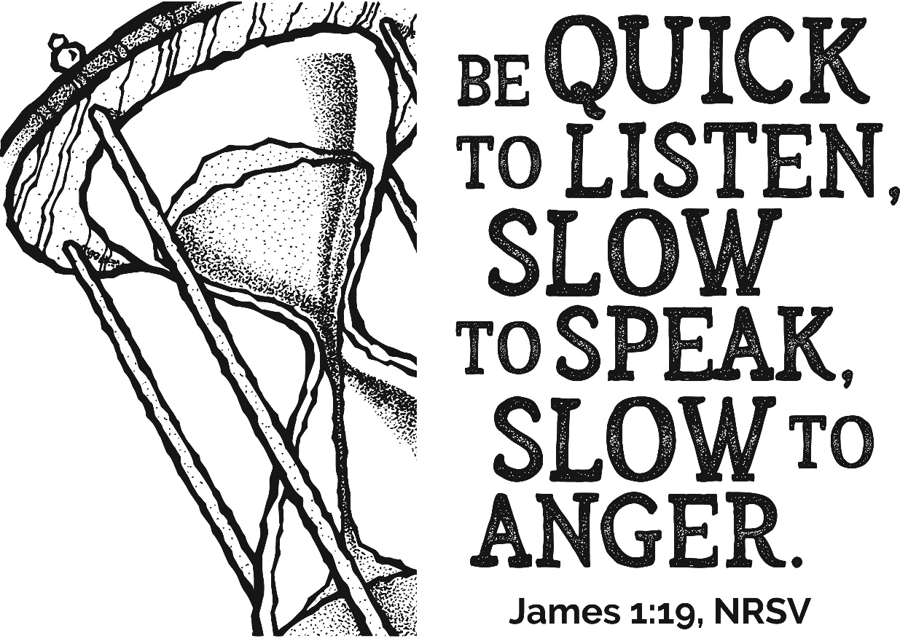

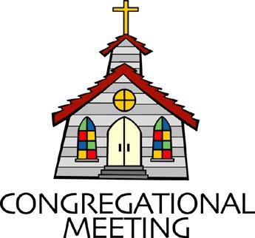
October 9, 2022 - 10:30 am

WELCOME VISITORS!
We're glad you are here! Cards at the ends of each pew are for you to fill out and drop in the Offering Plate. Please let us know you are visiting, and join us for refreshments and fellowship following the service. The Sanctuary has an induction loop system to assist the hearing impaired. The system will also work on the telephone setting of hearing aids.

Springfield Presbyterian Church is rooted in the gospel of Jesus Christ, led by the Holy Spirit, and called to loving relationships through vibrant worship and service. Valuing all people, we are committed to developing disciples and fostering stewardship.
PREPARATION FOR THE WORD
(* those who are able are invited to stand)

PRELUDE

GATHERING OF THE PEOPLE

The Lord be with you! And also with you! (Greeting)

LIGHTING THE CHRIST CANDLE
Leader: Whenever we light this candle we proclaim:
People: Christ is the Light of the world and the center of our lives.

CALL TO WORSHIP
Leader: Family of faith, this must be the place.
People: This is the place for connection and growth.
Leader: This is the place for community and growth.
People: This is the place for questions like,
Leader: “Where are you from?” and, “What do you need?”
People: For whispers of: “I’ve been thinking of you,” and “I’ve been meaning to ask.”
Leader: This must be the place, because all belong here.
People: All are welcome here.
Leader: All hurt and joy, need and prayers, dreams and love, are welcome here.
People: Today we are going to lean into invitation for connection.
ALL: God is near. Let us worship the Risen Christ.

* HYMN Make Me a Channel of Your Peace GTG #753
Make me a channel of your peace.
Where there is hatred, let me bring your love.
Where there is injury, pardon, Lord,
And where there’s doubt, true faith in you.

Make me a channel of your peace.
Where there’s despair in life, let me bring hope.
Where there is darkness, only light,
And where there’s sadness, ever joy.

O, Master, grant that I may never seek
So much to be consoled, as to console,
To be understood, as to understand,
To be loved, as to love, with all my soul.

Make me a channel of your peace.
It is in pardoning that we are pardoned,
In giving of ourselves that we receive,
And in dying that we’re born to eternal life.

CALL TO CONFESSION
Leader: How many of you have ever had a bad day and found someone offering you unsolicited advice? How many of you have ever had a bad week and had someone rush in with dozens of suggestions for how you might fix things, as if you hadn’t thought of that before? We have all been there, and we have all done that. It is part of our humanity. Our scripture reminds us today that often in the face of hurt, what people really need is not a list or advice or solutions, but the simple presence of love. So let us pray to God today, acknowledging that we are works in progress, and that relationships always come with mistakes and confession. Let us pray:

PRAYER OF CONFESSION
Gracious God, sometimes life feels like cooking with flour – it looks like it should be easy, but we always make a mess. This is particularly true when it comes to our relationships. We so desperately long to say the right thing, to be the right thing, to find the right solution, that we overstep the line. Forgive us for assuming the place you fill. Forgive us for imaging that we, in all our humanity, could possibly fix all the hurt in this world. Instead, give us the grace and the strength to stand by our loved ones in their moments of need to witness their hurt without trying to fix it. You are God. We are not. Teach us how to be a friend. Teach us how to ask, “What do you need?” Teach us how to point to you. Gratefully we pray. Amen.

SILENT PRAYERS OF CONFESSION

RESPONSE Hear My Prayer, O God Tune #782
Hear my prayer, O God, and listen to my plea;
Faithful, righteous One, give ear and answer me.
Judge me not, I pray; no merit dare I claim;
Knowing my own faults, I trust in your just Name.

WORDS OF ASSURANCE
Leader: Family of faith, no matter how many times you have spoken without listening, assumed without knowing, offered without asking, or rushed without waiting – you are forgiven. God knows your desire and your intent. God knows when we try and miss the mark, and God surrounds us in grace. So hear and believe the good news of the gospel and let us say it together:
People: Every day is a new day for love. We are claimed. We are forgiven. We are invited into relationship. Thanks be to God for growth and grace that know no end. Amen.

* MUSICAL RESPONSE OF PRAISE O My Soul, Bless Your Redeemer
Bless your Maker, all you creatures, ever under God’s control,
All throughout God’s vast dominion; bless the Lord of all, my soul!
* THE PEACE The peace of Christ be with you! And also with you!
(You may greet those around you.)

* RESPONSE Here I Am, Lord
Here I am, Lord, Is it I, Lord? I have heard you calling in the night.
I will go, Lord, if you lead me. I will hold your people in my heart.

THE PROCLAMATION OF THE WORD

PRAYER OF ILLUMINATION
Great God, in the words of Paul, do your best to come to us quickly. Come to us with loud praise and joy, or appear to us in a still, small voice. Come to us through friends, or come to us through strangers. Come to us in this text and in this hour of worship, and come to us quickly. We are seeking you. With grateful hearts cracked open by love, we pray. Amen.

FIRST SCRIPTURE LESSON Job 2:11a, 12-13
¹¹Now when Job’s three friends heard of all these troubles that had come upon him, each of them set out from his home. They met together to go and console and comfort him. ¹²When they saw him from a distance, they did not recognize him, and they raised their voices and wept aloud; they tore their robes and threw dust in the air upon their heads. ¹³They sat with him on the ground for seven days and seven nights, and no one spoke a word to him, for they saw that his suffering was very great.

SECOND SCRIPTURE LESSON James 1:1-5, 19-22
To the twelve tribes in the Dispersion: Greetings.
²My brothers and sisters, whenever you face trials of any kind, consider it nothing but joy, ³because you know that the testing of your faith produces endurance; ⁴and let endurance have its full effect, so that you may be mature and complete, lacking in nothing.
⁵If any of you is lacking in wisdom, ask God, who gives to all generously and ungrudgingly, and it will be given you. ¹⁹You must understand this, my beloved: let everyone be quick to listen, slow to speak, slow to anger; ²⁰for your anger does not produce God’s righteousness. ²¹Therefore rid yourselves of all sordidness and rank growth of wickedness, and welcome with meekness the implanted word that has the power to save your souls. ²²But be doers of the word, and not merely hearers who deceive themselves.

Leader: Hear what the Spirit is saying to the Church.
All: Thanks be to God.

SERMON “What do you need?” Rev. Becca Price

THE RESPONSE TO THE WORD

* HYMN There Is a Time for Silence Tune #216

(SEE LAST PAGE OF BULLETIN)

PASTORAL PRAYER AND OUR LORD’S PRAYER

OFFERTORY Lean on Me arr. Jack Zaino
SONG OF THANKS Great God of Every Blessing Tune #694
Great God of every blessing, of faithful, loving care,
You are the fount of goodness, the daily bread we share.
How can we hope to thank you? Our praise is but a start:
Sincerely and completely I offer you my heart.
PRAYER OF DEDICATION

* HYMN Will You Let Me Be Your Servant GTG #727

Will you let me be your servant, let me be as Christ to you?
Pray that I may have the grace to let you be my servant too.

We are pilgrims on a journey; we’re together on the road.
We are here to help each other walk the mile and bear the load.

I will hold the Christ-light for you in the nighttime of your fear.
I will hold my hand out to you, speak the peace you long to hear.

I will weep when you are weeping; when you laugh I’ll laugh with you.
I will share your joy and sorrow till we’ve seen this journey through.

When we sing to God in heaven, we shall find such harmony,
Born of all we’ve known together of Christ’s love and agony.

Will you let me be your servant, let me be as Christ to you?
Pray that I may have the grace to let you be my servant too.

* CHARGE AND BENEDICTION
Leader: As you leave this place, may God grant us,
People: The curiosity to counter assumptions,
Leader: The vulnerability to befriend,
People: The bravery to speak your truth,
Leader: The wisdom to listen,
People: The strength to ask for help,
Leader: The resiliency to choose love, even when it’s hard,
People: And the awareness of the Holy Spirit always beside us.
Leader: In the name of our Great God, who is Love itself, may you go in peace.

* UNISON AMEN

POSTLUDE

Sunday, October 16, 2022 Lectionary
2 Timothy 4:9-18
Assisting in Worship: We appreciate those who serve:

Today 10/9 Next Week 10/16
Sunday Opener Ron Holmes Bob Rogers
Ushers/Greeters Sharon Pappas Elizabeth Meirowitz
Henry Halvorson Brenda McClung
Lay Leader Elizabeth Meirowitz Sharon Pappas

Happy Birthday! October 13 – Joy Barwick
October 13 – Ron Holmes
October 15 – Jessica Lane

Happy Anniversary! October 10 – Scott & Stephanie Schroeder

Announcements

Concert TODAY! Join us at 3:00 pm today for our concert featuring Ken and Brad Kolodner, the dynamic father-son team who weave together a captivating soundscape on hammered dulcimer and clawhammer banjo blurring the lines of Old-Time, Bluegrass and American Roots music. We invite you to come enjoy the music and a reception with delicious food following the concert!

ESCAPE Lunches: ESCAPE (Enabling Social and Church Advocacy for People Enrichment) is a nonprofit volunteer organization, supported by area churches and civic groups, which helps people in Carroll and northern Howard counties find and secure needed services and resources, and coordinates relief assistance to needy families and individuals.

One way that Springfield participates in ESCAPE is to provide bag lunches on a rotating basis with other churches throughout the year. We are asked to prepare bag lunches four times a year, once in October, December, March, and May. We currently provide 48 lunches which are delivered to St. Paul’s Methodist Church in downtown Sykesville for distribution.

You may participate in two ways. You can sign up to provide some of the foods that go into the bags and/or you can come to the Manse on Tuesday, October 11 at 6:30 pm to help pack the bags. It's usually a fun evening and with several people we are done in less than an hour. Look for the sign-up sheet at Fellowship!

Fall Fellowship Time: The weather is changing! Time to make our plans for Fellowship through the fall. We'd love to have your help providing and serving the goodies we share as we visit after worship. If you have not hosted Fellowship, we can pair you with someone who knows the routine (and where we hide the toothpicks!).
If you don't want to host, we would be happy to have you sign up to bring something in. We always have a supply of crackers and cookies in the kitchen, but our table often includes fruit, cheese and baked goods. Let us know on the sign-up sheet in the kitchen or email me what you'd like to bring. Thanks so much!
Barbaracornell4@gmail.com or 240-308-0035

Christian Education: Our Time and Talents survey shows folks are interested in an adult bible study program, and Alex McClung is interested in leading a study group. We imagine meeting 2x/month before church, but content, format, and timing are all TBD. Please contact Alex with your suggestions, interests, and best times: akmcclungiii@gmail.com.

Mask Update: Due to the uptick in COVID-19 cases, the Session has decided to strongly encourage masking and social distancing. Though it is not a mandate, we seek to love one another by keeping each other as safe as possible. Thank you for your help in this endeavor.

Pastor-Parish Committee: The Pastor-Parish Committee invites you to share your concerns, suggestions, and gratitude. We have a form in the Narthex and a lock-box that we will open weekly and we ask that you share your name and be specific. We look forward to reading your comments so that we can continue to grow into the body of Christ.

Springfield Membership: Are you interested in finding out more about our faith community and becoming a member? We would love to answer any questions you have. Please contact Pastor Becca at springfieldpastor@gmail.com for more information.

Congregational Care / Mission & Outreach (CoCaMO): Do you know of a member or friend of our church family who is ill, needs prayers, would like call, a visit or a card, or might benefit from meal train? If so, please contact the Church Office (410-795-6152), Cathy Marsh (410-549-6916) or Diana Steppling (862-266-2242).

Prayers & Thanksgivings
~ Continued prayers for Sue Holmes’ mom, Betty Martlew, who fell and broke her hip and is recovering.

Today:
Sunday October 9
10:30 am Worship
11:30 am Fellowship
12:00 noon Pastor-Parish Committee Meeting
3:00 pm Concert

This Week:
Monday October 10
7:00 pm HeadHuggers (Manse)
Tuesday October 11
6:30 pm ESCAPE Lunch Packing (Manse)
7:15 pm CoCaMO Meeting (Manse)
Wednesday October 12
No Choir Practice
Thursday October 13
6:00 pm Session Dinner (Manse)
7:00 pm Session Meeting (Manse)

Looking Ahead:
Sunday October 16
10:30 am Worship
11:30 am Fellowship
Wednesday October 19
7:30 – 8:45 pm Adult Choir Practice

Office Hours: Tuesday, Wednesday & Friday
Springfield Presbyterian Church

10:30 am Worship
11:30 am Fellowship
Website: www.springfield-church.org Church Office: 410-795-6152
Like us on Facebook: www.facebook.com/SpringfieldPresbyterianChurch
Pastor: Rev. Becca Price
Email: springfieldpastor@gmail.com
Clerk of Session: Sharon Pappas
Minister of Music: Linda Caviglia
Accompanist/Organist: Aaron Thacker
Youth Group Coordinator: Dylan Vasbinder
Administrative Assistant: Donna Mazer e-mail: spc.office@verizon.net

