(Large Print)

Springfield Presbyterian Church (USA)
7300 Spout Hill Road, Sykesville, MD 21784 410-795-6152

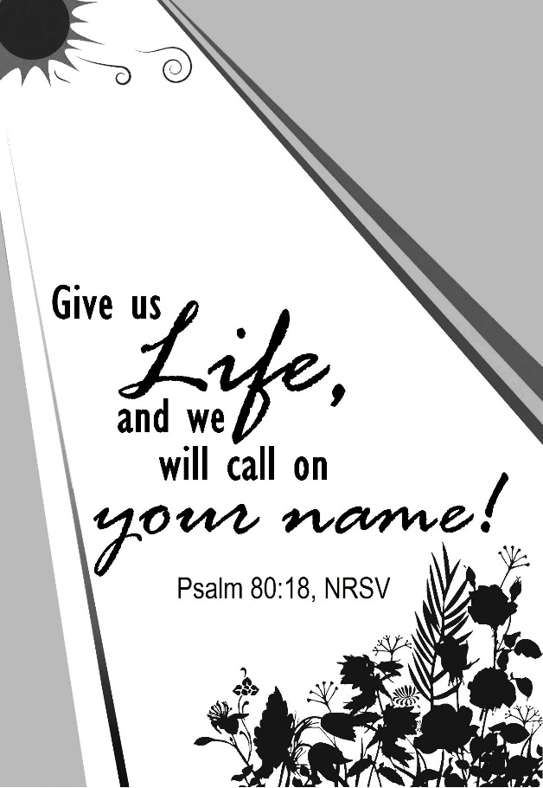

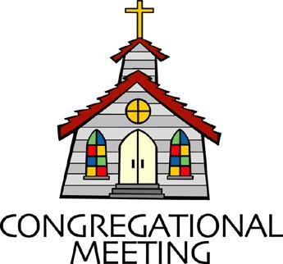
August 18, 2019 - 10:30 am

WELCOME VISITORS! We're glad you are here! Cards at the ends of each pew are for you to fill out and drop in the Offering Plate. Please let us know you are visiting, and join us for refreshments and fellowship following the service. The Sanctuary has an induction loop system to assist the hearing impaired. The system will also work on the telephone setting of hearing aids.

Springfield Presbyterian Church is rooted in the gospel of Jesus Christ, led by the Holy Spirit, and called to loving relationships through vibrant worship and service. Valuing all people, we are committed to developing disciples and fostering stewardship.

PREPARATION FOR THE WORD
(* those who are able are invited to stand)

PRELUDE

GATHERING OF THE PEOPLE

The Lord be with you! And also with you! (Greeting)

LIGHTING THE CHRIST CANDLE
Leader: Whenever we light this candle we proclaim:
People: Christ is the Light of the world and the center of our lives.

CALL TO WORSHIP [Excerpts of Psalm 40]
Leader: We waited patiently for the Lord, He inclined his ear to us and heard our cry.
People: He drew us up from the desolate pit, out of the miry bog, and He set our feet upon a rock, making our steps secure.
Leader: He put a new song in our mouths, a song of praise to our God. Many will see and fear and put their trust in the Lord.
People: Happy are those who make the Lord their trust, who do not turn to the proud, to those who go astray after false gods.
Leader: You have multiplied, O Lord our God, your wondrous deeds and your thoughts toward us; none can compare with you. Were we to proclaim and tell of them, they would be more than can be counted.
People: Sacrifice and offering you do not desire, but you have given us an open ear. Burnt offering and sin offering you have not required.
Leader: Then we said, “Here we are; in the scroll of the book it is written of me.
People: We will delight to do your will, O our God; your law is written within our hearts.
Leader: We have told the glad news of deliverance in the great congregation; see, we have not restrained our lips, O Lord.
People: May all who seek you rejoice and be glad in you; may those who love your salvation say continually, “Great is the Lord!”
ALL: Let all God’s people join together in worship and praise! Amen!

* HYMN O Love That Wilt Not Let Me Go

O Love that wilt not let me go, I rest my weary soul in thee;
I give thee back the life I owe, that in thine ocean depths its flow
may richer, fuller be.

O Light that followest all my way, I yield my flickering torch to thee;
My heart restores its borrowed ray, that in thy sunshine’s blaze its day
may brighter, fairer be.

O Joy that seekest me through pain, I cannot close my heart to thee;
I trace the rainbow through the rain, and feel the promise is not vain
that morn shall tearless be.

O Cross that liftest up my head, I dare not ask to fly from thee;
I lay in dust life’s glory dead, and from the ground there blossoms red
life that shall endless be.

PRAYER OF CONFESSION (Unison)
Gracious God, we are a people who seek unity, adverse to conflict. Yet there are times in which you call us to conflict, to challenge our own beliefs and the beliefs of others, and ask us to stretch our minds. You invite us into a holy disunity, yet we prefer quiet disunity. We can so easily live in a passive aggressive mindset, where our bonds with humanity are broken. Renew us and restore us and forgive us. Lead us to having honest and transparent conversations so that everyone’s faith may increase. Amen.
SILENT PRAYERS OF CONFESSION

RESPONSE Remember Not, O God
O Lord, our Savior, help, and glorify your name;
Deliver us from all our sins and take away our shame.

WORDS OF ASSURANCE
Leader: Hear the good news! Hope does not disappoint us, for God’s love has been poured into our hearts through the Holy Spirit given to us in baptism.
People: Believe this good news and give thanks: In Jesus Christ, we are forgiven! Alleluia! Amen.

* MUSICAL RESPONSE OF PRAISE Great Is Thy Faithfulness
Great is thy faithfulness! Great is thy faithfulness! Morning by morning new mercies I see. All I have needed thy hand hath provided. Great is thy faithfulness Lord unto me.

* THE PEACE The peace of Christ be with you! And also with you!
(You may greet those around you.)

* RESPONSE Here I Am, Lord
Here I am, Lord, Is it I, Lord? I have heard you calling in the night.
I will go, Lord, if you lead me. I will hold your people in my heart.

THE PROCLAMATION OF THE WORD

PRAYER OF ILLUMINATION
Leader: Generous God, pour out your Holy Spirit, and prepare our hearts to accept your word. Silence in us any voice but your own, that, hearing, we may also obey your will; through Jesus Christ our Lord. Amen.

FIRST SCRIPTURE LESSON Psalm 80:1-2, 8-19
¹ Give ear, O Shepherd of Israel, you who lead Joseph like a flock! You who are enthroned upon the cherubim, shine forth ² before Ephraim and Benjamin and Manasseh. Stir up your might, and come to save us!
⁸ You brought a vine out of Egypt; you drove out the nations and planted it. ⁹ You cleared the ground for it; it took deep root and filled the land. ¹⁰ The mountains were covered with its shade, the mighty cedars with its branches; ¹¹ it sent out its branches to the sea, and its shoots to the River. ¹² Why then have you broken down its walls, so that all who pass along the way pluck its fruit? ¹³ The boar from the forest ravages it, and all that move in the field feed on it. ¹⁴ Turn again, O God of hosts; look down from heaven, and see; have regard for this vine,
¹⁵ the stock that your right hand planted. ¹⁶ They have burned it with fire, they have cut it down; may they perish at the rebuke of your countenance. ¹⁷ But let your hand be upon the one at your right hand, the one whom you made strong for yourself. ¹⁸ Then we will never turn back from you; give us life, and we will call on your name. ¹⁹ Restore us, O Lord God of hosts; let your face shine, that we may be saved.

SECOND SCRIPTURE LESSON Hebrews 11:29-12:2
²⁹By faith the people passed through the Red Sea as if it were dry land, but when the Egyptians attempted to do so they were drowned. ³⁰By faith the walls of Jericho fell after they had been encircled for seven days. ³¹By faith Rahab the prostitute did not perish with those who were disobedient, because she had received the spies in peace. ³²And what more should I say? For time would fail me to tell of Gideon, Barak, Samson, Jephthah, of David and Samuel and the prophets— ³³who through faith conquered kingdoms, administered justice, obtained promises, shut the mouths of lions, ³⁴quenched raging fire, escaped the edge of the sword, won strength out of weakness, became mighty in war, put foreign armies to flight. ³⁵Women received their dead by

resurrection. Others were tortured, refusing to accept release, in order to obtain a better resurrection. ³⁶Others suffered mocking and flogging, and even chains and imprisonment. ³⁷They were stoned to death, they were sawn in two, they were killed by the sword; they went about in skins of sheep and goats, destitute, persecuted, tormented— ³⁸of whom the world was not worthy. They wandered in deserts and mountains, and in caves and holes in the ground. ³⁹Yet all these, though they were commended for their faith, did not receive what was promised, ⁴⁰since God had provided something better so that they would not, without us, be made perfect.
12 Therefore, since we are surrounded by so great a cloud of witnesses, let us also lay aside every weight and the sin that clings so closely, and let us run with perseverance the race that is set before us, ²looking to Jesus the pioneer and perfecter of our faith, who for the sake of the joy that was set before him endured the cross, disregarding its shame, and has taken his seat at the right hand of the throne of God.

Leader: Hear what the Spirit is saying to the Church.
All: Thanks be to God.

TIME WITH YOUNG PEOPLE

SERMON A Holy Disunity Rev. Becca Crate

THE RESPONSE TO THE WORD

* HYMN The Church of Christ Cannot Be Bound

The church of Christ cannot be bound by walls of wood or stone.
Where charity and love are found, there can the church be known.

True faith will open up the door and step into the street.
True service will seek out the poor and ask to wash their feet.

True love will not sit idly by when justice is denied.
True mercy hears the homeless cry and welcomes them inside.

If what we have we freely share to meet our neighbor’s need,
Then we extend the Spirit’s care through every selfless deed.

The church of Christ cannot be bound by walls of wood or stone.
Where charity and love are found, there can the church be known.

PASTORAL PRAYER AND THE LORD’S PRAYER
“For this I pray to God.” / “For this I give thanks to God.”
Congregational Response: “Hear our prayer, O God.”

PRESENTATION OF TITHES AND OFFERINGS
OFFERTORY
* SONG OF THANKS As Those of Old Their Firstfruits Brought
In gratitude and humble trust we bring our best today,
To serve your cause and share your love with all along life’s way.
O God who gave yourself to us in Jesus Christ your Son,
Help us to give ourselves each day until life’s work is done.
* PRAYER OF DEDICATION

* HYMN Lord, You Give the Great Commission

Lord, you give the great commission: “Heal the sick and preach the word.”
Lest the church neglect its mission, and the gospel go unheard,
Help us witness to your purpose with renewed integrity:
With the Spirit’s gifts empower us for the work of ministry.

Lord, you call us to your service: “In my name baptize and teach.”
That the world may trust your promise, life abundant meant for each,
Give us all new fervor, draw us closer in community:
With the Spirit’s gifts empower us for the work of ministry.

Lord, you make the common holy: “This, my body; this, my blood.”
Let us all, for earth’s true glory, daily lift life heavenward,
Asking that the world around us share your children’s liberty:
With the Spirit’s gifts empower us for the work of ministry.

Lord, you show us love’s true measure: “Father, what they do, forgive.”
Yet we hoard as private treasure all that you so freely give.
May your care and mercy lead us to a just society:
With the Spirit’s gifts empower us for the work of ministry.

Lord, you bless with words assuring: “I am with you to the end.”
Faith and hope and love restoring, may we serve as you intend,
And, amid the cares that claim us, hold in mind eternity:
With the Spirit’s gifts empower us for the work of ministry.

* CHARGE AND BENEDICTION
Leader: We are people with different ideas,
People: Yet we are united by God.
Leader: We are people with different lives,
People: Yet we are united by God.
Leader: We are people who serve God despite challenges,
People: So all people of all places may be united by our living and loving God. Amen.

* UNISON AMEN

POSTLUDE
Sunday August 25 Lectionary
Jeremiah 1:4-10; Psalm 71:1-6; Hebrews 12:18-29; Luke 13:10-17

Assisting in Worship: We appreciate those who serve:
Today 8/18 Next Week 8/25
Sunday Opener Beth Oates Jennifer Wise
Greeters & Ushers Don Vasbinder & Kathy Russ &
Bob Rogers Barbara Nickell
Lay Leader Mark Kearney Sharon Pappas
Children’s Activity Connie Robinson Connie Robinson
Fellowship Connie Gibbons & Brittany & Danny
Cathy Marsh Rachin

Church Attendance: August 4 – 32 August 11 - 43

Church Cleaning: August 23, 24 or 25 – Mark Kearney

Happy Birthday! August 19 – Madelyn McClung
August 23 – Robert Doyle

Announcements

Interested in trying out bell ringing? Linda Caviglia is holding an introductory bell session TODAY from 9:15 to 10:00 am.

Choir and Bell Choir: If anyone is interested in joining us for choir, there are no auditions! If you'll let Linda Caviglia know before the first practice, she will make sure to have a folder with all the music for you.

Wednesday, August 28
Adult Choir Practice - 6:30 - 9:00 As usual, we will try to read through all the music up to the end of the calendar year... and have a 1/2 hour for snacks and fellowship from 7:30 - 8:00pm.

Wednesday, September 4
Presbytones Bell Choir Practice 6:30 - 7:30 pm
Adult Choir Practice 7:45 - 9:00 pm

Feed My Sheep: Due to a contractor working at Wesley Freedom Church on 8/19, we will NOT be serving a meal that day.

Blessing Bags are in the Narthex. Please feel free to pick up a few. Handing one out to someone in need gives you a very real way to meet their immediate needs by providing them with some basic supplies.

Weekly Announcements: If you have an announcement to include with next week’s bulletin, please call the Office at 410-795-6152 or email to spc.office@verizon.net by Wednesday each week.

Prayers & Thanksgivings

~ Prayers of comfort and healing for Barbara Nickell who broke her arm.
~ Prayers for Christ Memorial Presbyterian from our Ministry Group.

The Congregational Care team wants to know what YOU or someone you know needs...a visit...a call...a meal. Please contact Diana Steppling or Connie Robinson. If you are in need of pastoral care, please contact Pastor Becca at 410-795-6152 or springfieldpastor@gmail.com.

Today:
Sunday August 18
10:30 am Worship
11:30 am Fellowship
12:00 noon Calendar Planning Meeting (Library)

Looking Ahead:
Sunday August 25
10:30 am Worship
11:30 am Fellowship
12:00 noon Session Meeting (Library)
Wednesday August 28
6:30 pm Adult Choir Practice

Office Hours: Tuesday, Wednesday, Friday 9:00 am - 3:00 pm

Springfield Presbyterian Church

10:30 am Worship
11:30 am Fellowship
Website: www.springfield-church.org Church Office: 410-795-6152
Like us on Facebook: www.facebook.com/SpringfieldPresbyterianChurch
Pastor: Rev. Becca Crate
Email: springfieldpastor@gmail.com
Clerk of Session: Sharon Pappas
Minister of Music: Linda Caviglia
Accompanist: Aaron Thacker Organist: Jennifer Wise
Youth Group Coordinators: Charles & Deb Sperling
Sunday School Coordinator: Connie Robinson
Administrative Assistant: Donna Mazer
e-mail: spc.office@verizon.net

