(Large Print)

Springfield Presbyterian Church (USA)
7300 Spout Hill Road, Sykesville, MD 21784 410-795-6152

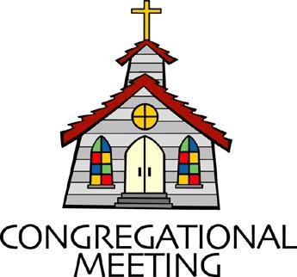
May 1, 2022 - 10:30 am

WELCOME VISITORS! We're glad you are here! Cards at the ends of each pew are for you to fill out and drop in the Offering Plate. Please let us know you are visiting, and join us for refreshments and fellowship following the service. The Sanctuary has an induction loop system to assist the hearing impaired. The system will also work on the telephone setting of hearing aids.

Springfield Presbyterian Church is rooted in the gospel of Jesus Christ, led by the Holy Spirit, and called to loving relationships through vibrant worship and service. Valuing all people, we are committed to developing disciples and fostering stewardship.
PREPARATION FOR THE WORD
(* those who are able are invited to stand)
PRELUDE

GATHERING OF THE PEOPLE

The Lord be with you! And also with you! (Greeting)

LIGHTING THE CHRIST CANDLE
Leader: Whenever we light this candle we proclaim:
People: Christ is the Light of the world and the center of our lives.

CALL TO WORSHIP
Leader: Joy is felt,
People: In the laughter that surrounds us,
Leader: In the wiggles of little children,
People: In the whispers of youth,
Leader: In the smiles of adults.
People: We praise God for this glorious day.
Leader: Let the praise break forth in the most unlikely places and in silly ways.
People: Let the joyous songs break through and the words reignite our hearts.
Leader: Let the laughter be deep,
People: For we are God’s people.

* HYMN Ten Lepers Facing Constant Scorn #179

Ten lepers facing constant scorn, emboldened by their daily plight,
Encountered One whose healing touch was known to put disease to flight.
The ten outsiders sought relief: “Have mercy, Master, hear our plea.”
“Seek out the priests,” the Healer said.
He knew the walk could set them free.

A nameless junction in the road became a holy turn-about.
One awestruck convert spun around and, praising God, began to shout.
God gave the space to turn around to all the others on the way,
But only one resolved to seize the miracle of grace that day.

Would we have stopped, retraced our steps, and then embraced the living Lord whose word had banished all our sores?
What kind of thanks would we afford? God, make of us your living tithes; the first fruits, fit to work for you.
Let each be like that one in ten: transformed and cleansed, restored, made new.

CALL TO CONFESSION
Leader: When we come together to confess our sin, we often sit with stoic faces and bowed heads. This morning though, we turn our hearts to the joy and laughter you have for us. We remember that we are your people, called to all of life’s emotions and we ask that you intercede as we gather to pray…

PRAYER OF CONFESSION
Generous God, forgive us for taking ourselves too seriously. We spend our days, often in our heads, contemplating big ideas and losing sight of the ways you are moving before us. Forgive us for not picking our heads up and looking to the skies, to the blossoming trees, to the beautiful flowers, or swaying to the sound of a song. Help us to have the faith of a child, the one that looks with awe upon all we see and slows down to find joy in simplicity. Forgive us and reignite the joy we find in you and lead us to laughter again. Amen.

SILENT PRAYERS OF CONFESSION

RESPONSE Restore in Us, O God Tune #434
Restore in us, O God, the splendor of your love;
Renew your image in our hearts, and all our sins remove.

WORDS OF ASSURANCE
Leader: We know that when we admit our sin and ask God to renew us, God responds with delight.
People: Thanks be to the God who rejoices with us as we are in fellowship with Him and with one another. Amen.

* MUSICAL RESPONSE OF PRAISE Alleluia, Alleluia! Give Thanks
Alleluia, alleluia! Give thanks to the risen Lord.
Alleluia, alleluia! Give praise to his name.

* THE PEACE The peace of Christ be with you! And also with you!
(You may greet those around you.)

* RESPONSE Here I Am, Lord
Here I am, Lord, Is it I, Lord? I have heard you calling in the night.
I will go, Lord, if you lead me. I will hold your people in my heart.

THE PROCLAMATION OF THE WORD

PRAYER OF ILLUMINATION
Loving God, let us hear afresh the words you have to say to us today and the words that point us to joy that we can find in you. Help us to focus upon that joyful spirit that surrounds these texts and lead us to a deeper understanding of the love and light that you embody. Amen.

FIRST SCRIPTURE LESSON Genesis 18:1-15

The Lord appeared to Abraham by the oaks of Mamre, as he sat at the entrance of his tent in the heat of the day. ²He looked up and saw three men standing near him. When he saw them, he ran from the tent entrance to meet them, and bowed down to the ground. ³He said, ‘My lord, if I find favor with you, do not pass by your servant. ⁴Let a little water be brought, and wash your feet, and rest yourselves under the tree. ⁵Let me bring a little bread, that you may refresh yourselves, and after that you may pass on—since you have come to your servant.’ So they said, ‘Do as you have said.’ ⁶And Abraham hastened into the tent to Sarah, and said, ‘Make ready quickly three measures of choice flour, knead it, and make cakes.’ ⁷Abraham ran to the herd, and took a calf, tender and good, and gave it to the servant, who hastened to prepare it. ⁸Then he took curds and milk and the calf that he had prepared, and set it before them; and he stood by them under the tree while they ate.
⁹They said to him, ‘Where is your wife Sarah?’ And he said, ‘There, in the tent.’ ¹⁰Then one said, ‘I will surely return to you in due season, and your wife Sarah shall have a son.’ And Sarah was listening at the tent entrance behind him. ¹¹Now Abraham and Sarah were old, advanced in age; it had ceased to be with Sarah after the manner of women. ¹²So Sarah laughed to herself, saying, ‘After I have grown old, and my husband is old, shall I have pleasure?’ ¹³The Lord said to Abraham, ‘Why did Sarah laugh, and say, “Shall I indeed bear a child, now that I am old?” ¹⁴Is anything too wonderful for the Lord? At the set time I will return to you, in due season, and Sarah shall have a son.’ ¹⁵But Sarah denied, saying, ‘I did not laugh’; for she was afraid. He said, ‘Oh yes, you did laugh.’

SECOND SCRIPTURE LESSON Psalm 100
¹ Make a joyful noise to the Lord, all the earth. ² Worship the Lord with gladness; come into his presence with singing. ³ Know that the Lord is God. It is he that made us, and we are his; we are his people, and the sheep of his pasture. ⁴ Enter his gates with thanksgiving, and his courts with praise. Give thanks to him, bless his name. ⁵ For the Lord is good; his steadfast love endures for ever, and his faithfulness to all generations.

Leader: Hear what the Spirit is saying to the Church.
All: Thanks be to God.

SERMON The God of Giggles Rev. Becca Crate-Price

THE RESPONSE TO THE WORD

* HYMN If Men Go to Hell, Who Cares?

(see next page)

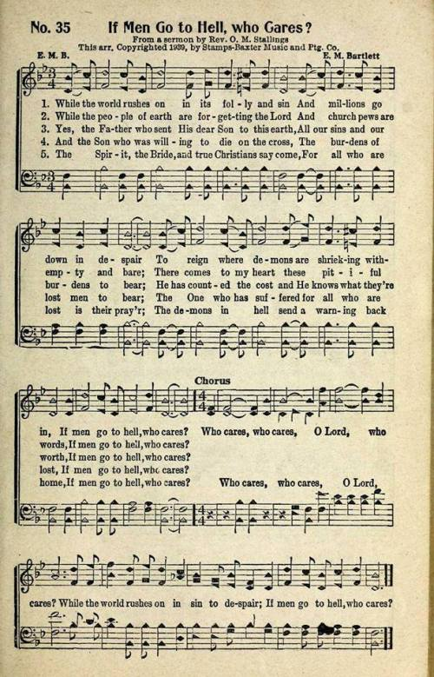

THE COMMUNION OF THE PEOPLE

INVITATION

THE GREAT PRAYER OF THANKSGIVING
Leader: The Lord be with you.
People: And also with you.
Leader: Lift up your hearts.
People: We lift them up to the Lord.
Leader: Let us give thanks to the Lord our God.
People: It is right to give our thanks and praise.
[The Pastor continues… “…with faithfulness to glorify your name...”]

IN PRAISE OF GOD Tune #552
Holy, holy, holy, Lord, God of Power and might.
Heaven and earth are full of your glory, Hosanna in the highest!
Blessed is He who comes in the name of the Lord.
Hosanna in the highest, hosanna in the highest.
[The Pastor continues… “…proclaim the one crucified and risen.”]

IN PRAISE OF CHRIST Tune #553
Christ has died; Christ is risen; Christ will come again.
Christ has died; Christ is risen; Christ will come again.

PASTORAL PRAYER AND THE LORD’S PRAYER

WORDS OF INSTITUTION

SHARING OF THE MEAL

PRAYER OF DEDICATION (Unison)
God of joy, we are grateful for a table where we can all meet and be welcomed by your holy presence. From this experience, we are refreshed to be the people you call us to be in this world. Help us to go out and live, transformed by this table and transformed by you. Amen.

COMMUNION ANTHEM

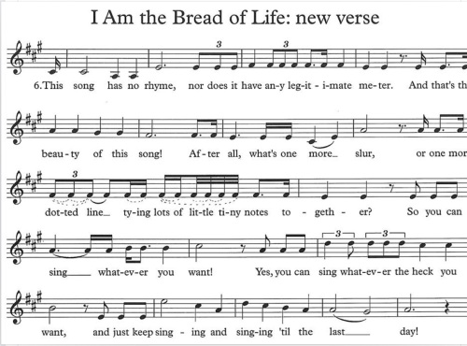

OFFERTORY Communion Invitation By Shackley/Frombach
SONG OF THANKS We Give Thee but Thine Own #708
We give thee but thine own, what e’er the gift may be;
All that we have is thine alone, a trust, O Lord, from thee.
PRAYER OF DEDICATION

* HYMN God of Earth and Outer Space (to the tune of #440)

God of earth and outer space, God of love and God of grace,
Bless the astronauts who fly as they soar beyond the sky.
God who flung the stars in space, God who set the sun ablaze,
Fling the spacecraft through the air, let man know your presence there.

God of atmosphere and air, God of life and planets bare,
Use man's courage and his skill as he seeks your holy will.
God of depth and God of height, God of darkness, God of light,
As man walks in outer space, teach him how to walk in grace.

God of man's exploring mind, God of wisdom, God of time,
Launch us from complacency to a world in need of thee.
God of power, God of might, God of rockets firing bright.
Hearts ignite and thrust within, love for Christ to share with men.

God of earth and outer space, God who guides the human race,
Guide the lives of seeking youth in their search for heavenly truth.
God who reigns below, above, God of universal love,
Love that gave Nativity, love that gave us Calvary.
Words © 1970 The Hymn Society (admin. Hope Publishing Company, 380 S Main Pl, Carol Stream, IL 60188)

* CHARGE AND BENEDICTION [Rev. Blain and Ressman]
Leader: May the God of surprises,
People: Bring smiles and joys to the everyday and ordinary.
Leader: May the God of love,
People: Be seen in all we do and say.
Leader: So let us go forth rejoicing,
People: For the good work has just begun.

* UNISON AMEN

POSTLUDE

Sunday May 8, 2022 Lectionary
Acts 9:36-43; Psalm 23; Revelation 7:9-17; John 10:22-30
Assisting in Worship: We appreciate those who serve:

Today 5/1 Next Week 5/8
Sunday Opener Bob Rogers Barbara Cornell
Ushers/Greeters Steve & Donna Don Vasbinder &
Mazer Bob Rogers
Lay Leader Christy Yeager Linda Black

Communion Servers Today: 1. Mark Kearney 4. Linda Caviglia
2. Kathy Russ 5. Barbara Cornell
3. Tony Caviglia

Happy Birthday! April 3 – Don Vasbinder

Announcements

Sunday School is back! On the 1st and 3rd Sundays of the month, we will be offering Sunday School! See Pastor Becca for details…

Ruth Gosnell Foundation (RGEF): The RGEF meeting is rescheduled for TODAY after worship.

Spring Plant Sale: Between May 1 and May 31, buy your spring plants at Buppert’s Farm and they will donate 10% of your purchase price back to Springfield’s ongoing projects and mission! Pick up a flyer in the Narthex and share it with your family and friends!

Springfield Membership: Are you interested in finding out more about our faith community and becoming a member? We would love to answer any questions you have. Please contact Pastor Becca at springfieldpastor@gmail.com for more information.

Mask Update: By the agreement of Session, we are now making masks optional. We do want to encourage you, if you feel compelled or have any underlying conditions, to keep your mask on. If you do wish to take off your mask though, we are also happy to see your faces. More information about fellowship and other practices will be coming as we make our way back to normalcy.

Congregational Care / Mission & Outreach: Do you know of a member or friend of our church family who is ill, needs prayers, would like call, a visit or a card, or might benefit from meal train? If so, please contact the Church Office (410-795-6152), Cathy Marsh (410-549-6916) or Diana Steppling (862-266-2242).

Fellowship Help Needed: If you are interested in helping with Fellowship, please contact Barbara Cornell (401-549-9397). A sign-up sheet will also be available.

Today:
Sunday May 1
10:30 am Worship
11:30 am Fellowship

This Week:
Wednesday May 4
6:15 – 7:15 pm Bell Choir Practice
7:30 – 8:45 pm Adult Choir Practice

Looking Ahead:
Sunday May 8
10:30 am Worship
11:30 am Fellowship
Wednesday May 11
6:15 – 7:15 pm Bell Choir Practice
7:30 – 8:45 pm Adult Choir Practice
Thursday May 12
7:00 pm Session Meeting

Office Hours: Tuesday, Wednesday & Friday
Springfield Presbyterian Church

10:30 am Worship
11:30 am Fellowship
Website: www.springfield-church.org Church Office: 410-795-6152
Like us on Facebook: www.facebook.com/SpringfieldPresbyterianChurch
Pastor: Rev. Becca Crate-Price
Email: springfieldpastor@gmail.com
Clerk of Session: Sharon Pappas
Minister of Music: Linda Caviglia
Accompanist/Organist: Aaron Thacker
Youth Group Coordinator: Dylan Vasbinder
Administrative Assistant: Donna Mazer e-mail: spc.office@verizon.net

