(Large Print)

Springfield Presbyterian Church (USA)
7300 Spout Hill Road, Sykesville, MD 21784 410-795-6152

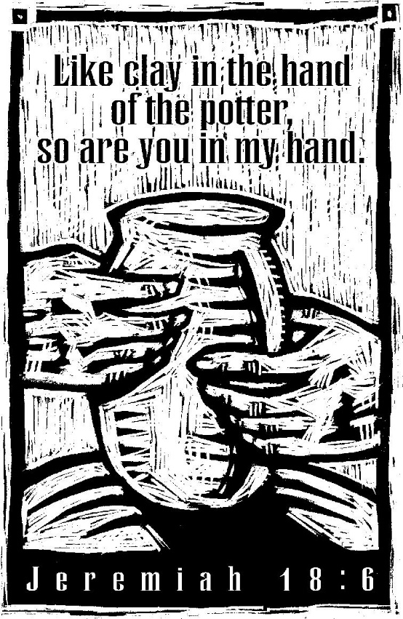

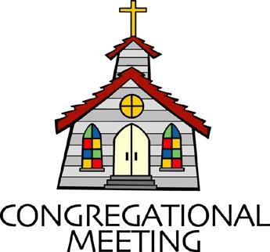
September 4, 2022 - 10:30 am

WELCOME VISITORS!
We're glad you are here! Cards at the ends of each pew are for you to fill out and drop in the Offering Plate. Please let us know you are visiting, and join us for refreshments and fellowship following the service. The Sanctuary has an induction loop system to assist the hearing impaired. The system will also work on the telephone setting of hearing aids.

Springfield Presbyterian Church is rooted in the gospel of Jesus Christ, led by the Holy Spirit, and called to loving relationships through vibrant worship and service. Valuing all people, we are committed to developing disciples and fostering stewardship.
PREPARATION FOR THE WORD
(* those who are able are invited to stand)

PRELUDE

GATHERING OF THE PEOPLE

The Lord be with you! And also with you! (Greeting)

LIGHTING THE CHRIST CANDLE
Leader: Whenever we light this candle we proclaim:
People: Christ is the Light of the world and the center of our lives.

CALL TO WORSHIP
Leader: During new light, God created all that is - the earth, the waters, living creatures. God called all creation good and blessed it.
People: Yet, human creation rejected God’s compassion. We decided that we would go our own way - living in fear and anger rather than peace and hope. Lord, hear our cries! Heal our wounds.
Leader: Sweep over us again, O God. Cleanse and purify us that we may serve you.
People: Open our hearts to hear your healing words of love. Let us be the people of your beloved Creation.
Leader: On this Lord's Day, as we prepare to come to the Lord's Table, let us present ourselves to worship God in spirit and truth, in compassion and love. Amen.

* HYMN O Day of Rest and Gladness GTG #393

O day of rest and gladness, O day of joy and light,
O balm for care and sadness, most beautiful, most bright;
On you, the high and lowly, through ages joined in tune,
Sing “Holy, holy, holy” to the great God triune.

On you, at earth’s creation the light first had its birth;
On you, for our salvation Christ rose from depths of earth;
On you, our Lord victorious sent Spirit forth from heaven.
And thus on you, most glorious, a triple light was given.

On you, God’s people, meeting, the Holy Scripture hear,
Christ’s living presence greeting, through bread and wine made near.
New graces ever gaining from this our day of rest,
We reach the rest remaining to spirits of the blest.

CALL TO CONFESSION
Leader: This is the boldness that we have in God, that if we ask anything according to God’s will, our requests will be granted.
People: Let us confess our sin before God.

PRAYER OF CONFESSION
Forgiving God, we have failed in so many ways. You gave us a wonderful world, filled with beauty, power, and majesty, and we have ravaged it - tearing away at its gifts with our own greed and cowardice. We have not treated this world or one another with compassionate love. We have turned our backs on situations of need in which we could have been instruments of help, healing, and peace. We have neglected service to others and have focused our lives on accumulating things and status. We have chased after false gods - greed, power, fame. You are the potter, O Lord. You fashioned us, but we focused on developing our flaws rather than working with our strengths. Please forgive us, Lord. Refashion us to be your people, celebrating your love in service to others. For we ask this in the name of Jesus Christ. Amen.

SILENT PRAYERS OF CONFESSION

RESPONSE The Woman Hiding in the Crowd Tune #178
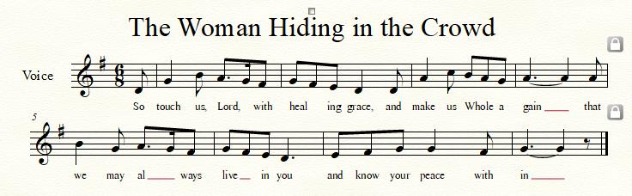

WORDS OF ASSURANCE
Leader: God’s loving choice for you is peace and hope. God has fashioned you to be God’s people. Rejoice! For God is with you, reaching out to heal and care for you.
People: Thanks be to God.
Leader: In the waters of baptism, God’s love has been poured out. In the name of Jesus Christ, we are forgiven.
People: Alleluia, and Amen.

* MUSICAL RESPONSE OF PRAISE O My Soul, Bless Your Redeemer
Bless your Maker, all you creatures, ever under God’s control,
All throughout God’s vast dominion; bless the Lord of all, my soul!

* THE PEACE The peace of Christ be with you! And also with you!
(You may greet those around you.)

* RESPONSE Here I Am, Lord
Here I am, Lord, Is it I, Lord? I have heard you calling in the night.
I will go, Lord, if you lead me. I will hold your people in my heart.

THE PROCLAMATION OF THE WORD

PRAYER OF ILLUMINATION
Lord God, though we say we want to follow, too often we close our ears to your word, and close our hearts to your will. May the words of Scripture now pry us open that your love and your will may be seen in all we do. Amen.

FIRST SCRIPTURE LESSON Jeremiah 18:1-11
The word that came to Jeremiah from the Lord: ²‘Come, go down to the potter’s house, and there I will let you hear my words.’ ³So I went down to the potter’s house, and there he was working at his wheel. ⁴The vessel he was making of clay was spoiled in the potter’s hand, and he reworked it into another vessel, as seemed good to him. ⁵Then the word of the Lord came to me: ⁶Can I not do with you, O house of Israel, just as this potter has done? says the Lord. Just like the clay in the potter’s hand, so are you in my hand, O house of Israel. ⁷At one moment I may declare concerning a nation or a kingdom, that I will pluck up and break down and destroy it, ⁸but if that nation, concerning which I have spoken, turns from its evil, I will change my mind about the disaster that I intended to bring on it. ⁹And at another moment I may declare concerning a nation or a kingdom that I will build and plant it, ¹⁰but if it does evil in my sight, not listening to my voice, then I will change my mind about the good that I had intended to do to it. ¹¹Now, therefore, say to the people of Judah and the inhabitants of Jerusalem: Thus says the Lord: Look, I am a potter shaping evil against you and devising a plan against you. Turn now, all of you from your evil way, and amend your ways and your doings.

SECOND SCRIPTURE LESSON Luke 14:25-33
²⁵Now large crowds were travelling with him; and he turned and said to them, ²⁶‘Whoever comes to me and does not hate father and mother, wife and children, brothers and sisters, yes, and even life itself, cannot

be my disciple. ²⁷Whoever does not carry the cross and follow me cannot be my disciple. ²⁸For which of you, intending to build a tower, does not first sit down and estimate the cost, to see whether he has enough to complete it? ²⁹Otherwise, when he has laid a foundation and is not able to finish, all who see it will begin to ridicule him, ³⁰saying, “This fellow began to build and was not able to finish.” ³¹Or what king, going out to wage war against another king, will not sit down first and consider whether he is able with ten thousand to oppose the one who comes against him with twenty thousand? ³²If he cannot, then, while the other is still far away, he sends a delegation and asks for the terms of peace. ³³So therefore, none of you can become my disciple if you do not give up all your possessions.

Leader: Hear what the Spirit is saying to the Church.
All: Thanks be to God.

SERMON Thou Art the Potter, We Are the Clay Rev. Jack Carlson

THE RESPONSE TO THE WORD

* HYMN Have Thine Own Way

Have Thine own way, Lord! Have Thine own way!
Thou art the Potter, we are the clay.
Mold us and make us that we may be
Christ’s holy people living for Thee.

Have Thine own way, Lord! Have Thine own way!
Search us and try us, Master today.
Whiter than Lord, wash us just now,
As in repentance, humbly we bow.

Have Thine own way, Lord! Have Thine own way!
Wounded and broken, help us we pray.
Power, all power, surely is Thine,
Heal and restore us, Savior divine!

Have Thine own way, Lord! Have Thine own way!
Hold o’er your people absolute sway.
Fill with your Spirit, till all shall see
Christ’s holy people, living for Thee.

THE COMMUNION OF THE PEOPLE

INVITATION

THE GREAT PRAYER OF THANKSGIVING
Leader: The Lord be with you.
People: And also with you.
Leader: Lift up your hearts.
People: We lift them up to the Lord.
Leader: Let us give thanks to the Lord our God.
People: It is right to give our thanks and praise.
[The Pastor continues… “…who forever sing to the glory of your name.”]

IN PRAISE OF GOD Tune #552
Holy, holy, holy, Lord, God of Power and might.
Heaven and earth are full of your glory, Hosanna in the highest!
Blessed is He who comes in the name of the Lord.
Hosanna in the highest, hosanna in the highest.
[The Pastor continues… “…proclaim the one crucified and risen.”]

IN PRAISE OF CHRIST Tune #553
Christ has died; Christ is risen; Christ will come again.
Christ has died; Christ is risen; Christ will come again.

PASTORAL PRAYER AND THE LORD’S PRAYER

WORDS OF INSTITUTION

SHARING OF THE MEAL

PRAYER OF DEDICATION (Unison)
Dear God, take us out to live as changed people because we have shared the living bread and cannot remain the same. Ask much of us, expect much from us, enable much by us, encourage many through us. So, Lord, may we live to your glory, both as inhabitants of the earth, and citizens of the commonwealth of Heaven. Through Christ, with Christ, in Christ, in the unity of the Holy Spirit, all glory and honor are yours, almighty God, now and forever. Amen.
OFFERTORY
SONG OF THANKS As Those of Old Their Firstfruits Brought #712
In gratitude and humble trust we bring our best today, to serve your cause and share your love with all along life’s way. O God who gave yourself to us in Jesus Christ your Son, help us to give ourselves each day until life’s work is done.
PRAYER OF DEDICATION

* HYMN God, You Spin the Whirling Planets GTG #23
God, you spin the whirling planets, fill the seas and spread the plain,
Mold the mountains, fashion blossoms,
Call forth sunshine, wind, and rain.
We, created in your image, would a true reflection be
Of your justice, grace, and mercy and the truth that makes us free.

You have called us to be faithful in our life and ministry.
We respond in grateful worship joined in one community.
When we blur your gracious image, focus us and make us whole.
Healed and strengthened as your people, we move onward toward your goal.

God, your word is still creating, calling us to life made new.
Now reveal to us fresh vistas where there’s work to dare and do.
Keep us clear of all distortion. Polish us with loving care.
Thus, new creatures in your image, we’ll proclaim Christ everywhere.

* CHARGE AND BENEDICTION
Leader: Happy are those who do not follow the advice of the wicked, or take the path that sinners tread, or sit in the seat of scoffers;
People: But their delight is in the law of the Lord, and on God’s law they meditate day and night.
Leader: They are like trees planted by streams of water, which yield their fruit in its season, and their leaves do not wither. In all that they do, they prosper.
People: The Lord watches over the way of the righteous, but the way of the wicked will perish.
Leader: And now may the grace of the Lord Jesus Christ, the love of God, and the fellowship of the Holy Spirit come upon you, and remain with you, this day and always.
People: Amen.

* UNISON AMEN

POSTLUDE

Sunday, September 11, 2022 Lectionary
Exodus 32:7-14; Psalm 51:1-10; 1 Timothy 1:12-17; Luke 15:1-10
Assisting in Worship: We appreciate those who serve:

Today 9/4 Next Week 9/11
Sunday Opener Beth Oates Ron Holmes
Ushers/Greeters Leah & Henry Sharon Pappas
Halvorson Bob Rogers
Lay Leader Tim Oates Don Vasbinder
Communion Servers Today: Bob Rogers & Barbara Cornell

Happy Birthday! September 9 – Rachel Spicer
September 11 – Spencer McClung

Happy Anniversary! September 5 – Stephanie & John Bunting
September 7 – Max & Margaret Carroll
September 7 – Becky & Mike Spicer

Announcements

We welcome the Rev. John V. “Jack” Carlson to our pulpit today! Jack retired from active ministry in the PCUSA in January, 2016. Prior to his retirement, he served for 13 years as Pastor at Highland Presbyterian Church, in Harford County, MD. Before that he served churches in Lockport, NY, and Hyattsville, MD, and was a pastoral counselor for more than 20 years in the Washington DC area. After serving a term as Moderator of the Presbytery of Baltimore, in September of 2017 he was elected Stated Clerk of the Presbytery; he retired from that post in 2020. He has published three books: The Spiritual Dimensions of Self-Esteem, The Spiritual Power of Communication, and The Disciple's Song, a poetic rendering of the Gospel of Mark. Jack is married to Lynn McCormick Carlson and has three grown children and three grandchildren. In his retirement, he spends time with his grandchildren, oil painting, travel, and golf.
SPC Adult Choir: Practice will start on Wednesday, September 7 with a longer than normal rehearsal – starting at 6:30 and ending at 8:30. We will plan to sight read through much of the music planned for the fall and work on our first anthem to be sung on Sunday, September 11. During our 2 hours, we will take a 30 minute break for fellowship and refreshments. Hope you can all be there and will enjoy our time to start singing again!

Presbytones Bell Choir: Bell Choir will begin rehearsing on September 14 from 6:15 to 7:15 pm, with Choir to follow from 7:30 to 8:45 pm.

Headhuggers: The first meeting of the Headhuggers will be on Monday, September 12 at 7:00 pm at the Manse. See Amy Vasbinder for more information.

Sunday School is back! We will be offering Sunday School beginning on September 18, and on the 1st and 3rd Sundays of each month thereafter. See Pastor Becca for details.

Mask Update: Due to the uptick in COVID-19 cases, the Session has decided to strongly encourage masking and social distancing. Though it is not a mandate, we seek to love one another by keeping each other as safe as possible. Thank you for your help in this endeavor.

Pastor-Parish Committee: The Pastor-Parish Committee invites you to share your concerns, suggestions, and gratitude. We have a form in the Narthex and a lock-box that we will open weekly and we ask that you share your name and be specific. We look forward to reading your comments so that we can continue to grow into the body of Christ.

Springfield Membership: Are you interested in finding out more about our faith community and becoming a member? We would love to answer any questions you have. Please contact Pastor Becca at springfieldpastor@gmail.com for more information.

Congregational Care / Mission & Outreach: Do you know of a member or friend of our church family who is ill, needs prayers, would like call, a visit or a card, or might benefit from meal train? If so, please contact the Church Office (410-795-6152), Cathy Marsh (410-549-6916) or Diana Steppling (862-266-2242).

Fellowship Help Needed: If you are interested in helping with Fellowship, please contact Barbara Cornell (240-308-0035). A sign-up sheet will also be available.

Today:
Sunday September 4
10:30 am Worship
11:30 am Fellowship

This Week:
Wednesday September 7
6:30 – 8:30 pm Adult Choir Practice
Thursday September 8
7:00 pm Session Meeting (Manse)

Looking Ahead:
Sunday September 11
10:30 am Worship
11:30 am Fellowship
12:00 noon Pastor-Parish Committee Meeting
Monday September 12
7:00 pm Headhuggers (Manse)
Wednesday September 14
6:15 – 7:15 pm Bell Choir Practice
7:30 – 8:45 pm Adult Choir Practice

Office Hours: Tuesday, Wednesday & Friday
Springfield Presbyterian Church

10:30 am Worship
11:30 am Fellowship
Website: www.springfield-church.org Church Office: 410-795-6152
Like us on Facebook: www.facebook.com/SpringfieldPresbyterianChurch
Pastor: Rev. Becca Crate-Price
Email: springfieldpastor@gmail.com
Clerk of Session: Sharon Pappas
Minister of Music: Linda Caviglia
Accompanist/Organist: Aaron Thacker
Youth Group Coordinator: Dylan Vasbinder
Administrative Assistant: Donna Mazer e-mail: spc.office@verizon.net

