(Large Print)

Springfield Presbyterian Church (USA)
7300 Spout Hill Road, Sykesville, MD 21784 410-795-6152

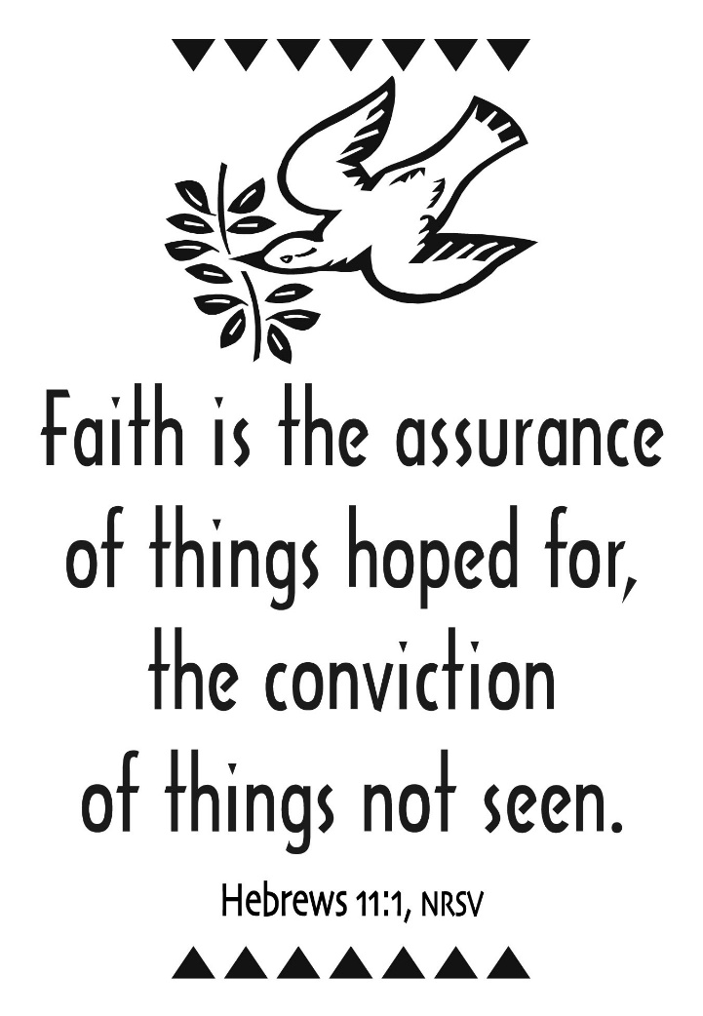

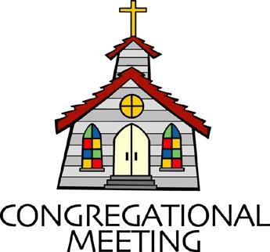
August 7, 2022 - 10:30 am

WELCOME VISITORS!
We're glad you are here! Cards at the ends of each pew are for you to fill out and drop in the Offering Plate. Please let us know you are visiting, and join us for refreshments and fellowship following the service. The Sanctuary has an induction loop system to assist the hearing impaired. The system will also work on the telephone setting of hearing aids.

Springfield Presbyterian Church is rooted in the gospel of Jesus Christ, led by the Holy Spirit, and called to loving relationships through vibrant worship and service. Valuing all people, we are committed to developing disciples and fostering stewardship.
PREPARATION FOR THE WORD
(* those who are able are invited to stand)
PRELUDE

GATHERING OF THE PEOPLE

The Lord be with you! And also with you! (Greeting)

LIGHTING THE CHRIST CANDLE
Leader: Whenever we light this candle we proclaim:
People: Christ is the Light of the world and the center of our lives.

CALL TO WORSHIP
Leader: As we gather in the pews this morning,
People: We remember our Biblical ancestors,
Leader: Those like Abraham, Sarah, David, and more,
People: Who followed God’s call even when they didn’t know where it would lead.
Leader: We remember the ancestors of our family,
People: Our great grandparents and beyond, whose love brought us here on Earth.
Leader: We remember God’s call on our hearts,
People: For the generations to come, for what we hope may not be evident in our lifetime.
Leader: Yet God’s covenant promises continue to shine through.
People: Let us gather together to praise the God whose presence with us is from everlasting to everlasting.

* HYMN God of Our Life GTG #686

God of our life, through all the circling years, we trust in thee.
In all the past, through all our hopes and fears, thy hand we see.
With each new day, when morning lifts the veil,
We own thy mercies, Lord, which never fail.

God of the past, our times are in thy hand. With us abide.
Lead us by faith to hope’s true promised land. Be thou our guide.
With thee to bless, the darkness shines as light,
And faith’s fair vision changes into sight.

God of the coming years, through paths unknown we follow thee.
When we are strong, Lord, leave us not alone. Our refuge be.
Be thou for us in life our daily bread,
Our heart’s true home when all our years have sped.

CALL TO CONFESSION
Leader: In a fast-paced world, sometimes it can be hard to slow down and see where God is calling us. One of the more difficult parts of faith is that when we are called, we might not see the blessing and fruition of that call in our lifetime. We are reminded through Scripture though that we need to take a long view, we need to see that God’s Kingdom is much bigger than our timeline. So we set our hurried bodies and minds down and seek to be in alignment with God’s call once again.

PRAYER OF CONFESSION
Generous God, we are human and, in our humanity, we wish to see the fruits of our labors immediately. We struggle with the long view of your Kingdom. Help us to release ourselves from our own desires and to place your call first on our hearts. Deconstruct our vision of the future for your vision; one that is more beautiful, hopeful, and in line with the values of your Kingdom. Renew and restore us through the power of your forgiveness as we seek to be better disciples of your Word here in this place. Amen.

SILENT PRAYERS OF CONFESSION

RESPONSE The Woman Hiding in the Crowd Tune #178
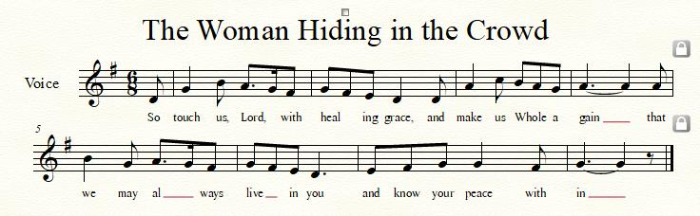
WORDS OF ASSURANCE
Leader: God’s gracious love keeps loving us, again and again, and through the power of that love and our atonement, we are forgiven once again.
People: Thanks be to God! We are forgiven! Alleluia and amen.

* MUSICAL RESPONSE OF PRAISE O My Soul, Bless Your Redeemer
Bless your Maker, all you creatures, ever under God’s control,
All throughout God’s vast dominion; bless the Lord of all, my soul!

* THE PEACE The peace of Christ be with you! And also with you!
(You may greet those around you.)

* RESPONSE Here I Am, Lord
Here I am, Lord, Is it I, Lord? I have heard you calling in the night.
I will go, Lord, if you lead me. I will hold your people in my heart.

THE PROCLAMATION OF THE WORD

PRAYER OF ILLUMINATION
Merciful God, as we seek to hear your Word, remove every obstacle from our hearts and minds. Let us lay our worries and fast-paced lives down for these moments to hear your Word more clearly. As we hear the Scripture, let us then seek to understand how we can live it out in our lives today, tomorrow, and in all our days to come. Amen.
FIRST SCRIPTURE LESSON Psalm 100
¹ Make a joyful noise to the Lord, all the earth. ² Worship the Lord with gladness; come into his presence with singing. ³ Know that the Lord is God. It is he that made us, and we are his; we are his people, and the sheep of his pasture. ⁴ Enter his gates with thanksgiving, and his courts with praise. Give thanks to him, bless his name. ⁵ For the Lord is good; his steadfast love endures for ever, and his faithfulness to all generations.

SECOND SCRIPTURE LESSON Hebrews 11:1-3, 8-16
Now faith is the assurance of things hoped for, the conviction of things not seen. ²Indeed, by faith our ancestors received approval. ³By faith we understand that the worlds were prepared by the word of God, so that what is seen was made from things that are not visible. ⁸By faith Abraham obeyed when he was called to set out for a place that he was to receive as an inheritance; and he set out, not knowing where he was going. ⁹By faith he stayed for a time in the land he had been promised, as in a foreign land, living in tents, as did Isaac and Jacob, who were heirs with him of the same promise. ¹⁰For he looked forward to the city that has foundations, whose architect and builder is God. ¹¹By faith he received power of procreation, even though he was too old—and Sarah herself was barren—because he considered him faithful who had promised. ¹²Therefore from one person, and this one as good as dead, descendants were born, ‘as many as the stars of heaven and as the innumerable grains of sand by the seashore.’ ¹³All of these died in faith without having received the promises, but from a distance they saw and greeted them. They confessed that they were strangers and foreigners on the earth, ¹⁴for people who speak in this way make it clear that they are seeking a homeland. ¹⁵If they had been thinking of the land that they had left behind, they would have had opportunity to return. ¹⁶But as it is, they desire a better country, that is, a heavenly one. Therefore God is not ashamed to be called their God; indeed, he has prepared a city for them.

Leader: Hear what the Spirit is saying to the Church.
All: Thanks be to God.

SERMON Taking a Long View Rev. Becca Crate-Price

THE RESPONSE TO THE WORD

* HYMN How Firm a Foundation GTG #463
How firm a foundation, ye saints of the Lord,
is laid for your faith in God's excellent Word!
What more can be said than to you God hath said,
to you who for refuge to Jesus have fled?

"Fear not, I am with thee, O be not dismayed,
for I am thy God, and will still give thee aid;
I'll strengthen thee, help thee, and cause thee to stand,
upheld by my righteous, omnipotent hand.

"When through the deep waters I call thee to go,
the rivers of sorrow shall not overflow;
for I will be near thee, thy troubles to bless,
and sanctify to thee thy deepest distress.

"When through fiery trials thy pathway shall lie,
my grace, all sufficient, shall be thy supply;
the flame shall not hurt thee; I only design
thy dross to consume, and thy gold to refine.

"The soul that on Jesus hath leaned for repose,
I will not, I will not desert to its foes;
that soul, though all hell should endeavor to shake,
I'll never, no, never, no, never forsake."
THE COMMUNION OF THE PEOPLE

INVITATION

THE GREAT PRAYER OF THANKSGIVING
Leader: The Lord be with you.
People: And also with you.
Leader: Lift up your hearts.
People: We lift them up to the Lord.
Leader: Let us give thanks to the Lord our God.
People: It is right to give our thanks and praise.
[The Pastor continues… “…who forever sing to the glory of your name.”]

IN PRAISE OF GOD Tune #552
Holy, holy, holy, Lord, God of Power and might.
Heaven and earth are full of your glory, Hosanna in the highest!
Blessed is He who comes in the name of the Lord.
Hosanna in the highest, hosanna in the highest.
[The Pastor continues… “…proclaim the one crucified and risen.”]

IN PRAISE OF CHRIST Tune #553
Christ has died; Christ is risen; Christ will come again.
Christ has died; Christ is risen; Christ will come again.

PASTORAL PRAYER AND THE LORD’S PRAYER

WORDS OF INSTITUTION

SHARING OF THE MEAL

PRAYER OF DEDICATION (Unison)
Dear God, take us out to live as changed people because we have shared the living bread and cannot remain the same. Ask much of

us, expect much from us, enable much by us, encourage many through us. So, Lord, may we live to your glory, both as inhabitants of the earth, and citizens of the commonwealth of Heaven. Through Christ, with Christ, in Christ, in the unity of the Holy Spirit, all glory and honor are yours, almighty God, now and forever. Amen.
OFFERTORY
SONG OF THANKS As Those of Old Their Firstfruits Brought #712
In gratitude and humble trust we bring our best today, to serve your cause and share your love with all along life’s way. O God who gave yourself to us in Jesus Christ your Son, help us to give ourselves each day until life’s work is done.
PRAYER OF DEDICATION

* HYMN Come Sing, O Church, in Joy! GTG #305

Come sing, O church, in joy! Come join, O church, in song!
For Christ the Lord has led us through the ages long!
In bold accord, come celebrate the journey now and praise the Lord!

Long years have come and gone, and still God reigns supreme,
Empowering us to catch the vision, dream the dream!
In bold accord, come celebrate the journey now and praise the Lord!

Let courage be our friend; let wisdom be our guide,
As we in mission magnify the Crucified!
In bold accord, come celebrate the journey now and praise the Lord!

Come sing, O church, in joy! Come join O church, in song!
For Christ the Lord has triumphed o’er the ages long!
In bold accord, come celebrate the journey now and praise the Lord!

* CHARGE AND BENEDICTION
Leader: As we go from this place,
People: We remember that God’s Kingdom is much bigger than our understanding.
Leader: We remember our ancestors and give thanks for their vision.
People: We remember that our calling might not seem clear.
Leader: We remember that we may not see our works of faith in our lifetime,
People: Yet we proclaim and continue to proclaim: God is faithful still.

* UNISON AMEN

POSTLUDE

Assisting in Worship: We appreciate those who serve:

Today 8/7 Next Week 8/14
Sunday Opener Beth Oates Ron Holmes
Ushers/Greeters Leah & Henry Don Vasbinder
Halvorson Bob Rogers
Lay Leader Mark Kearney Tony Caviglia
Communion Servers Today: Linda Caviglia & Bob Steppling

Happy Birthday! August 10 – Phoebe Klass

Sunday, August 14, 2022 Lectionary
Jeremiah 23:23-29; Psalm 82; Hebrews 11:29-12:2; Luke 12:49-56
Announcements

Welcome Northminster! We welcome our friends from Northminster Presbyterian Church to our pews and join us in worship this morning! We hope you will come to fellowship for our indoor picnic where we can learn more about one another!

Upcoming Concert: Mark your calendars for our next free concert on Sunday, August 14, at 3:00 pm when we will present The Satyr Hill Band. Although primarily a bluegrass band, they play a variety of music and styles which include bluegrass, new grass (as in Revival), progressive, acoustic country and rock & roll, as well as innovative originals. An ice cream social will follow. Bring your family and friends!

Mask Update: Due to the uptick in COVID-19 cases, the Session has decided to strongly encourage masking and social distancing. Though it is not a mandate, we seek to love one another by keeping each other as safe as possible. Thank you for your help in this endeavor.

Sunday School is back! On the 1st and 3rd Sundays of the month, we will be offering Sunday School! See Pastor Becca for details…

Summer Mission Project: It won’t be long before school starts again. Preparing for a new school year includes buying items on the STUDENT SUPPLY LIST. For some children and their families, this can be a challenge and in some instances buying needed supplies just isn’t possible. For that reason, during July and August, we will be collecting school supplies to help these children. The GIVING TREE is in the Narthex. If you would like to help with this project, you can take a tag from the tree and buy the item written on it or simply choose from the below items (taken from Sykesville Middle School STUDENT SUPPLY LIST). Please place your donated items in the designated basket in the Narthex. Thank you! ~ CoCaMO Committee

3-ring binders-1, 1 ½ or 2” Pencil pouch Glue sticks
Loose-leaf paper Pack of #2 pencils Pair of Ear Buds
Pack of 5-tab binder dividers Pocket folders Scissors
Blue, black or red pens Block or cap erasers Sticky notes
3X5 ruled index cards Dry erase markers Crayons
Folders with brads 10-pack colored pencils
Spiral notebook-200 pgs. Pencil sharpener
Multi-colored highlighters Composition book

Pastor-Parish Committee: The Pastor-Parish Committee invites you to share your concerns, suggestions, and gratitude. We have a form in the Narthex and a lock-box that we will open weekly and we ask that you share your name and be specific. We look forward to reading your comments so that we can continue to grow into the body of Christ.

Springfield Membership: Are you interested in finding out more about our faith community and becoming a member? We would love to answer any questions you have. Please contact Pastor Becca at springfieldpastor@gmail.com for more information.

Congregational Care / Mission & Outreach: Do you know of a member or friend of our church family who is ill, needs prayers, would like call, a visit or a card, or might benefit from meal train? If so, please contact the Church Office (410-795-6152), Cathy Marsh (410-549-6916) or Diana Steppling (862-266-2242).

Fellowship Help Needed: If you are interested in helping with Fellowship, please contact Barbara Cornell (240-308-0035). A sign-up sheet will also be available.

Today:
Sunday August 7
10:30 am Worship
11:30 am Fellowship

Looking Ahead:
Sunday August 14
10:30 am Worship
11:30 am Fellowship
3:00 pm Concert & Ice Cream Social
Thursday August 18, 2022
7:00 pm Session Meeting

Office Hours: Tuesday, Wednesday & Friday
Springfield Presbyterian Church

10:30 am Worship
11:30 am Fellowship
Website: www.springfield-church.org Church Office: 410-795-6152
Like us on Facebook: www.facebook.com/SpringfieldPresbyterianChurch
Pastor: Rev. Becca Crate-Price
Email: springfieldpastor@gmail.com
Clerk of Session: Sharon Pappas
Minister of Music: Linda Caviglia
Accompanist/Organist: Aaron Thacker
Youth Group Coordinator: Dylan Vasbinder
Administrative Assistant: Donna Mazer e-mail: spc.office@verizon.net

