(Large Print)

Springfield Presbyterian Church (USA)
7300 Spout Hill Road, Sykesville, MD 21784 410-795-6152

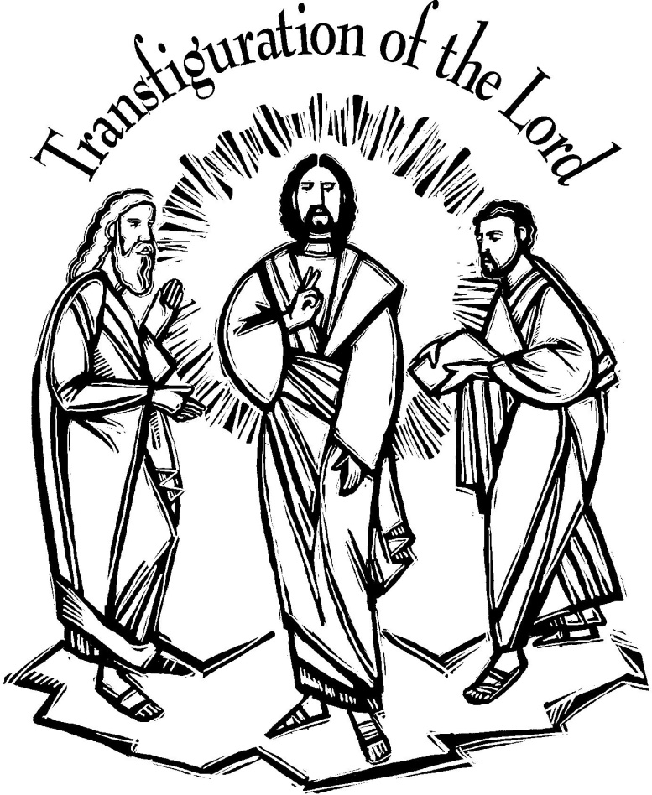

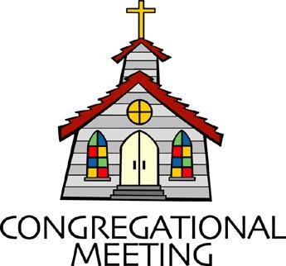
March 3, 2019 - 10:30 am

WELCOME VISITORS! We're glad you are here! Cards at the ends of each pew are for you to fill out and drop in the Offering Plate. Please let us know you are visiting, and join us for refreshments and fellowship following the service. The Sanctuary has an induction loop system to assist the hearing impaired. The system will also work on the telephone setting of hearing aids.

Springfield Presbyterian Church is rooted in the gospel of Jesus Christ, led by the Holy Spirit, and called to loving relationships through vibrant worship and service. Valuing all people, we are committed to developing disciples and fostering stewardship.
PREPARATION FOR THE WORD
(* those who are able are invited to stand)

Please prepare for worship by listening to the music of the Prelude.

PRELUDE

GATHERING OF THE PEOPLE

The Lord be with you! And also with you! (Greeting)

LIGHTING THE CHRIST CANDLE
Leader: Whenever we light this candle we proclaim:
People: Christ is the Light of the world and the center of our lives.

CALL TO WORSHIP
Leader: Blessed is the Lord our God, who revealed the law to Moses.
People: The Lord our God is holy!
Leader: Blessed is the Lord our God, who has spoken through the prophets.
People: The Lord our God is holy!
Leader: Blessed is the Lord our God, who came to us in Jesus Christ.
People: The Lord our God is holy!
Leader: The one who spoke and called light out of darkness now shines in our hearts.
People: The Lord our God is holy!
Leader: The one who comes and does not keep silence now speaks in our midst.
People: The Lord our God is holy!
Leader: Now we have seen the glory of God in the face of Jesus Christ.
People: The Lord our God is holy! Let us worship our God!

* HYMN All of Life is Filled With Wonder
(sung to the tune of Joyful, Joyful, We Adore Thee)

All of life is filled with wonder, so we thank you, God of love —
For the crash of evening thunder, clearing clouds, then stars above;
For the night that turns to glowing as we feel the morning mist,
God, we praise and thank you, knowing every day we're truly blessed.

For the joy of daily waking, for the gift of each new day,
For the smell of fresh bread baking, for the sound of children's play,
For the ways we seek to serve you as we work and volunteer,
God we humbly praise and thank you for your presence with us here.

For the ways we're blessed with plenty — love and laughter, neighbors, friends,
Nature's wonders, seasons' bounty, life in you that never ends,
For the ones who've gone before us, giving witness to your way —
We rejoice in all you give us every moment, every day.

For your love in times of trouble, for your peace when things are tough,
For your help when hardships double, for your grace that is enough,
For a stranger's gentle kindness, for a doctor's healing skill —
God, we thank you that you bless us, and you bless your world as well.

For the baby in the manger, for the cross and empty tomb,
For each time a searching stranger finds at church a welcome home,
For your kingdom's great surprises — poor ones lifted, lost ones found
God, we thank you! Hope still rises, for your gifts of grace abound.

Text: Copyright © 2010 by Carolyn Winfrey Gillette. All rights reserved.

PRAYER OF CONFESSION
God of Compassion, in Jesus Christ you reveal the light of your glory, but we turn away, distracted by our own plans. We confess that we speak when we should listen, and act when we should
wait. Forgive our aimless enthusiasms. Grant us wisdom to live in your light and to follow in the way of your beloved Son, Jesus Christ, our Savior. Amen.

SILENT PRAYERS OF CONFESSION

RESPONSE Restore in Us, O God
Restore in us, O God, the splendor of your love;
Renew your image in our hearts, and all our sins remove.

WORDS OF ASSURANCE
Leader: The one who calls light out of darkness now shines in our hearts to reveal the glory of God in the face of Jesus Christ.
People: In the name of Jesus Christ, we are forgiven! Amen.

* MUSICAL RESPONSE OF PRAISE Gloria Patri
Glory be to the Father, and to the Son, and to the Holy Ghost;
As it was in the beginning, is now, and ever shall be,
World without end. Amen, amen.

* THE PEACE The peace of Christ be with you! And also with you!
(You may greet those around you.)

* RESPONSE Here I Am, Lord
Here I am, Lord, Is it I, Lord? I have heard you calling in the night.
I will go, Lord, if you lead me. I will hold your people in my heart.

THE PROCLAMATION OF THE WORD

PRAYER OF ILLUMINATION
God of shining splendor, your voice makes the earth tremble in wonder. Overshadow us with your spirit so that we may hear your Word and live as faithful disciples and covenant people; through Jesus Christ our Lord. Amen.
FIRST SCRIPTURE LESSON Exodus 34:29-35
²⁹Moses came down from Mount Sinai. As he came down from the mountain with the two tablets of the covenant in his hand, Moses did not know that the skin of his face shone because he had been talking with God. ³⁰When Aaron and all the Israelites saw Moses, the skin of his face was shining, and they were afraid to come near him. ³¹But Moses called to them; and Aaron and all the leaders of the congregation returned to him, and Moses spoke with them. ³²Afterwards all the Israelites came near, and he gave them in commandment all that the Lord had spoken with him on Mount Sinai. ³³When Moses had finished speaking with them, he put a veil on his face; ³⁴but whenever Moses went in before the Lord to speak with him, he would take the veil off, until he came out; and when he came out, and told the Israelites what he had been commanded, ³⁵the Israelites would see the face of Moses, that the skin of his face was shining; and Moses would put the veil on his face again, until he went in to speak with him.

SECOND SCRIPTURE LESSON Luke 9:28-36
²⁸Now about eight days after these sayings Jesus took with him Peter and John and James, and went up on the mountain to pray. ²⁹And while he was praying, the appearance of his face changed, and his clothes became dazzling white. ³⁰Suddenly they saw two men, Moses and Elijah, talking to him. ³¹They appeared in glory and were speaking of his departure, which he was about to accomplish at Jerusalem. ³²Now Peter and his companions were weighed down with sleep; but since they had stayed awake, they saw his glory and the two men who stood with him. ³³Just as they were leaving him, Peter said to Jesus, ‘Master, it is good for us to be here; let us make three dwellings, one for you, one for Moses, and one for Elijah’—not knowing what he said. ³⁴While he was saying this, a cloud came and overshadowed them; and they were terrified as they entered the cloud. ³⁵Then from the cloud came a voice

that said, ‘This is my Son, my Chosen; listen to him!’ ³⁶When the voice had spoken, Jesus was found alone. And they kept silent and in those days told no one any of the things they had seen.

Leader: Hear what the Spirit is saying to the Church.
All: Thanks be to God.

TIME WITH YOUNG PEOPLE

SERMON The Shining, Bright, and Dazzling Light Rev. Becca Crate

THE RESPONSE TO THE WORD

* HYMN Spirit of the Living God
Spirit of the living God, fall afresh on me.
Spirit of the living God, fall afresh on me.
Melt me; mold me; fill me; use me.
Spirit of the living God, fall afresh on me.

THE SACRAMENT OF HOLY COMMUNION

INVITATION

THE GREAT PRAYER OF THANKSGIVING
Leader: The Lord be with you.
People: And also with you.
Leader: Lift up your hearts.
People: We lift them up to the Lord.
Leader: Let us give thanks to the Lord our God.
People: It is right to give our thanks and praise.
[The Pastor continues… “…who forever sing to the glory of your name.”]

IN PRAISE OF GOD Tune #552
Holy, holy, holy, Lord, God of Power and might.
Heaven and earth are full of your glory, Hosanna in the highest!
Blessed is He who comes in the name of the Lord.
Hosanna in the highest, hosanna in the highest.
[The Pastor continues… “…dedicated to your service.”]

IN PRAISE OF CHRIST Tune #553
Christ has died; Christ is risen; Christ will come again.
Christ has died; Christ is risen; Christ will come again.

PASTORAL PRAYER AND THE LORD’S PRAYER
“For this I pray to God.” / “For this I give thanks to God.”
Congregational Response: “Hear our prayer, O God.”

WORDS OF INSTITUTION

SHARING OF THE MEAL

PRAYER OF DEDICATION (Unison)
Dear God, take us out to live as changed people because we have shared the living bread and cannot remain the same. Ask much of us, expect much from us, enable much by us, encourage many through us. So, Lord, may we live to your glory, both as inhabitants of the earth, and citizens of the commonwealth of Heaven. Through Christ, with Christ, in Christ, in the unity of the Holy Spirit, all glory and honor are yours, almighty God, now and forever. Amen.

PRESENTATION OF TITHES AND OFFERINGS
OFFERTORY Communion Invitation by Shackley/Frombach

* SONG OF THANKS Take Thou Our Minds, Dear Lord
Take thou ourselves, O Lord, heart, mind and will;
Through our surrendered souls thy plans fulfill.
We yield ourselves to thee: time, talents, all;
We hear, and henceforth heed, thy sovereign call.
* PRAYER OF DEDICATION

* HYMN My Hope Is Built on Nothing Less
My hope is built on nothing less than Jesus' blood and righteousness;
I dare not trust the sweetest frame, but wholly lean on Jesus' name.

Refrain:
On Christ, the solid Rock, I stand;
all other ground is sinking sand;
all other ground is sinking sand.

When darkness seems to hide his face, I rest on his unchanging grace;
in every high and stormy gale, my anchor holds within the veil. [Refrain]

His oath, his covenant, his blood support me in the whelming flood;
when all around my soul gives way, he then is all my hope and stay. [Refrain]

When he shall come with trumpet sound, O may I then in him be found, dressed in his righteousness alone,
faultless to stand before the throne. [Refrain]

* CHARGE AND BENEDICTION
Leader: In bright and glorious beauty,
People: You shine your light on your people.
Leader: To send your good news, to empower prophets,
People: As we feel the warmth of your light on our face,
Leader: We celebrate, and we ourselves are transfigured,
People: Into your people, called in awe to serve you. Amen.

* UNISON AMEN

POSTLUDE

Assisting in Worship: We appreciate those who serve:

Today 3/3 Next Week 3/10
Sunday Opener Ron Holmes Bob Rogers
Greeters & Ushers Ed & Sandy Cynthia Smith &
Newsome Beth Oates
Lay Leader Elizabeth Meirowitz Don Vasbinder
Sunday School Connie Robinson Connie Robinson
Fellowship Shrove Sunday Linda Caviglia

Communion Servers Today:
1. Charlie Sperling 4. Ron Holmes
2. Jim Wise 5. Tony Caviglia
3. Sue Holmes

Church Attendance: February 17 - 38 February 24 - 49

Church Cleaning: March 8, 9 or 10 - Deb & Charlie Sperling

Happy Birthday! March 4 - Anna Bunting
March 4 - Charlie Sperling
March 5 - Andrea Lane
March 5 - Patty Salmon
March 6 - Sue Holmes

Sunday March 10 Lectionary
Deuteronomy 26:1-11; Psalm 91:1-2, 9-16; Romans 10:8b-13;
Luke 4:1-13
Announcements

Shrove Sunday Pancakes!!! Join us TODAY as we celebrate Shrove Sunday with a pancake lunch/brunch in the Fellowship Room after Worship.

Easter Flowers: The deadline to order Easter flowers is March 10. Please place your completed order form and check in the offering plate or send it to the Church Office at 7314 Spout Hill Road, Sykesville, MD 21784. Additional order forms are available in the Narthex.

Concert Committee: It is time again to get a few of us together to decide on what groups we'd like to invite for our next Concert Series year. We will meet 2 or 3 times in the next couple of months and plan to have our lineup for the 2019-2020 year finished by the end of April. We'd love to have people on the committee who are interested in the concerts and music in general... please consider joining us! If you are interested, please let Linda Caviglia know. (410-746-1221 or cavig5@comcast.net)

Bible Study: Sarah Lantz will lead a Bible Study from Namesake: When God Rewrites Your Story by Jessica LaGrone. We will meet on two more Tuesday evenings at 7:00 pm at Panera in Eldersburg - March 5 and March 19. Please join us!

C.I.A. (Community In Action) will meet TOMORROW from 4:30-6 pm at the Manse. Pizza and drinks provided. Friends are welcome and encouraged to attend! C.I.A is a group open to all religious and non-religious people as a means of providing the community with acts of kindness. We will be doing different activities throughout the school year to help people in our community who are in need. Come and be part of giving back to our community.

Blessing Bags are in the Narthex. Please feel free to pick up a few and pass them out to those in need.

Weekly Announcements: If you have an announcement to include with next week’s bulletin, please call the Office at 410-795-6152 or email to spc.office@verizon.net by Wednesday each week.

The Congregational Care team wants to know what YOU or someone you know needs...a visit...a call...a meal. Please contact Diana Steppling or Connie Robinson.

Prayers & Thanksgivings

~ “Don and I and family want to thank everyone for the thoughtful and caring cards sent in sympathy for the passing of my sister, Janet, and also for the thoughts and prayers for my health issues. We are so thankful for our loving church family.” ~ Belle & Don Vasbinder and Family
~ Prayers of comfort for the family of Robert Frothingham, who passed away on February 10.
~ Prayers for First of Howard County from our Ministry Group.

Today:
Sunday March 3 - Shrove Sunday
10:30 am Worship & Sunday School
11:30 am Pancake Lunch/Brunch

This Week:
Monday March 4
4:30 pm C.I.A. Meeting (Manse)
Tuesday March 5
7:00 pm Bible Study (Panera)
Wednesday March 6 - Ash Wednesday
7:00 pm Worship

Looking Ahead:
Sunday March 10
10:30 am Worship & Sunday School
11:30 am Fellowship
12:00 noon Inquirer’s Class (Library)
12:00 noon Concert Committee Meeting (Sanctuary)
6:30 pm Youth Movie Night (Manse)
Monday March 11
7:00 pm HeadHuggers (Manse)
Tuesday March 12
10:30 am Prayer Group (Manse)
7:00 pm ESCAPE Lunch Packing (Manse)
Wednesday March 13
6:30 pm Bell Choir Practice
7:45 pm Adult Choir Practice
Thursday March 14
7:00 pm Session Meeting (Manse)
Friday March 15
7:00 pm Family Game Night (Fellowship Room)

Office Hours: Tuesday, Wednesday, Friday 9:00 am - 3:00 pm
Springfield Presbyterian Church

10:30 am Worship & Sunday School
11:30 am Fellowship
Website: www.springfield-church.org Church Office: 410-795-6152
Like us on Facebook: www.facebook.com/SpringfieldPresbyterianChurch
Pastor: Rev. Becca Crate
Email: springfieldpastor@gmail.com
Clerk of Session: Sharon Pappas
Minister of Music: Linda Caviglia
Accompanist: Aaron Thacker Organist: Jennifer Wise
Youth Group Coordinators: Charles & Deb Sperling
Sunday School Coordinator: Connie Robinson
Administrative Assistant: Donna Mazer
e-mail: spc.office@verizon.net

