SPRINGFIELD PRESBYTERIAN CHURCH (USA)

7300 Spout Hill Road Sykesville, Maryland 21784

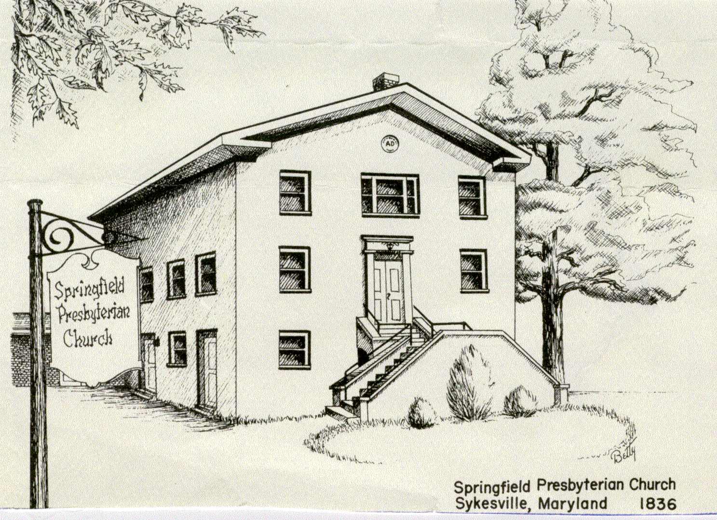

MARCH 27, 2022

WELCOME VISITORS!
We're glad you are here! Cards at the ends of each pew are for you to fill out and drop in the Offering Plate. Please let us know if you are visiting and join us for refreshments and fellowship following the service. The Sanctuary has an induction loop system to assist the hearing impaired. The system will also work on the telephone setting of hearing aids. A headset is available upon request.

Springfield Presbyterian Church is rooted in the gospel of Jesus Christ, led by the Holy Spirit, and called to loving relationships through vibrant worship and service. Valuing all people, we are committed to developing disciples and fostering stewardship.

PREPARATION FOR THE WORD
(*those who are able are invited to stand)

PRELUDE

Gathering of the People The Lord be with you! People: And also with you! [Greetings and Announcements]
LIGHTING THE CHRIST CANDLE
Leader: Whenever we light this candle we proclaim:
People: Christ is the Light of the world and center of our lives.
Call to Worship
Leader: God’s reach is endless
People: God’s mercy is unstoppable.
Leader: God’s grace is lavish.
People: God’s love is constant.
Leader: God’s wisdom is vast.
People: God’s hope is stubborn.
Leader: God’s presence is here –
People: It is with us, among us, moving through us.
Leader: Breathe easy. Breathe deeply.
People: We are in God’s house.
ALL: Let us worship the One who welcomes us home.

* Hymn Great is Thy Faithfulness #39

CALL TO CONFESSION
If you ask any parent with a teenager what it’s like to wait up for their child to meet curfew, they will tell you – they’re standing at the door. The porch light is on. No one can sleep until that child is home safe.
Friends, I think God is like that for us. The porch light is on. The door is unlocked. We might be late for curfew, but God is just so glad we’re home.
So let us pray the prayer of confession together, trusting that no matter what we do or what we leave undone, the porch light is always on. Let us pray…

PRAYER OF CONFESSION
Generous God, the prodigal son isn’t given a name, but we know his name. It sounds like ours. And we know his story. It sounds like ours. For whom among us hasn’t burned a bridge? Who among us hasn’t forgotten that we belong to one another? Who among us has not ached for home? The prodigal son isn’t given a name, but we know his name. Forgive us God. We want to come home.

SILENT PRAYERS OF CONFESSION

RESPONSE O Lord, Hear My Prayer (Sing two times) Tune #471
O Lord, hear my prayer. O Lord, hear my prayer. When I call, answer me; O Lord, hear my prayer, O Lord hear my prayer. Come and listen to me.

WORDS OF ASSURANCE
Leader: Family of faith, the word ‘prodigal’ can be defined as wasteful or imprudent, hence the name, “prodigal son.” However, ‘prodigal’ can also be described as extravagant and excessive. Friends, we worship a prodigal God – a God who is extravagant in mercy and excessive in grace. For no matter how many times we run, no matter how far we go or how lost we get, God is standing at the end of the driveway for us. The doors are open. The feast is for you. This grace is extravagant.
People: We are a forgiven people, ready to walk in the door. Thanks be to God.

*MUSICAL RESPONSE OF PRAISE Come, Thou Almighty King - #2 v. 4
To thee, great One in Three, eternal praises be, hence evermore!
Thy sovereign majesty may we in glory see, and to eternity love and adore.

* THE PEACE The peace of Christ be with you! And also with you! (You may greet those around you)

*RESPONSE Here I Am, Lord
Here I am, Lord, is it I, Lord? I have heard you calling in the night.
I will go, Lord, if you lead me. I will hold your people in my heart.

THE PROCLAMATION OF THE WORD

PRAYER OF ILLUMINATION
God of Open Doors, we often long to come home to you, to love, and to ourselves, but we aren’t always sure how to get there. We know that we need you, but the road back to you is heavy with distractions. So, we boldly ask you, reach into the chaos of our hearts and minds and make yourself known. Quiet everything but your Word for us today. Leave us awestruck. Drown out the distractions. Come as thunder or come as a still small voice. Turn on the light. Speak through these words. Find the parts of us that are lost. With hope and confidence, we pray, amen.

FIRST SCRIPTURE LESSON Psalm 32 OT page 479
¹Happy are those whose transgression is forgiven, whose sin is covered.
²Happy are those to whom the Lord imputes no iniquity, and in whose spirit there is no deceit.
³While I kept silence, my body wasted away through my groaning all day long.
⁴For day and night your hand was heavy upon me; my strength was dried up as by the heat of summer. Selah
⁵Then I acknowledged my sin to you, and I did not hide my iniquity; I said, “I will confess my transgressions to the Lord,” and you forgave the guilt of my sin. Selah
⁶Therefore let all who are faithful offer prayer to you; at a time of distress, the rush of mighty waters shall not reach them.
⁷You are a hiding place for me; you preserve me from trouble; you surround me with glad cries of deliverance. Selah
⁸I will instruct you and teach you the way you should go; I will counsel you with my eye upon you.
⁹Do not be like a horse or a mule, without understanding, whose temper must be curbed with bit and bridle, else it will not stay near you.
¹⁰Many are the torments of the wicked, but steadfast love surrounds those who trust in the Lord.
¹¹Be glad in the Lord and rejoice, O righteous, and shout for joy, all you upright in heart.
SECOND SCRIPTURE LESSON Luke 15:1-32 NT page 73
15Now all the tax collectors and sinners were coming near to listen to him. ²And the Pharisees and the scribes were grumbling and saying, “This fellow welcomes sinners and eats with them.” ³So he told them this parable: ⁴“Which one of you, having a hundred sheep and losing one of them, does not leave the ninety-nine in the wilderness and go after the one that is lost until he finds it? ⁵When he has found it, he lays it on his shoulders and rejoices. ⁶And when he comes home, he calls together his friends and neighbors, saying to them, ‘Rejoice with me, for I have found my sheep that was lost.’ ⁷Just so, I tell you, there will be more joy in heaven over one sinner who repents than over ninety-nine righteous persons who need no repentance. ⁸“Or what woman having ten silver coins, if she loses one of them, does not light a lamp, sweep the house, and search carefully until she finds it? ⁹When she has found it, she calls together her friends and neighbors, saying, ‘Rejoice with me, for I have found the coin that I had lost.’ ¹⁰Just so, I tell you, there is joy in the presence of the angels of God over one sinner who repents.”
¹¹Then Jesus said, “There was a man who had two sons. ¹²The younger of them said to his father, ‘Father, give me the share of the property that will belong to me.’ So he divided his property between them. ¹³A few days later the younger son gathered all he had and traveled to a distant country, and there he squandered his property in dissolute living. ¹⁴When he had spent everything, a severe famine took place throughout that country, and he began to be in need. ¹⁵So he went and hired himself out to one of the citizens of that country, who sent him to his fields to feed the pigs. ¹⁶He would gladly have filled himself with the pods that the pigs were eating; and no one gave him anything. ¹⁷But when he came to himself he said, ‘How many of my father’s hired hands have bread enough and to spare, but here I am dying of hunger! ¹⁸I will get up and go to my father, and I will say to him, “Father, I have sinned against heaven and before you; ¹⁹I am no longer worthy to be called your son; treat me like one of your hired hands.”’ ²⁰So he set off and went to his father. But while he was still far off, his father saw him and was filled with compassion; he ran and put his arms around him and kissed him. ²¹Then the son said to him, ‘Father, I have sinned against heaven and before you; I am no longer worthy to be called your son.’ ²²But the father said to his slaves, ‘Quickly, bring out a robe—the best one—and put it on him; put a ring on his finger and sandals on his feet. ²³And get the fatted calf and kill it, and let us eat and celebrate; ²⁴for this son of mine was dead and is alive again; he was lost and is found!’ And they began to celebrate. ²⁵“Now his elder son was in the field; and when he came and approached the house, he heard music and dancing. ²⁶He called one of the slaves and asked what was going on. ²⁷He replied, ‘Your brother has come, and your father has killed the fatted calf, because he has got him back safe and sound.’ ²⁸Then he became angry and refused to go in. His father came out and began to plead with him. ²⁹But he answered his father, ‘Listen! For all these years I have been working like a slave for you, and I have never disobeyed your command; yet you have never given me even a young goat so that I might celebrate with my friends. ³⁰But when this son of yours came back, who has devoured your property with prostitutes, you killed the fatted calf for him!’ ³¹Then the father said to him, ‘Son, you are always with me, and all that is mine is yours. ³²But we had to celebrate and rejoice, because this brother of yours was dead and has come to life; he was lost and has been found.’”
SERMON The Door Is Open – Rev. Becca Crate-Price

THE RESPONSE TO THE WORD
* HYMN God of Compassion, in Mercy Befriend Us #436

PASTORAL PRAYER & THE LORD’S PRAYER

ANTHEM Mercy Still Arr. Heather Sorenson

* HYMN Love Divine, All Loves Excelling #366

CHARGE AND BENEDICTION
Leader: As you leave this place, may we be awestruck by the beauty of this world.
People: May we laugh and may it be contagious
Leader: May we overflow with love for those around us.
People: May we be filled with hope and quick to point out joy.
Leader: In all of our living, and breathing, and being,
People: May we find ourselves full to the brim with the God’s Holy Spirit.
Leader: And may it change our lives,
People: In the name of the Beloved and Love itself – let us go in peace, full to the brim. Amen.

*UNISON AMEN

POSTLUDE

