(Large Print)

Springfield Presbyterian Church (USA)
7300 Spout Hill Road, Sykesville, MD 21784 410-795-6152

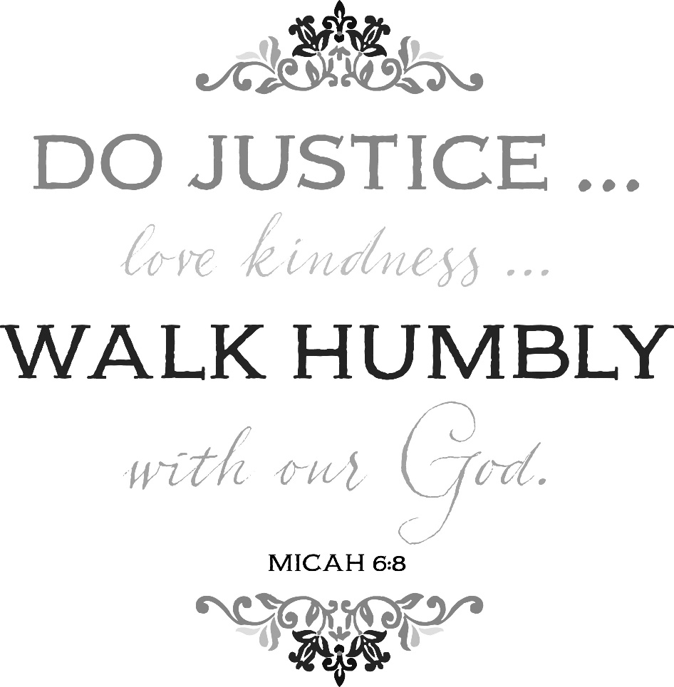

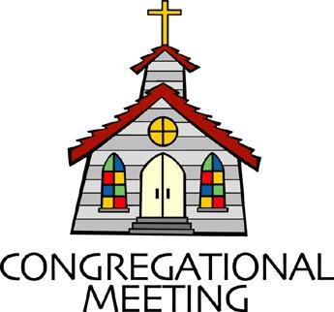
February 9, 2020 - 10:30 am

WELCOME VISITORS! We're glad you are here! Cards at the ends of each pew are for you to fill out and drop in the Offering Plate. Please let us know you are visiting, and join us for refreshments and fellowship following the service. The Sanctuary has an induction loop system to assist the hearing impaired. The system will also work on the telephone setting of hearing aids.

Springfield Presbyterian Church is rooted in the gospel of Jesus Christ, led by the Holy Spirit, and called to loving relationships through vibrant worship and service. Valuing all people, we are committed to developing disciples and fostering stewardship.
PREPARATION FOR THE WORD
(* those who are able are invited to stand)

PRELUDE

GATHERING OF THE PEOPLE

The Lord be with you! And also with you! (Greeting)

LIGHTING THE CHRIST CANDLE
Leader: Whenever we light this candle we proclaim:
People: Christ is the Light of the world and the center of our lives.

CALL TO WORSHIP [Psalm 146]
Leader: Praise the Lord! Praise the Lord, O our souls!
People: We will praise the Lord as long as we live; we will sing praises to our God all our life long.
Leader: We do not put our trust in princes, in mortals, in whom there is no help.
People: When their breath departs, they return to the earth; on that very day their plans perish.
Leader: Happy are those whose help is the God of Jacob, whose hope is in the Lord their God,
People: He made heaven and earth, the sea, and all that is in them; His faithfulness endures forever.
Leader: He executes justice for the oppressed and gives food to the hungry, He sets prisoners free;
People: He opens the eyes of the blind. He lifts up those who are bowed down and He loves the righteous.
Leader: The Lord watches over strangers; He upholds the orphan and the widow, but the way of the wicked He destroys.
People: The Lord will reign forever and ever, for all generations!
ALL: Let us praise the Lord!

* HYMN Here in This Place (Gather Us In)

Here in the place the new light is streaming; now is the darkness vanished away; see in this space our fears and our dreamings brought here to you in the light of this day.
Gather us in, the lost and forsaken; gather us in, the blind and the lame; call to us now, and we shall awaken; we shall arise at the sound of our name.

We are the young, our lives are a mystery. We are the old who yearn for your face. We have been sung throughout all of history, called to be light in the whole human race.
Gather us in, the rich and the haughty; gather us in, the proud and the strong; give us a heart, so meek and so lowly; give us the courage to enter the song.

Here we will take the wine and the water; here we will take the bread of new birth. Here you shall call your sons and your daughters, call us anew to be salt for the earth.
Give us to drink the wine of compassion; give us to eat the bread that is you; nourish us well, and teach us to fashion live that are holy and hearts that are true.

Not in the dark of buildings confining, not in some heaven, light years away: here in this place the new light is shining; now is the kingdom, and now is the day.
Gather us in and hold us forever; gather us in and make us your own; gather us in, all peoples together, fire of love in our flesh and our bone.

PRAYER OF CONFESSION
Gracious God, we confess that we have sinned against you in thought, word, and deed. We have sinned by what we have done

and left undone. We have not loved you with our whole heart and mind and strength. We have not loved our neighbors as ourselves. In your mercy forgive what we have been, help us amend what we are, and direct us to who we shall be. Forgive us, restore us, and renew us, by your grace and powerful love. Amen.

SILENT PRAYERS OF CONFESSION

RESPONSE Restore in Us, O God
Restore in us, O God, the splendor of your love;
Renew your image in our hearts, and all our sins remove.

WORDS OF ASSURANCE
Leader: Hear the good news! Who is in a position to condemn?
People: Only Christ, and Christ died for us, Christ rose for us, Christ reigns in power for us, and Christ prays for us.
Leader: Anyone who is in Christ is a new creation. The old life has gone; a new life has begun.
People: We are forgiven and we shall be at peace. Thanks be to God!

* MUSICAL RESPONSE OF PRAISE O for a Thousand Tongues
To God all glory, praise, and love be now and ever given
By saints below and saints above, the church in earth and heaven.

* THE PEACE The peace of Christ be with you! And also with you!
(You may greet those around you.)

* RESPONSE Here I Am, Lord
Here I am, Lord, Is it I, Lord? I have heard you calling in the night.
I will go, Lord, if you lead me. I will hold your people in my heart.

THE PROCLAMATION OF THE WORD

PRAYER OF ILLUMINATION
Leader: O Lord and our God, now as we hear your Word, fill us with your Spirit. Soften our hearts that we may delight in your presence. Sharpen our minds that we may discern your truth. Shape our wills that we may desire your ways, through Jesus Christ, our Lord. Amen.

FIRST SCRIPTURE LESSON Psalm 15
¹ O Lord, who may abide in your tent? Who may dwell on your holy hill? ² Those who walk blamelessly, and do what is right, and speak the truth from their heart; ³ who do not slander with their tongue, and do no evil to their friends, nor take up a reproach against their neighbors;
⁴ in whose eyes the wicked are despised, but who honor those who fear the Lord; who stand by their oath even to their hurt; ⁵ who do not lend money at interest, and do not take a bribe against the innocent.
Those who do these things shall never be moved.

SECOND SCRIPTURE LESSON Micah 6:1-8
Hear what the Lord says: Rise, plead your case before the mountains, and let the hills hear your voice. ² Hear, you mountains, the controversy of the Lord, and you enduring foundations of the earth; for the Lord has a controversy with his people, and he will contend with Israel.
³ ‘O my people, what have I done to you? In what have I wearied you? Answer me! ⁴ For I brought you up from the land of Egypt, and redeemed you from the house of slavery; and I sent before you Moses, Aaron, and Miriam. ⁵ O my people, remember now what King Balak of Moab devised, what Balaam son of Beor answered him, and what happened from Shittim to Gilgal, that you may know the saving acts of the Lord.’ ⁶ ‘With what shall I come before the Lord, and bow myself before God on high? Shall I come before him with burnt-offerings, with calves a year old? ⁷ Will the Lord be pleased with thousands of rams, with tens of thousands of rivers of oil? Shall I give my firstborn for my transgression, the fruit of my body for the sin of my soul?’ ⁸ He has told you, O mortal, what is good; and what does the Lord require of you
but to do justice, and to love kindness, and to walk humbly with your God?

Leader: Hear what the Spirit is saying to the Church.
All: Thanks be to God.

TIME WITH YOUNG PEOPLE

SERMON The Messiness of Justice, Kindness, and Humility Rev. Becca Crate

THE RESPONSE TO THE WORD

* HYMN Come and Seek the Ways of Wisdom
Come and seek the ways of Wisdom, she who danced when earth was new.
Follow closely what she teaches, for her words are right and true.
Wisdom clears the path to justice, showing us what love must do.

Listen to the voice of Wisdom, crying in the marketplace.
Hear the Word made flesh among us, full of glory, truth and grace.
When the word takes root and ripens, peace and righteousness embrace.

Sister Wisdom, come, assist us; nurture all who seek rebirth.
Spirit-guide and close companion, bring to light our sacred worth.
Free us to become your people, holy friends of God and earth.

PASTORAL PRAYER AND THE LORD’S PRAYER
“For this I pray to God.” / “For this I give thanks to God.”
Congregational Response: “Hear our prayer, O God.”

PRESENTATION OF TITHES AND OFFERINGS
OFFERTORY We Are Called By: Becki S. Mayo
* SONG OF THANKS God of the Fertile Fields
We would be stewards true, holding in trust from you all that you give;
Help us in love to share, teach us like you to care for people everywhere, that all may live.
* PRAYER OF DEDICATION

* HYMN Standing on the Promises
Standing on the promises of Christ my king,
Through eternal ages let his praises ring;
Glory in the highest, I will shout and sing,
Standing on the promises of God.

Refrain:
Standing, standing, standing on the promises of God my Savior;
Standing, standing, I’m standing on the promises of God.

Standing on the promises that cannot fail,
When the howling storms of doubt and fear assail,
By the living Word of God I shall prevail,
Standing on the promises of God. [Refrain]

Standing on the promises of Christ the Lord,
Bound to him eternally by love’s strong cord,
Overcoming daily with the Spirit’s sword,
Standing on the promises of God. [Refrain]

Standing on the promises I cannot fall,
Listening every moment to the Spirit’s call,
Resting in my Savior as my all in all,
Standing on the promises of God. [Refrain]

* CHARGE AND BENEDICTION
Leader: As we step into acts of justice,
People: Guide our feet with mercy.
Leader: As we pursue kindness,
People: May your love lead us on.
Leader: And as we live our humility,
People: Teach us every day how to live anew. Amen.

* UNISON AMEN

POSTLUDE

Assisting in Worship: We appreciate those who serve:

Today 2/9 Next Week 2/16
Sunday Opener Beth Oates Barbara Cornell
Greeters & Ushers Connie Gibbons & Don Vasbinder &
Cathy Marsh Charlie Sperling
Lay Leader Dylan Vasbinder Linda Black
Sunday School Connie Robinson Connie Robinson
Fellowship Linda Caviglia Barbara Cornell

Church Attendance: January 26 – 31 February 2 - 42

Church Cleaning: Feb. 21, 22 or 23 – Sandy & Ed Newsome

Happy Birthday! February 12 – Megan Anderson

Sunday February 16 Lectionary
Deuteronomy 30:15-20; Psalm 119:1-8; 1 Corinthians 3:1-9;
Matthew 5:21-37

Announcements

Congregational Meeting: There will be a Congregational Meeting TODAY immediately following Worship, where Session will present the 2020 budget and committees share their work done in 2019. We meet again in April to elect officers to be installed in June, and in November to approve Terms of Call for Pastor Becca.

No War with Iran – War Powers Webinar: The Presbyterian Office of Public Witness is co-hosting a webinar on February 13 from 1:00-2:30 pm that will delve into what happened between the US and Iran in January, why congressional War Powers are important, and what you can do to help end these wars! This webinar will be broadcast as a Facebook Live. Sign up at American Friends Service Committee’s Facebook page at https://www.facebook.com/events/207469833632258.

Heifer Donations: Thanks to your generous donations to the Heifer Project in 2019, we were able to purchase two goats for families in need. Goats provide milk, cheese and butter for nourishment, boost family income through sales of extra milk, and encourage better crop yields by creating fertilizer and clearing land.

Shrove Sunday Pancakes!!! No, you’re reading that right - Shrove Sunday, not Tuesday! On Sunday, February 23, we will celebrate Shrove Sunday with a pancake lunch/brunch in the Fellowship Room. We need volunteers to bring in griddles, pancake mix, syrup, etc., so please indicate what you’ll bring on the sign-up sheet downstairs.

Easter Flowers: Believe it or not, it’s time to place your Easter flower orders! Order forms and payment are due no later than February 23. Extra order forms are available in the Narthex.

Inclement Weather: If we feel the need to cancel Worship and Sunday School, there will be a message on the Church answering machine, as well as on Facebook. You may also receive an email with that information.

Coat Drive: Shepherd’s Staff is collecting new or gently used coats, hats, mittens, gloves and socks. Bring them (clean) to church and Julie Ballard will deliver them to Shepherd’s Staff throughout the winter.

Blessing Bags are in the Narthex. Please feel free to pick up a few. Handing one out to someone in need gives you a very real way to meet their immediate needs by providing them with some basic supplies.

Prayers & Thanksgivings

~ Prayers of comfort for the family of Phil Pobletts (Barbara and Jim Nickell’s nephew) who passed away on February 5.
~ Prayers of strength and healing for Elaine Cleland for health concerns.
~ Prayers for Catonsville Presbyterian Church from our Ministry Group.

The Congregational Care team wants to know what YOU or someone you know needs...a visit...a call...a meal. Please contact Diana Steppling or Connie Robinson. If you are in need of pastoral care, please contact Pastor Becca at 410-795-6152 or springfieldpastor@gmail.com.

Today:
Sunday February 9
10:30 am Worship
11:30 am Congregational Meeting (Sanctuary)
12:00 noon Fellowship
3:00 pm Concert – Eric Byrd Trio (Jazz)

This Week:
Monday February 10
7:00 pm Head Huggers (Manse)
Tuesday February 11
10:30 am Prayer Group (Manse)
Wednesday February 12
6:30 pm Bell Choir Practice
7:45 pm Adult Choir Practice

Looking Ahead:
Sunday February 16
9:00 am Red Sea Parting Practice
10:30 am Worship
11:30 am Fellowship
12:00 noon Social Justice Book Club Meeting (Library)
Monday February 17
9:30 am Feed My Sheep (Wesley Freedom)
4:30 pm C.I.A. Meeting (Manse)
Tuesday February 18
7:00 pm Mission/Outreach Committee Meeting (Manse)
Wednesday February 19
6:30 pm Bell Choir Practice
7:45 pm Adult Choir Practice
Friday February 21
7:00 pm Family Game Night (Fellowship Room)

Office Hours: Tuesday, Wednesday, Friday 9:00 am - 3:00 pm

Springfield Presbyterian Church

10:30 am Worship & Sunday School
11:30 am Fellowship
Website: www.springfield-church.org Church Office: 410-795-6152
Like us on Facebook: www.facebook.com/SpringfieldPresbyterianChurch
Pastor: Rev. Becca Crate
Email: springfieldpastor@gmail.com
Clerk of Session: Sharon Pappas
Minister of Music: Linda Caviglia
Accompanist: Aaron Thacker Organist: Jennifer Wise
Youth Group Coordinators: Charles & Deb Sperling
Sunday School Coordinator: Connie Robinson
Administrative Assistant: Donna Mazer
e-mail: spc.office@verizon.net

