(Large Print)

Springfield Presbyterian Church (USA)
7300 Spout Hill Road, Sykesville, MD 21784 410-795-6152

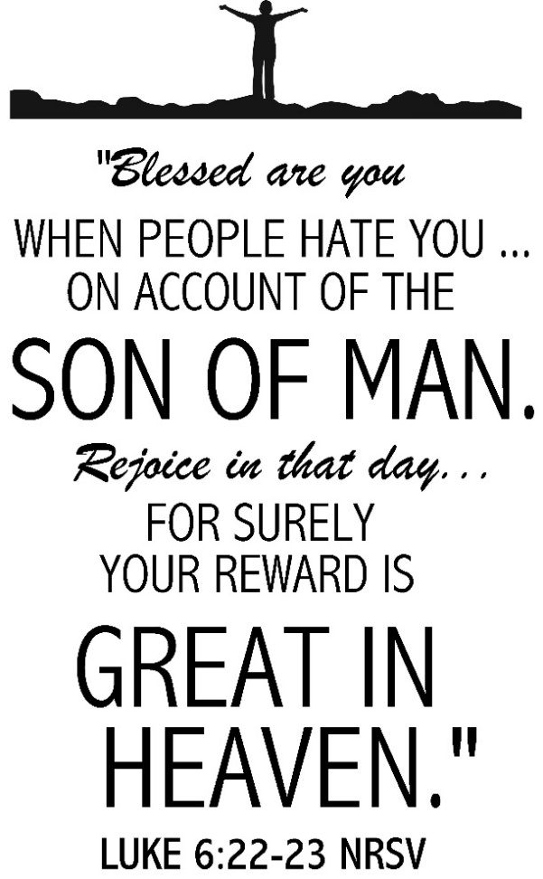

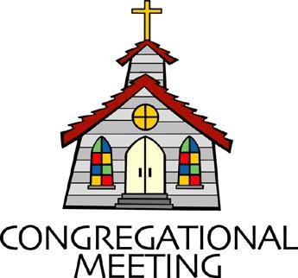
October 27, 2019 - 10:30 am

WELCOME VISITORS! We're glad you are here! Cards at the ends of each pew are for you to fill out and drop in the Offering Plate. Please let us know you are visiting, and join us for refreshments and fellowship following the service. The Sanctuary has an induction loop system to assist the hearing impaired. The system will also work on the telephone setting of hearing aids.

Springfield Presbyterian Church is rooted in the gospel of Jesus Christ, led by the Holy Spirit, and called to loving relationships through vibrant worship and service. Valuing all people, we are committed to developing disciples and fostering stewardship.
PREPARATION FOR THE WORD
(* those who are able are invited to stand)

PRELUDE

GATHERING OF THE PEOPLE

The Lord be with you! And also with you! (Greeting)

LIGHTING THE CHRIST CANDLE
Leader: Whenever we light this candle we proclaim:
People: Christ is the Light of the world and the center of our lives.

CALL TO WORSHIP
Leader: Creator God, you call us to this place,
People: To worship, to praise, to remember.
Leader: You invite us to hear your word and be challenged by it,
People: To sing your praises and find joy in fellowship.
Leader: As we remember the saints that have gone before us today,
People: Hold us in your merciful love.
Leader: Teach us those things that we should bring into our lives,
People: Your light throughout the ages.
Leader: Open us, guide us, lead us by your Spirit,
People: As we seek to worship you, Creator, Redeemer, Sustainer. Amen.

* HYMN I Sing a Song of the Saints of God
I sing a song of the saints of God, patient and brave and true,
Who toiled and fought and lived and died
For the Lord they loved and knew.
And one was a doctor, and one was a queen,
And one was a shepherdess on the green:
They were all of them saints of God, and I mean,
God helping, to be one too.

They loved their Lord so dear, so dear,
And God’s love made them strong;
And they followed the right, for Jesus’ sake,
The whole of their good lives long.
And one was a soldier, and one was a priest,
And one was slain by a fierce wild beast:
And there’s not any reason, no, not the least,
Why I shouldn’t be one too.

They lived not only in ages past; there are hundreds of thousands still;
The world is bright with the joyous saints who love to do Jesus’ will.
You can meet them in school, or in lanes, or at sea,
In church, or in trains, or in shops, or at tea;
For the saints of God are just folk like me, and I mean to be one too.

PRAYER OF CONFESSION
Eternal God, in every age you have raised up men and women to live and die in faith. We confess that we are indifferent to your will. You call us to proclaim your name, but we are silent. You call us to do what is just, but we remain idle. You call us to live faithfully, but we are afraid. In your mercy, forgive us. Give us courage to follow in your way, that joined with that from ages past, who have served you with faith, hope, and love, we may inherit the kingdom you promised in Jesus Christ. Amen.

SILENT PRAYERS OF CONFESSION

RESPONSE Just as I Am, without One Plea
Just as I am, thou wilt receive, wilt welcome, pardon, cleanse, relieve;
Because thy promise I believe, O Lamb of God, I come; I come!

WORDS OF ASSURANCE
Leader: Jesus said: Blessed are the merciful, for they will receive mercy.
People: In the name of Jesus Christ, we are forgiven! Alleluia, amen!

* MUSICAL RESPONSE OF PRAISE To God Be the Glory
Praise the Lord, praise the Lord; let the earth hear his voice!
Praise the Lord, praise the Lord; let the people rejoice!
O come to the Father through Jesus the Son,
And give him the glory: great things he has done!

* THE PEACE The peace of Christ be with you! And also with you!
(You may greet those around you.)

* RESPONSE Here I Am, Lord
Here I am, Lord, Is it I, Lord? I have heard you calling in the night.
I will go, Lord, if you lead me. I will hold your people in my heart.

THE PROCLAMATION OF THE WORD

PRAYER OF ILLUMINATION
Leader: Faithful God, how blessed are those who hunger and thirst for righteousness. Sanctify us by your Word and Spirit so that we may glorify you in the company of the faith; through Jesus Christ our Lord. Amen.

FIRST SCRIPTURE LESSON Psalm 149
¹ Praise the Lord! Sing to the Lord a new song, his praise in the assembly of the faithful. ² Let Israel be glad in its Maker; let the children of Zion rejoice in their King. ³ Let them praise his name with dancing, making melody to him with tambourine and lyre. ⁴ For the Lord takes pleasure in his people; he adorns the humble with victory. ⁵ Let the faithful exult in glory; let them sing for joy on their couches. ⁶ Let the high praises of God be in their throats and two-edged swords in their hands, ⁷ to execute vengeance on the nations and punishment on the peoples, ⁸ to bind their kings with fetters and their nobles with chains of iron, ⁹ to execute on them the judgement decreed. This is glory for all his faithful ones. Praise the Lord!

SECOND SCRIPTURE LESSON Luke 6:20-31
²⁰Then he looked up at his disciples and said: ‘Blessed are you who are poor, for yours is the kingdom of God. ²¹ ‘Blessed are you who are hungry now, for you will be filled. ‘Blessed are you who weep now, for you will laugh. ²² ‘Blessed are you when people hate you, and when they exclude you, revile you, and defame you on account of the Son of Man. ²³Rejoice on that day and leap for joy, for surely your reward is great in heaven; for that is what their ancestors did to the prophets.
²⁴ ‘But woe to you who are rich, for you have received your consolation.
²⁵ ‘Woe to you who are full now, for you will be hungry. ‘Woe to you who are laughing now, for you will mourn and weep. ²⁶ ‘Woe to you when all speak well of you, for that is what their ancestors did to the false prophets. ²⁷ ‘But I say to you that listen, Love your enemies, do good to those who hate you, ²⁸bless those who curse you, pray for those who abuse you. ²⁹If anyone strikes you on the cheek, offer the other also; and from anyone who takes away your coat do not withhold even your shirt. ³⁰Give to everyone who begs from you; and if anyone takes away your goods, do not ask for them again. ³¹Do to others as you would have them do to you.

Leader: Hear what the Spirit is saying to the Church.
All: Thanks be to God.

TIME WITH YOUNG PEOPLE

SERMON You Are the Result of the Love of Thousands Rev. Becca Crate
THE RESPONSE TO THE WORD

* HYMN For All the Saints

For all the saints who from their labors rest,
who thee by faith before the world confessed,
thy name, O Jesus, be forever blest. Alleluia! Alleluia!

Thou wast their rock, their fortress, and their might;
thou, Lord, their captain in the well-fought fight;
thou, in the darkness drear, their one true light. Alleluia! Alleluia!

O blest communion, fellowship divine!
We feebly struggle; they in glory shine;
yet all are one in thee, for all are thine. Alleluia! Alleluia!

And when the strife is fierce, the warfare long,
steals on the ear the distant triumph song,
and hearts are brave again, and arms are strong. Alleluia! Alleluia!

From earth's wide bounds, from ocean's farthest coast,
through gates of pearl streams in the countless host,
singing to Father, Son, and Holy Ghost, Alleluia! Alleluia!

A TIME TO REMEMBER
Leader: Let us give thanks to the Lord our God.
People: It is right to give our thanks and praise.
Leader: God of the ages, we praise you for all your servants, who have done justice, loved mercy, and walked humbly with their God. For apostles and martyrs and saints of every time and place, who in life and death have witnessed to your truth,
People: We praise you, O God.

Leader: For all your servants who have faithfully served you, witnessed bravely, and died in faith, who still are shining lights in the world,
People: We praise you, O God.
Leader: For those no longer remembered, who earnestly sought you in darkness, who held fast their faith in trial, and served others,
People: We praise you, O God.
Leader: For those we have known and loved, who by their faithful obedience and steadfast hope, have shown the same mind that was in Christ Jesus,
People: We praise you, O God.
Leader: Keep us grateful for their witness, and, like them, eager to follow in the way of Christ. Then at the last, bring us with them to share in the inheritance of the saints in light; through Jesus Christ the pioneer and perfecter of our faith, who lives and reigns with you and the Holy Spirit, one God, forever and ever.
ALL: Amen.

PASTORAL PRAYER AND THE LORD’S PRAYER
“For this I pray to God.” / “For this I give thanks to God.”
Congregational Response: “Hear our prayer, O God.”

PRESENTATION OF TITHES AND OFFERINGS
OFFERTORY Gather By the River to Pray Arr. Pepper Choplin
* SONG OF THANKS Lord of All Good Tune #711
Lord of all good, our gifts we bring to you; use them your holy purpose to fulfill, tokens of love and pledges brought anew, that our whole life is offered to your will.
* PRAYER OF DEDICATION

* HYMN Sing with All the Saints in Glory
Sing with all the saints in glory, sing the resurrection song!
Death and sorrow, earth’s dark story, to the former days belong.
All around the clouds are breaking, soon the storms of time shall cease;
In God’s likeness we, awaking, know the everlasting peace.

O what glory, far exceeding all that eye has yet perceived!
Holiest hearts, for ages pleading, never that full joy conceived.
God has promised, Christ prepares it, there on high our welcome waits.
Every humble spirit shares it; Christ has passed the eternal gates.

Life eternal! heaven rejoices: Jesus lives, who once was dead.
Join we now the deathless voices; Child of God, lift up your head!
Patriarchs from the distant ages, saints all longing for their heaven,
Prophets, psalmists, seers, and sages, all await the glory given.

Life eternal! O what wonders crowd on faith; what joy unknown,
When, amidst earth's closing thunders, saints shall stand before the throne!
Oh, to enter that bright portal, see that glowing firmament,
Know, with thee, O God immortal, Jesus Christ whom thou has sent!

* CHARGE AND BENEDICTION
Leader: We go out of this place and remember,
People: The voices of the people who shaped our faith.
Leader: With honor and integrity,
People: We continue to live out those values,
Leader: With joy and gratitude,
People: To carry their light and love - today, tomorrow, and forevermore.

* UNISON AMEN

POSTLUDE
Sunday November 3 Lectionary
Hab. 1:1-4; 2:1-4; Psalm 119:137-144; 2 Thessalonians 1:1-4, 11-12;
Luke 19:1-10

Assisting in Worship: We appreciate those who serve:

Today 10/27 Next Week 11/3
Sunday Opener Barbara Cornell Ron Holmes
Greeters & Ushers Don Vasbinder & Steve & Donna
Martha Streaker Mazer
Lay Leader Ron Holmes Bob Steppling
Sunday School Connie Robinson Connie Robinson
Fellowship Brittany & Danny Rachin

Church Attendance: October 13 – 33 October 20 - 30
Concert - 41

Church Cleaning: November 1, 2 or 3 – Jim & Mary Rhodes

Happy Birthday! October 27 – Amy Vasbinder
November 1 – Olivia Oates
November 3 – Brenda McClung

Announcements

All Saints’ Day: Today we will celebrate All Saints’ Day. During Worship, you will have the opportunity to come forward and place a carnation in a vase while saying the name of a loved one who has passed.

Stewardship Sunday is set for November 3. At this time, we will be accepting pledges for the next year. Immediately following the service, we will have a special home-made soup luncheon that is being coordinated with Fellowship. Please plan on joining us as we celebrate all that God has given us. Stewardship letters have been mailed. If you haven’t received one, please contact the church office or Bob Steppling (862-266-2240).

Called Meeting of the Congregation will be held on Sunday, November 10 immediately following Worship for the purpose of approving Terms of Call for Pastor Becca and election of 2020 Nominating Committee members.

Daylight Saving Time Ends: Don’t forget to “fall back” and change your clocks next weekend!

Children/Youth Activities: If your child/youth is participating in any activities this Fall, please let Connie Robinson know as we want to be part of the activity.

Blessing Bags are in the Narthex. Please feel free to pick up a few. Handing one out to someone in need gives you a very real way to meet their immediate needs by providing them with some basic supplies.

Weekly Announcements: If you have an announcement to include with next week’s bulletin, please call the Office at 410-795-6152 or email to spc.office@verizon.net by Wednesday each week.

Prayers & Thanksgivings

~ Prayers for Jennifer Wise and her family as they transition her father to a long-term care facility.
~ Prayers for Alan Pobletts’ brother Phil, who is hospitalized and awaiting a liver transplant.
~ Prayers for St. John United Church from our Ministry Group.

The Congregational Care team wants to know what YOU or someone you know needs...a visit...a call...a meal. Please contact Diana Steppling or Connie Robinson. If you are in need of pastoral care, please contact Pastor Becca at 410-795-6152 or springfieldpastor@gmail.com.

Today:
Sunday October 27 – All Saints’ Day Celebration
10:30 am Worship
11:30 am Fellowship
12:00 noon Worship Committee Meeting (Library)
6:00 pm Youth - Haunted Tour of Frederick

This Week:
Tuesday October 29
7:00 pm Mission Committee Meeting (Manse)
Saturday November 2
9:00 am Elders Retreat (Turf Valley Resort)

Looking Ahead:
Sunday November 3 – Stewardship Sunday
9:00 am Red Sea Parting Practice
10:30 am Worship
11:30 am Soup Luncheon
Monday November 4
4:30 pm C.I.A. Meeting (Manse)
Wednesday November 6
6:30 pm Bell Choir Practice
7:45 pm Adult Choir Practice
Saturday November 9
9:00 am Church/Manse Clean-Up

Office Hours: Tuesday, Wednesday, Friday 9:00 am - 3:00 pm

Springfield Presbyterian Church

10:30 am Worship & Sunday School
11:30 am Fellowship
Website: www.springfield-church.org Church Office: 410-795-6152
Like us on Facebook: www.facebook.com/SpringfieldPresbyterianChurch
Pastor: Rev. Becca Crate
Email: springfieldpastor@gmail.com
Clerk of Session: Sharon Pappas
Minister of Music: Linda Caviglia
Accompanist: Aaron Thacker Organist: Jennifer Wise
Youth Group Coordinators: Charles & Deb Sperling
Sunday School Coordinator: Connie Robinson
Administrative Assistant: Donna Mazer
e-mail: spc.office@verizon.net

