(Large Print)

Springfield Presbyterian Church (USA)
7300 Spout Hill Road, Sykesville, MD 21784 410-795-6152

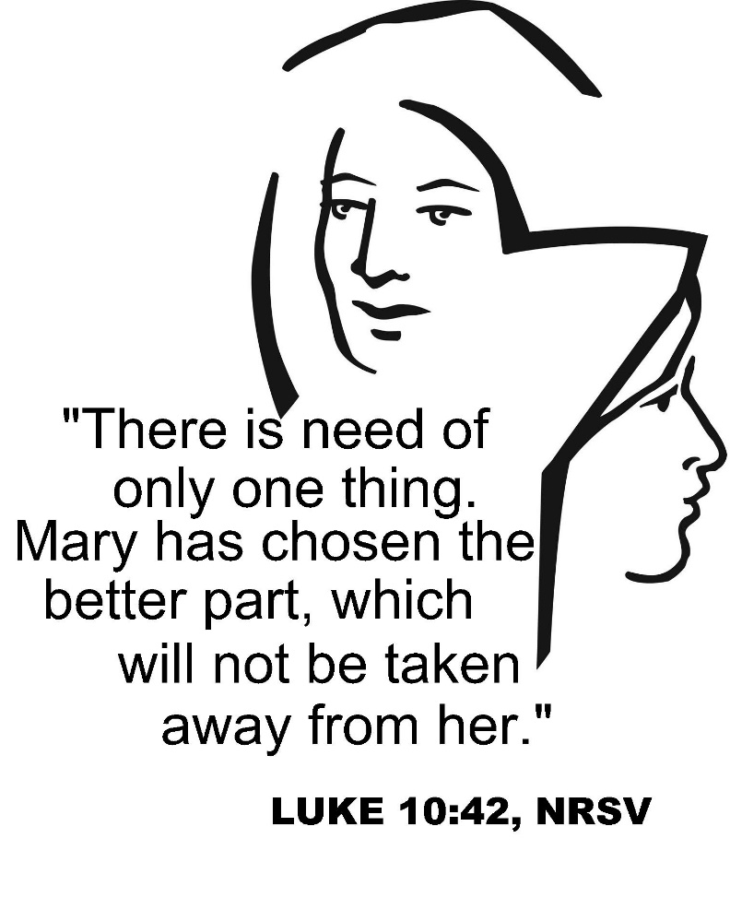

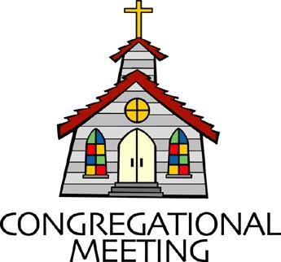
July 21, 2019 - 10:30 am

WELCOME VISITORS! We're glad you are here! Cards at the ends of each pew are for you to fill out and drop in the Offering Plate. Please let us know you are visiting, and join us for refreshments and fellowship following the service. The Sanctuary has an induction loop system to assist the hearing impaired. The system will also work on the telephone setting of hearing aids.

Springfield Presbyterian Church is rooted in the gospel of Jesus Christ, led by the Holy Spirit, and called to loving relationships through vibrant worship and service. Valuing all people, we are committed to developing disciples and fostering stewardship.
PREPARATION FOR THE WORD
(* those who are able are invited to stand)

PRELUDE

GATHERING OF THE PEOPLE

The Lord be with you! And also with you! (Greeting)

LIGHTING THE CHRIST CANDLE
Leader: Whenever we light this candle we proclaim:
People: Christ is the Light of the world and the center of our lives.

CALL TO WORSHIP
Leader: We gather this day from a week filled with needs and demands.
People: We come to find rest and renewal of our spirits.
Leader: Open your hearts in love to hear the voice of God.
People: We want to quietly rest in God’s presence, free from the clamor of the world.
Leader: This is the day that the Lord has made.
People: Let us rejoice and be glad in it. AMEN.

* HYMN I Sing the Mighty Power of God

I sing the mighty power of God that made the mountains rise,
That spread the flowing seas abroad and built the lofty skies.
I sing the wisdom that ordained the sun to rule the day.
The moon shines full at God's command, and all the stars obey.

I sing the goodness of the Lord who filled the earth with food.
God formed the creatures through the Word, and then pronounced them good.
Lord, how thy wonders are displayed, where'er I turn my eye,
If I survey the ground I tread, or gaze upon the sky!

There's not a plant or flower below but makes thy glories known.
And clouds arise, and tempests blow, by order from thy throne,
While all that borrows life from thee is ever in thy care,
And everywhere that we can be, thou, God, art present there.

CALL TO CONFESSION:
Leader: God sent Jesus Christ into the world not to condemn us, but to save us.
People: We confess in sorrow for our sin, but in the hope of God’s forgiveness.

PRAYER OF CONFESSION (Unison)
Patient Lord, we schedule our lives down to the very second. We crowd in as much activity as we can and then wonder why we are so stressed out and tired. We are afraid to miss out on anything. And when it comes time to be with others, we spend our time worrying about details rather than longing for the visit. Forgive us when we get so caught up in the details and miss the opportunity to sit at your feet, learning, listening, growing in our faith. Help us to place ourselves in your care. Slow us down, just a bit, so that we can see the wonders you have placed before us and truly enjoy and share the blessings you have given to us. For we ask this in Jesus’ name. AMEN.

SILENT PRAYERS OF CONFESSION

RESPONSE Remember Not, O God
O Lord, our Savior, help, and glorify your name;
Deliver us from all our sins and take away our shame.

ASSURANCE OF PARDON
Leader: Friends! You are anxious and troubled about many things; only one thing is needful.
People: May God help us to choose that one thing!
Leader: The Spirit is moving; God’s love is flowing. In Jesus Christ, we are forgiven.
People: Alleluia, and Amen!

* MUSICAL RESPONSE OF PRAISE Great Is Thy Faithfulness
Great is thy faithfulness! Great is thy faithfulness! Morning by morning new mercies I see. All I have needed thy hand hath provided. Great is thy faithfulness Lord unto me.

* THE PEACE The peace of Christ be with you! And also with you!
(You may greet those around you.)

* RESPONSE Here I Am, Lord
Here I am, Lord, Is it I, Lord? I have heard you calling in the night.
I will go, Lord, if you lead me. I will hold your people in my heart.

THE PROCLAMATION OF THE WORD

FIRST SCRIPTURE LESSON Colossians 1:15-28
¹⁵He is the image of the invisible God, the firstborn of all creation; ¹⁶for in him all things in heaven and on earth were created, things visible and invisible, whether thrones or dominions or rulers or powers—all things have been created through him and for him. ¹⁷He himself is before all things, and in him all things hold together. ¹⁸He is the head of the body, the church; he is the beginning, the firstborn from the dead, so that he might come to have first place in everything. ¹⁹For in him all the fullness of God was pleased to dwell, ²⁰and through him God was pleased to reconcile to himself all things, whether on earth or in heaven, by making peace through the blood of his cross. ²¹And you who were once estranged and hostile in mind, doing evil deeds, ²²he has now reconciled in his fleshly body through death, so as to present

you holy and blameless and irreproachable before him— ²³provided that you continue securely established and steadfast in the faith, without shifting from the hope promised by the gospel that you heard, which has been proclaimed to every creature under heaven. I, Paul, became a servant of this gospel. ²⁴I am now rejoicing in my sufferings for your sake, and in my flesh I am completing what is lacking in Christ’s afflictions for the sake of his body, that is, the church. ²⁵I became its servant according to God’s commission that was given to me for you, to make the word of God fully known, ²⁶the mystery that has been hidden throughout the ages and generations but has now been revealed to his saints. ²⁷To them God chose to make known how great among the Gentiles are the riches of the glory of this mystery, which is Christ in you, the hope of glory. ²⁸It is he whom we proclaim, warning everyone and teaching everyone in all wisdom, so that we may present everyone mature in Christ.

SECOND SCRIPTURE LESSON Luke 10:38-42
³⁸Now as they went on their way, he entered a certain village, where a woman named Martha welcomed him into her home. ³⁹She had a sister named Mary, who sat at the Lord’s feet and listened to what he was saying. ⁴⁰But Martha was distracted by her many tasks; so she came to him and asked, ‘Lord, do you not care that my sister has left me to do all the work by myself? Tell her then to help me.’ ⁴¹But the Lord answered her, ‘Martha, Martha, you are worried and distracted by many things; ⁴²there is need of only one thing. Mary has chosen the better part, which will not be taken away from her.’

Leader: Hear what the Spirit is saying to the Church.
All: Thanks be to God.

TIME WITH YOUNG PEOPLE

SERMON Distracted Rev. Jack Carlson

THE RESPONSE TO THE WORD

* HYMN Be Thou My Vision

Be thou my vision, O Lord of my heart;
Naught be all else to me, save that thou art;
Thou my best thought, by day or by night,
Waking or sleeping, thy presence my light.

Be thou my wisdom, and thou my true Word;
I ever with thee and thou with me, Lord;
Thou my soul’s shelter, and thou my high tower;
Raise thou me heavenward, O Power of my power.

Riches I heed not, nor vain, empty praise;
Thou, mine inheritance, now and always;
Thou and thou only, first in my heart,
High King of Heaven, my treasure thou art.

High King of Heaven, my victory won,
May I reach heaven’s joys, O bright heaven’s Sun!
Heart of my own heart, whatever befall,
Still be my vision, O Ruler of all.

PASTORAL PRAYER AND THE LORD’S PRAYER
“For this I pray to God.” / “For this I give thanks to God.”
Congregational Response: “Hear our prayer, O God.”

PRESENTATION OF TITHES AND OFFERINGS
OFFERTORY

* SONG OF THANKS As Those of Old Their Firstfruits Brought
In gratitude and humble trust we bring our best today,
To serve your cause and share your love with all along life’s way.
O God who gave yourself to us in Jesus Christ your Son,
Help us to give ourselves each day until life’s work is done.

* PRAYER OF DEDICATION
Leader: We are many different people, O God, united by our love for you and for the ministry of Jesus Christ. We bring our gifts from our many places and we combine them in a symbolic gesture of our unity and acceptance in you.
People: Consecrate these gifts we offer that they might sustain the weary, comfort the afflicted and extend your reign over all creation. Amen.

* HYMN Come! Live in the Light!

Come! Live in the light! Shine with the joy and the love of the Lord!
We are called to be light for the kingdom, to live in the freedom of the city of God.

Refrain:
We are called to act with justice; we are called to love tenderly;
We are called to serve one another, to walk humbly with God.

Come! Open your heart! Show your mercy to all those in fear!
We are called to be hope for the hopeless so hatred and violence will be no more. [Refrain]

Sing! Sing a new song! Sing of that great day when all will be one!
God will reign, and we’ll walk with each other as sisters and brother united in love. [Refrain]

* CHARGE AND BENEDICTION

* UNISON AMEN

POSTLUDE

Assisting in Worship: We appreciate those who serve:

Today 7/21 Next Week 7/28
Sunday Opener Ron Holmes Beth Oates
Greeters & Ushers Jim & Mary Cynthia Smith &
Rhodes Amy Vasbinder
Lay Leader Don Vasbinder Kathy Russ
Children’s Activity Connie Robinson Connie Robinson
Fellowship Barbara Cornell Connie Gibbons &
Cathy Marsh

Church Attendance: July 7 – 56 Concert – 26 July 14 - 37

Church Cleaning: July 26, 27 or 28 – Sandy & Ed Newsome

Happy Birthday! July 22 – Brian Spicer
July 24 – Becca Crate
July 26 – Stephanie Izaguirre

Sunday July 28 Lectionary
Hosea 1:2-10; Psalm 85; Colossians 2:6-15 (16-19); Luke 11:1-13
Announcements

We welcome the Rev. John V. “Jack” Carlson to our pulpit today! Rev. Carlson retired from active ministry in the PCUSA in January, 2016. Prior to his retirement, he served for 13 years as Pastor at Highland Presbyterian Church in Harford County, MD. Before that he served churches in Lockport, NY, and Hyattsville, MD, and was a pastoral counselor for more than 20 years in the Washington, DC area. After serving a term as Moderator of the Presbytery of Baltimore, in September of 2017 he was elected Stated Clerk of the Presbytery. He has published three books: The Spiritual Dimensions of Self-Esteem, The Spiritual Power of Communication, and The Disciple's Song, a poetic rendering of the Gospel of Mark. Jack is married to Lynn McCormick Carlson and has three grown children and three grandchildren.

Red Cross Blood Drive: Wesley Freedom United Methodist Church is hosting a Red Cross blood drive on August 10 from 7:30 am to 1pm at 961 Johnsville Road in Eldersburg.

Big Tent: Volunteers are still needed for Big Tent on August 1 – 3 in Baltimore. Big Tent is PCUSA’s 3-day conference featuring bible studies, learning opportunities, worship, workshops, and speakers from around the country. To learn more and sign up to help, go to http://oga.pcusa.org/section/big-tent-2019/volunteer-opportunities/ or email Sonce Reese at sonce.reese@pcusa.org.

Contribution Statements: Mid-year contribution statements are available in the Narthex for you to pick up.

Caregiving: If anyone needs help with caregiving or knows of someone who needs help, Jessica Lane is a certified caregiver and has plenty of references. She can be contacted at 443-789-7204.

Interested in trying out bell ringing? Linda Caviglia is starting introductory bell sessions TODAY and on August 4, and August 18, 9:15 to 10:00 am. There is a signup sheet on the bulletin board in the Narthex if you are interested (Fall 2019 going into 4th grade and up).

Summer Music for Worship: If you'd like to share some of your musical talents (all levels of accomplishment) over the summer while the choir and bell choir take a rest, we'd love to have you participate. There is a sign-up sheet in the Narthex for each Sunday over the summer. Please talk with Linda Caviglia about your thoughts/plans if you need Aaron to accompany you, or would like some other "backup" music.

Blessing Bags are in the Narthex. Please feel free to pick up a few. Handing one out to someone in need gives you a very real way to meet their immediate needs by providing them with some basic supplies.

Weekly Announcements: If you have an announcement to include with next week’s bulletin, please call the Office at 410-795-6152 or email to spc.office@verizon.net by Wednesday each week.

Prayers & Thanksgivings

~ Continued prayers of healing for Shona Klein who had surgery.
~ Prayers for St. John United from our Ministry Group.

The Congregational Care team wants to know what YOU or someone you know needs...a visit...a call...a meal. Please contact Diana Steppling or Connie Robinson.

Today:
Sunday July 21
10:30 am Worship
11:30 am Fellowship

Looking Ahead:
Sunday July 28
10:30 am Worship
11:30 am Fellowship

Office Hours: Tuesday, Wednesday, Friday 9:00 am - 3:00 pm

Springfield Presbyterian Church

10:30 am Worship
11:30 am Fellowship
Website: www.springfield-church.org Church Office: 410-795-6152
Like us on Facebook: www.facebook.com/SpringfieldPresbyterianChurch
Pastor: Rev. Becca Crate
Email: springfieldpastor@gmail.com
Clerk of Session: Sharon Pappas
Minister of Music: Linda Caviglia
Accompanist: Aaron Thacker Organist: Jennifer Wise
Youth Group Coordinators: Charles & Deb Sperling
Sunday School Coordinator: Connie Robinson
Administrative Assistant: Donna Mazer
e-mail: spc.office@verizon.net

