(Large Print)

Springfield Presbyterian Church (USA)
7300 Spout Hill Road, Sykesville, MD 21784 410-795-6152

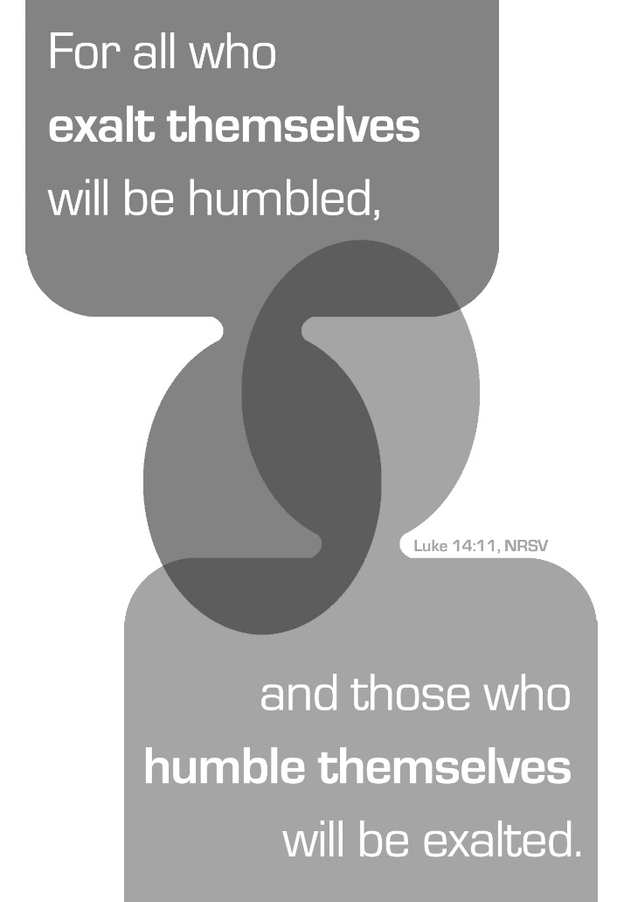

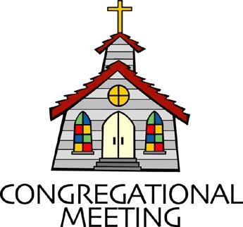
August 28, 2022 - 10:30 am

WELCOME VISITORS!
We're glad you are here! Cards at the ends of each pew are for you to fill out and drop in the Offering Plate. Please let us know you are visiting, and join us for refreshments and fellowship following the service. The Sanctuary has an induction loop system to assist the hearing impaired. The system will also work on the telephone setting of hearing aids.

Springfield Presbyterian Church is rooted in the gospel of Jesus Christ, led by the Holy Spirit, and called to loving relationships through vibrant worship and service. Valuing all people, we are committed to developing disciples and fostering stewardship.
PREPARATION FOR THE WORD
(* those who are able are invited to stand)

PRELUDE

GATHERING OF THE PEOPLE

The Lord be with you! And also with you! (Greeting)

LIGHTING THE CHRIST CANDLE
Leader: Whenever we light this candle we proclaim:
People: Christ is the Light of the world and the center of our lives.

CALL TO WORSHIP
Leader: You are the parent,
People: And we are your children.
Leader: As we progress on the path of Life,
People: May we develop in accordance with your principles and guidance.
Leader: Teach us to return to your path when we stray from it,
People: And help us to remember these errors so that we do not repeat them.
Leader: May your blessings guide us as we walk your path,
People: And grow in faith and humility. Amen.

* HYMN All Things Bright and Beautiful GTG #20

Refrain:
All things bright and beautiful, all creatures great and small,
All things wise and wonderful, the Lord God made them all.

Each little flower that opens, each little bird that sings,
God made their glowing colors; God made their tiny wings. [Refrain]

The purple-headed mountain, the river running by,
The sunset, and the morning that brightens up the sky: [Refrain]

The cold wind in the winter, the pleasant summer sun,
The ripe fruits in the garden, God made them every one. [Refrain]

God gave us eyes to see them, and lips that we might tell
How great is God Almighty, who has made all things well. [Refrain]

CALL TO CONFESSION
Leader: The Path of Life is not often a straight one and it is difficult to avoid stumbles and occasionally falls as we walk upon it. In your Word may we find the guidance that we need to maintain our balance, not be led astray, and provide an example that others may follow, profiting from our experience as well as their own.

PRAYER OF CONFESSION
Almighty God, you are the teacher and we are your students. Your lessons are simple, but not always easy to implement as we progress through a world that is full of easy answers, quick fixes, and false guidance. Enable our repentance, forgive us our sins, and return us to the Path of Righteousness. Amen.

SILENT PRAYERS OF CONFESSION

RESPONSE The Woman Hiding in the Crowd Tune #178
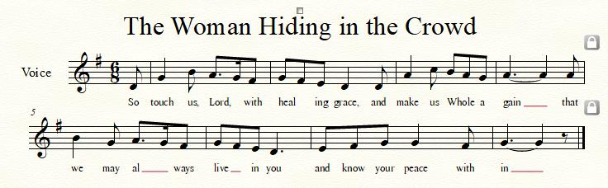

WORDS OF ASSURANCE [Hebrews 12: 1-2]
Leader: Let us also lay aside every weight and the sin that clings so closely, and let us run with perseverance the race that is set before us, ²looking to Jesus the pioneer and perfecter of our faith, who for the sake of the joy that was set before him endured the cross, disregarding its shame, and has taken his seat at the right hand of the throne of God.
People: Help us stay on your path, Lord, for by the Grace of Jesus Christ we are forgiven, forgiven indeed. Alleluia and amen!

* MUSICAL RESPONSE OF PRAISE O My Soul, Bless Your Redeemer
Bless your Maker, all you creatures, ever under God’s control,
All throughout God’s vast dominion; bless the Lord of all, my soul!

* THE PEACE The peace of Christ be with you! And also with you!
(You may greet those around you.)

* RESPONSE Here I Am, Lord
Here I am, Lord, Is it I, Lord? I have heard you calling in the night.
I will go, Lord, if you lead me. I will hold your people in my heart.

THE PROCLAMATION OF THE WORD

PRAYER OF ILLUMINATION
Lord, you are a lamp unto our feet and a light unto our lives, and your word guides us. Fill us with your Holy Spirit that we may appreciate these your gifts and use them to guide our lives, through Jesus Christ our Lord. Amen.

FIRST SCRIPTURE LESSON Ecclesiastes 3:1-8
For everything there is a season, and a time for every matter under heaven:
² a time to be born, and a time to die;
a time to plant, and a time to pluck up what is planted;
³ a time to kill, and a time to heal;
a time to break down, and a time to build up;
⁴ a time to weep, and a time to laugh;
a time to mourn, and a time to dance;
⁵ a time to throw away stones, and a time to gather stones together;
a time to embrace, and a time to refrain from embracing;
⁶ a time to seek, and a time to lose;
a time to keep, and a time to throw away;
⁷ a time to tear, and a time to sew;
a time to keep silence, and a time to speak;
⁸ a time to love, and a time to hate;
a time for war, and a time for peace.

SECOND SCRIPTURE LESSON Luke 14:7-11
⁷When he noticed how the guests chose the places of honor, he told them a parable. ⁸‘When you are invited by someone to a wedding banquet, do not sit down at the place of honor, in case someone more distinguished than you has been invited by your host; ⁹and the host who invited both of you may come and say to you, “Give this person your place”, and then in disgrace you would start to take the lowest place. ¹⁰But when you are invited, go and sit down at the lowest place, so that when your host comes, he may say to you, “Friend, move up higher”; then you will be honored in the presence of all who sit at the table with you. ¹¹For all who exalt themselves will be humbled, and those who humble themselves will be exalted.’

Leader: Hear what the Spirit is saying to the Church.
All: Thanks be to God.

SERMON The Vicissitudes of Life Mark Kearney

THE RESPONSE TO THE WORD

* HYMN For Everyone Born GTG #769

For everyone born, a place at the table,
for everyone born, clean water and bread,
a shelter, a space, a safe place for growing,
for everyone born, a star overhead,

Refrain:
And God will delight when we are creators of justice and joy, compassion and peace: yes, God will delight when we are creators
of justice, justice and joy!

For woman and man, a place at the table,
revising the roles, deciding the share,
with wisdom and grace, dividing the power,
for woman and man, a system that's fair, [Refrain]

For young and for old, a place at the table,
a voice to be heard, a part in the song,
the hands of a child in hands that are wrinkled,
for young and for old, the right to belong, [Refrain]

For just and unjust, a place at the table,
abuser, abused, with need to forgive,
in anger, in hurt, a mindset of mercy,
for just and unjust, a new way to live, [Refrain]

For everyone born, a place at the table,
to live without fear, and simply to be,
to work, to speak out, to witness and worship,
for everyone born, the right to be free, [Refrain]

PASTORAL PRAYER AND THE LORD’S PRAYER

OFFERTORY
SONG OF THANKS Praise God, from Whom All Blessings Flow Tune 606
Praise God, from whom all blessing flow; praise him, all creatures here below; praise him above, ye heavenly host; praise Father, Son and Holy Ghost. Amen.
PRAYER OF DEDICATION

* SPECIAL MESSAGE FOR TRAVELERS HYMN
Eternal Father, Strong to Save GTG #8
O Trinity of love and power, all travelers guard in danger’s hour;
From rock and tempest, fire and foe, protect them whereso-e’er they go;
Thus evermore shall rise to thee glad praise from air and land and sea.

* CHARGE AND BENEDICTION
Leader: Lord, as we depart from here,
People: Shine your light upon us.
Leader: Make it easier to see your path,
People: That we may follow your guidance with fewer stumbles,
Leader: And more easily avoid temptations.
People: In Jesus’ name we pray. Amen.

* UNISON AMEN

POSTLUDE

Sunday, September 4, 2022 Lectionary
Deuteronomy 30:15-20; Psalm 1; Philemon 1:1-21; Luke 14:25-33
Assisting in Worship: We appreciate those who serve:

Today 8/28 Next Week 9/4
Sunday Opener Barbara Cornell Beth Oates
Ushers/Greeters Tim & Beth Leah & Henry
Oates Halvorson
Lay Leader Sharon Pappas Tim Oates

Happy Birthday! August 28 – Bob Rogers
August 31 – Bridget Doyle

Announcements

SPC Adult Choir and Bell Choir: August is here and already going by quickly! I wanted to let everyone know what the plans are for choir and bell choir this year.

Choir practice will start on September 7th with a longer than normal rehearsal – starting at 6:30 and ending at 8:30. We will plan to sight read through much of the music planned for the fall and work on our first anthem to be sung on Sunday September 11th . During our 2 hours, we will take a 30 minute break for fellowship and refreshments. Hope you can all be there and will enjoy our time to start singing again!

The Presbytones Bell Choir will begin rehearsing on September 14th from 6:15 to 7:15 pm. Choir will follow from 7:30 to 8:45 pm.

Looking forward to seeing everyone! ~ Linda Caviglia

Summer Mission Project: It won’t be long before school starts again. Preparing for a new school year includes buying items on the STUDENT SUPPLY LIST. For some children and their families, this can be a challenge and in some instances buying needed supplies just isn’t possible. For that reason, during July and August, we will be collecting school supplies to help these children. The GIVING TREE is in the Narthex. If you would like to help with this project, you can take a tag from the tree and buy the item written on it or simply choose from the below items (taken from Sykesville Middle School STUDENT SUPPLY LIST). Please place your donated items in the designated basket in the Narthex. Thank you! ~ CoCaMO Committee

3-ring binders-1, 1 ½ or 2” Pencil pouch Glue sticks
Loose-leaf paper Pack of #2 pencils Pair of Ear Buds
Pack of 5-tab binder dividers Pocket folders Scissors
Blue, black or red pens Block or cap erasers Sticky notes
3X5 ruled index cards Dry erase markers Crayons
Folders with brads 10-pack colored pencils
Spiral notebook-200 pgs. Pencil sharpener
Multi-colored highlighters Composition book

Mask Update: Due to the uptick in COVID-19 cases, the Session has decided to strongly encourage masking and social distancing. Though it is not a mandate, we seek to love one another by keeping each other as safe as possible. Thank you for your help in this endeavor.

Sunday School is back! On the 1st and 3rd Sundays of the month, we will be offering Sunday School! See Pastor Becca for details…

Pastor-Parish Committee: The Pastor-Parish Committee invites you to share your concerns, suggestions, and gratitude. We have a form in the Narthex and a lock-box that we will open weekly and we ask that you share your name and be specific. We look forward to reading your comments so that we can continue to grow into the body of Christ.

Springfield Membership: Are you interested in finding out more about our faith community and becoming a member? We would love to answer any questions you have. Please contact Pastor Becca at springfieldpastor@gmail.com for more information.

Congregational Care / Mission & Outreach: Do you know of a member or friend of our church family who is ill, needs prayers, would like call, a visit or a card, or might benefit from meal train? If so, please contact the Church Office (410-795-6152), Cathy Marsh (410-549-6916) or Diana Steppling (862-266-2242).

Fellowship Help Needed: If you are interested in helping with Fellowship, please contact Barbara Cornell (240-308-0035). A sign-up sheet will also be available.

Today:
Sunday August 28
10:30 am Worship
11:30 am Fellowship

Looking Ahead:
Sunday September 4
10:30 am Worship
11:30 am Fellowship
Wednesday September 7
6:30 – 8:30 pm Adult Choir Practice
Thursday September 8
7:00 pm Session Meeting (Manse)

Office Hours: Tuesday, Wednesday & Friday
Springfield Presbyterian Church

10:30 am Worship
11:30 am Fellowship
Website: www.springfield-church.org Church Office: 410-795-6152
Like us on Facebook: www.facebook.com/SpringfieldPresbyterianChurch
Pastor: Rev. Becca Crate-Price
Email: springfieldpastor@gmail.com
Clerk of Session: Sharon Pappas
Minister of Music: Linda Caviglia
Accompanist/Organist: Aaron Thacker
Youth Group Coordinator: Dylan Vasbinder
Administrative Assistant: Donna Mazer e-mail: spc.office@verizon.net

