(Large Print)

Springfield Presbyterian Church (USA)
7300 Spout Hill Road, Sykesville, MD 21784 410-795-6152

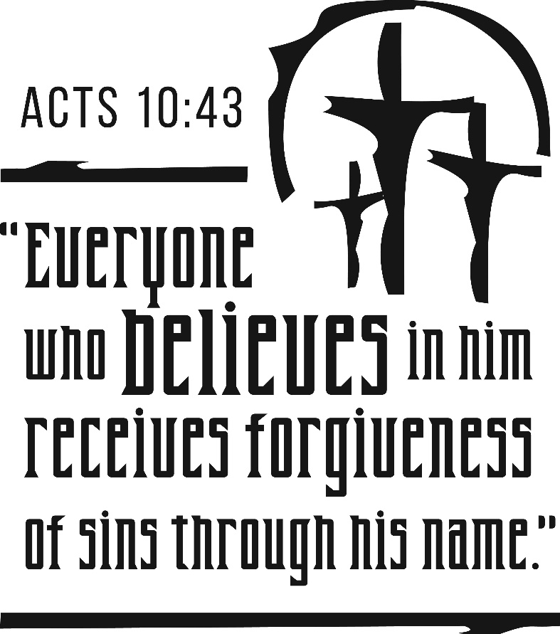

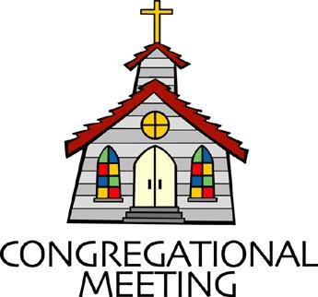
October 30, 2022 - 10:30 am

WELCOME VISITORS!
We're glad you are here! Cards at the ends of each pew are for you to fill out and drop in the Offering Plate. Please let us know you are visiting, and join us for refreshments and fellowship following the service. The Sanctuary has an induction loop system to assist the hearing impaired. The system will also work on the telephone setting of hearing aids.

Springfield Presbyterian Church is rooted in the gospel of Jesus Christ, led by the Holy Spirit, and called to loving relationships through vibrant worship and service. Valuing all people, we are committed to developing disciples and fostering stewardship.
PREPARATION FOR THE WORD
(* those who are able are invited to stand)

PRELUDE

GATHERING OF THE PEOPLE

The Lord be with you! And also with you! (Greeting)

LIGHTING THE CHRIST CANDLE
Leader: Whenever we light this candle we proclaim:
People: Christ is the Light of the world and the center of our lives.

INTROIT Morning Has Broken Gwen Yeager, Cymbells

CALL TO WORSHIP
Leader: In the last eight weeks, we have asked important questions of ourselves and one another.
People: We have opened our hearts, minds, and spirits to curiosity and vulnerability.
Leader: We have asked, “Where do you come from?”
People: We celebrated the diversity and unity among us.
Leader: We have asked, “Where does it hurt?”
People: We acknowledged the pain that resounds and have sought to be Christ to one another.
Leader: We have asked, “What do you need?”
People: We know that where one may be in need, another may be able to provide.
Leader: As we end this series, the question, “Where do we go from here?” leads us on.
People: It leads us to continue the conversation and reflect Christ’s kingdom on Earth.
Leader: So let us enter this space of worship, asking the Holy Spirit to reign over us, for Christ’s light to guide us, and for God’s covenantal love to be present within us and around us.
People: Let us worship our Sovereign God.

* HYMN There’s a Wideness in God’s Mercy GTG #435
There’s a wideness in God’s mercy, like the wideness of the sea.
There’s a kindness in God’s justice, which is more than liberty.
There is no place where earth’s sorrows are more felt that up in heaven.
There is no place where earth’s failings have such kindly judgment given.

For the love of God is broader than the measures of the mind.
And the heart of the Eternal is most wonderfully kind.
If our love were but more faithful, we would gladly trust God’s Word,
And our lives reflect thanksgiving for the goodness of our Lord.

CALL TO CONFESSION
Leader: This time together in this series has been one of growth, but I must admit, it is hard to answer the last question, “Where do we go from here?” Where do we even start? I know that I do not stand alone in wondering how we let these questions and other questions that arise become part of our practice of Christian life together. The blessing is, that as we come to admit our sin before God, the Spirit will take over and lead us together. With that abiding trust, let us confess our sins together…

PRAYER OF CONFESSION
Generous God, it would be easy to close this chapter and not look back on the questions that have been asked and answered these last eight weeks. It is tempting, in fact, to stay in our comfort zones and to avoid vulnerability. As we feel ourselves drifting,

forgive us and lead us back. Bring us back to this space, help us to commit to the continued work, and forgive us for our human inclination to not carry Sunday worship beyond these doors. Restore us, renew us, reclaim us as your people, O Lord we pray. Amen.

SILENT PRAYERS OF CONFESSION

RESPONSE Hear My Prayer, O God Tune #782
Hear my prayer, O God, and listen to my plea;
Faithful, righteous One, give ear and answer me.
Judge me not, I pray; no merit dare I claim;
Knowing my own faults, I trust in your just Name.

WORDS OF ASSURANCE
Leader: The blessing of authentic confession is that once we name the sin, it has been let go of and peace can be found. In that peace, God forgives us and renews us once again to be in right relationship with God and one another.
People: Thanks be to God for this abundant grace and forgiveness. Alleluia and amen!

* MUSICAL RESPONSE OF PRAISE O My Soul, Bless Your Redeemer
Bless your Maker, all you creatures, ever under God’s control,
All throughout God’s vast dominion; bless the Lord of all, my soul!

* THE PEACE The peace of Christ be with you! And also with you!
(You may greet those around you.)

* RESPONSE Here I Am, Lord
Here I am, Lord, Is it I, Lord? I have heard you calling in the night.
I will go, Lord, if you lead me. I will hold your people in my heart.

THE PROCLAMATION OF THE WORD

PRAYER OF ILLUMINATION
Loving God, by the power of your Spirit, remove any obstacle from our path and reveal your Word to us. Teach us how your Word meets the world and our lives. In Jesus Christ we pray, amen.

FIRST SCRIPTURE LESSON Acts 10:10-33
¹⁰He became hungry and wanted something to eat; and while it was being prepared, he fell into a trance. ¹¹He saw the heaven opened and something like a large sheet coming down, being lowered to the ground by its four corners. ¹²In it were all kinds of four-footed creatures and reptiles and birds of the air. ¹³Then he heard a voice saying, ‘Get up, Peter; kill and eat.’ ¹⁴But Peter said, ‘By no means, Lord; for I have never eaten anything that is profane or unclean.’ ¹⁵The voice said to him again, a second time, ‘What God has made clean, you must not call profane.’ ¹⁶This happened three times, and the thing was suddenly taken up to heaven. ¹⁷Now while Peter was greatly puzzled about what to make of the vision that he had seen, suddenly the men sent by Cornelius appeared. They were asking for Simon’s house and were standing by the gate. ¹⁸They called out to ask whether Simon, who was called Peter, was staying there. ¹⁹While Peter was still thinking about the vision, the Spirit said to him, ‘Look, three men are searching for you. ²⁰Now get up, go down, and go with them without hesitation; for I have sent them.’ ²¹So Peter went down to the men and said, ‘I am the one you are looking for; what is the reason for your coming?’ ²²They answered, ‘Cornelius, a centurion, an upright and God-fearing man, who is well spoken of by the whole Jewish nation, was directed by a holy angel to send for you to come to his house and to hear what you have to say.’ ²³So Peter invited them in and gave them lodging.
The next day he got up and went with them, and some of the believers from Joppa accompanied him. ²⁴The following day they came to Caesarea. Cornelius was expecting them and had called together his relatives and close friends. ²⁵On Peter’s arrival Cornelius met him, and falling at his feet, worshipped him. ²⁶But Peter made him get up, saying, ‘Stand up; I am only a mortal.’ ²⁷And as he talked with him, he went in and found that many had assembled; ²⁸and he said to them, ‘You yourselves know that it is unlawful for a Jew to associate with or to visit a Gentile; but God has shown me that I should not call anyone profane or unclean. ²⁹So when I was sent for, I came without objection. Now may I ask why you sent for me?’ ³⁰Cornelius replied, ‘Four days ago at this very hour, at three o’clock, I was praying in my house when suddenly a man in dazzling clothes stood before me. ³¹He said, “Cornelius, your prayer has been heard and your alms have been remembered before God. ³²Send therefore to Joppa and ask for Simon, who is called Peter; he is staying in the home of Simon, a tanner, by the sea.” ³³Therefore I sent for you immediately, and you have been kind enough to come. So now all of us are here in the presence of God to listen to all that the Lord has commanded you to say.’

SECOND SCRIPTURE LESSON Acts 10:34-48
³⁴Then Peter began to speak to them: ‘I truly understand that God shows no partiality, ³⁵but in every nation anyone who fears him and does what is right is acceptable to him. ³⁶You know the message he sent to the people of Israel, preaching peace by Jesus Christ—he is Lord of all. ³⁷That message spread throughout Judea, beginning in Galilee after the baptism that John announced: ³⁸how God anointed Jesus of Nazareth with the Holy Spirit and with power; how he went about doing good and healing all who were oppressed by the devil, for God was with him. ³⁹We are witnesses to all that he did both in Judea and in Jerusalem. They put him to death by hanging him on a tree; ⁴⁰but God raised him on the third day and allowed him to appear, ⁴¹not to all the people but to us who were chosen by God as witnesses, and who ate and drank with him after he rose from the dead. ⁴²He commanded us to preach to the people and to testify that he is the one ordained by God as judge of the living and the dead. ⁴³All the prophets testify about him that everyone who believes in him receives forgiveness of sins through his name.’ ⁴⁴While Peter was still speaking, the Holy Spirit fell upon all who heard the word. ⁴⁵The circumcised believers who had come with Peter were astounded that the gift of the Holy Spirit had been poured out even on the Gentiles, ⁴⁶for they heard them speaking in tongues and extolling God. Then Peter said, ⁴⁷‘Can anyone withhold the water for baptizing these people who have received the Holy Spirit just as we have?’ ⁴⁸So he ordered them to be baptized in the name of Jesus Christ. Then they invited him to stay for several days.

Leader: Hear what the Spirit is saying to the Church.
All: Thanks be to God.

SERMON Staying Curious Rev. Becca Price

THE RESPONSE TO THE WORD

* HYMN No Longer Tune #49
No longer Jew or Greek, no longer slave or free —
In you, O Christ, we're given wondrous unity.
Here in your church we learn that nothing can divide;
Here men and women, called by God, serve side by side.

No longer in your church should there be rich or poor —
You taught us kingdom values worth our struggling for.
Here some have wealth to give, and some, great faith to share.
The life we live together is an answered prayer.

No longer left or right, defending our own case —
O God, we're sinners in your sight, in need of grace.
The common bond we know is Christ who sets us free;
In Christ we live and love and grow in unity.

O God, we look around and know (each one) our guilt;
By your own Spirit, now break down the walls we've built.
When we were all baptized, we died to our old ways;
A church diverse, yet one in Christ, we give you praise.

Biblical Reference: Galatians 3:23-29
Tune: Traditional Hebrew Melody ("The God of Abraham Praise") (MIDI)
Text: Copyright © 2005 by Carolyn Winfrey Gillette. All rights reserved.
ALL SAINTS’ DAY

Prayer of Thanksgiving

Leader: Let us give thanks to the Lord our God.

People: It is right to give our thanks and praise.

Leader: God of the ages, we praise you for all your servants, who have done justice, loved mercy, and walked humbly with their God. For apostles and martyrs and saints of every time and place, who in life and death have witnessed to your truth.

People: We praise you, O God.

Leader: For all your servants who have faithfully served you, witnessed bravely, and died in faith, who still are shining lights in the world,

People: We praise you, O God.

Leader: For those no longer remembered, who earnestly sought you in darkness, who held fast their faith in trial, and served others,

People: We praise you, O God.
Leader: For those we have known and loved, who by their faithful obedience and steadfast hope, have shown the same mind that was in Christ Jesus,

People: We praise you, O God.

Leader: Keep us grateful for their witness, and, like them, eager to follow in the way of Christ. Then at the last, bring us to them to share in the inheritance of the saints in light; through Jesus Christ the pioneer and perfector of our faith, who lives and reigns with you and the Holy Spirit, one God, forever and ever.

All: Amen.

The Saints in Our Presence (Exploration of three panels)

The Placing of the Carnations

PASTORAL PRAYER AND OUR LORD’S PRAYER

OFFERTORY Christ, We See You by Ken Medema
SONG OF THANKS Great God of Every Blessing Tune #694
Great God of every blessing, of faithful, loving care,
You are the fount of goodness, the daily bread we share.
How can we hope to thank you? Our praise is but a start:
Sincerely and completely I offer you my heart.
PRAYER OF DEDICATION

* HYMN Lord, Speak to Me That I May Speak GTG #722

Lord, speak to me that I may speak in living echoes of your tone.
As you have sought, so let me seek your erring children, lost and lone.

O lead me, Lord, that I may lead the wandering and the wavering feet.
O feed me, Lord, that I may feed your hungering ones with manna sweet.

O teach me, Lord, that I may teach the precious truths which you impart.
And wing my words that they may reach the hidden depths of many a heart.

O fill me with your fullness, Lord, until my very heart o'erflow
in kindling thought and glowing word, your love to tell, your praise to show.

O use me, Lord, use even me, just as you will, and when, and where
until your blessed face I see, your rest, your joy, your glory share.

* CHARGE AND BENEDICTION
Leader: As you leave this place, may God grant us,
People: The curiosity to counter assumptions,
Leader: The vulnerability to befriend,
People: The bravery to speak your truth,
Leader: The wisdom to listen,
People: The strength to ask for help,
Leader: The resiliency to choose love, even when it’s hard,
People: And the awareness of the Holy Spirit always beside us.
Leader: In the name of our Great God, who is Love itself, may you go in peace.

* UNISON AMEN

POSTLUDE

Sunday, November 6, 2022 Lectionary
Job 19:23-27a; Psalm 17:1-9; 2 Thessalonians 2:1-5, 13-17;
Luke 20:27-38
Assisting in Worship: We appreciate those who serve:

Today 10/30 Next Week 11/6
Sunday Opener Beth Oates Ron Holmes
Ushers/Greeters Steve & Donna Elizabeth Meirowitz
Mazer Beth Oates
Lay Leader Bob Steppling Diana Steppling

Happy Birthday! November 1 – Olivia Oates
November 2 – Omar Izaguirre
November 3 – Brenda McClung

Happy Anniversary! November 4 – Alex & Brenda McClung

Announcements

All Saints’ Day: As a community of faith, we will have the opportunity to celebrate and remember the saints that came before us; in particular, the ones who have touched our lives. During worship TODAY, there will be a time for reflection and naming those who have passed on.

Noisy Offering: The final Noisy Offering of the year will be received
TODAY. The money collected will be sent to HAPPY THON, a local Christmas event for underserved children and families in the Sykesville area. So, bring your change and let’s make some noise and a difference!

Fall Clean-Up: Please join us on Saturday, November 5 from 9-11 am for our fall clean-up around the Church and Manse grounds. See Carl Anderson or Sharon Pappas for more information.

Giving Thanks Potluck: November is a month of giving thanks. We may gather with family and friends around a Thanksgiving table at the end of the month, but we have another opportunity as well. On November 6, Springfield will celebrate our annual “Giving Thanks Potluck Lunch” after worship. We invite you to sign up and bring your favorite dish to share, pitch in with rolls, or chips, or just bring yourselves and your family. Signing up will show us how many tables to set up and what gaps we need to fill, but please come anyway. November 6 is also Stewardship Sunday, another opportunity to give thanks through giving. And don't forget to change your clocks back--you'll have an extra hour to prepare for the lunch!

Called Congregational Meeting: Our called congregational meeting is immediately following worship on Sunday, November 13. We will vote on Pastor Becca's Terms of Call for 2023. We will also elect new members to the nominating committee for work next year putting together a slate of three elders for election in April. Copies of the Terms of Call will be available that Sunday and Zoomers will also be able to see the document.

Mask Update: Since COVID-19 is still with us, the Session has decided that masking and social distancing is encouraged but is optional. Though it is not a mandate, we seek to love one another by keeping each other as safe as possible. Thank you for your help in this endeavor.

Christian Education: Our Time and Talents survey shows folks are interested in an adult bible study program, and Alex McClung is interested in leading a study group. We imagine meeting 2x/month before church, but content, format, and timing are all TBD. Please contact Alex with your suggestions, interests, and best times: akmcclungiii@gmail.com.

Pastor-Parish Committee: The Pastor-Parish Committee invites you to share your concerns, suggestions, and gratitude. We have a form in the Narthex and a lock-box that we will open weekly and we ask that you share your name and be specific. We look forward to reading your comments so that we can continue to grow into the body of Christ.

Springfield Membership: Are you interested in finding out more about our faith community and becoming a member? We would love to answer any questions you have. Please contact Pastor Becca at springfieldpastor@gmail.com for more information.

Congregational Care / Mission & Outreach (CoCaMO): Do you know of a member or friend of our church family who is ill, needs prayers, would like call, a visit or a card, or might benefit from meal train? If so, please contact the Church Office (410-795-6152), Cathy Marsh (410-549-6916) or Diana Steppling (862-266-2242).

Prayers & Thanksgivings
~ Continued prayers for Sue Holmes’ mom, Betty Martlew, who fell and broke her hip and is recovering.
Today:
Sunday October 30 – All Saints’ Day
10:30 am Worship
11:30 am Fellowship
12:00 noon Worship Committee Meeting

This Week:
Wednesday November 2
6:15 – 7:15 pm Bell Choir Practice
7:30 – 8:45 pm Adult Choir Practice
Saturday November 5
9:00 – 11:00 am Clean Up

Looking Ahead:
Sunday November 6 – Stewardship Sunday
10:30 am Worship
11:30 am Potluck Lunch
Monday November 7
7:00 pm HeadHuggers (Manse)
Tuesday November 8
7:00 pm CoCaMO Meeting (Manse)
Wednesday November 9
6:15 – 7:15 pm Bell Choir Practice
7:30 – 8:45 pm Adult Choir Practice
Thursday November 10
7:00 pm Session Meeting (Manse)

Office Hours: Tuesday, Wednesday & Friday
Springfield Presbyterian Church

10:30 am Worship
11:30 am Fellowship
Website: www.springfield-church.org Church Office: 410-795-6152
Like us on Facebook: www.facebook.com/SpringfieldPresbyterianChurch
Pastor: Rev. Becca Price
Email: springfieldpastor@gmail.com
Clerk of Session: Sharon Pappas
Minister of Music: Linda Caviglia
Accompanist/Organist: Aaron Thacker
Youth Group Coordinator: Dylan Vasbinder
Administrative Assistant: Donna Mazer e-mail: spc.office@verizon.net

