(Large Print)

Springfield Presbyterian Church (USA)
7300 Spout Hill Road, Sykesville, MD 21784 410-795-6152

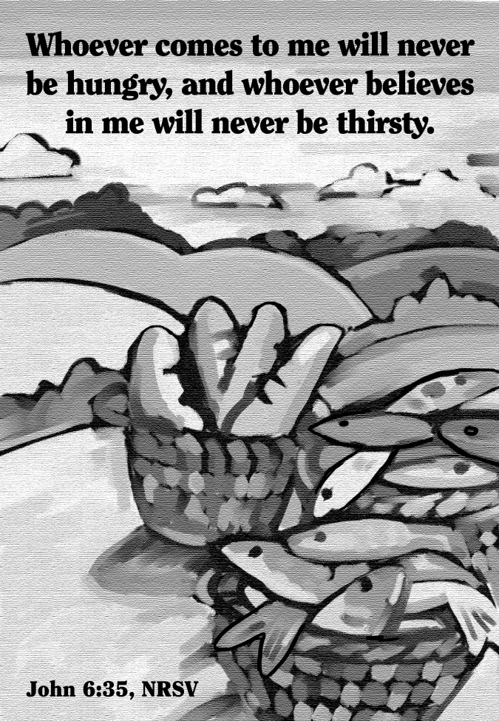

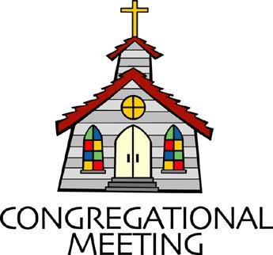
August 1, 2021 - 10:30 am

WELCOME VISITORS! We're glad you are here! Cards at the ends of each pew are for you to fill out and drop in the Offering Plate. Please let us know you are visiting, and join us for refreshments and fellowship following the service. The Sanctuary has an induction loop system to assist the hearing impaired. The system will also work on the telephone setting of hearing aids.

Springfield Presbyterian Church is rooted in the gospel of Jesus Christ, led by the Holy Spirit, and called to loving relationships through vibrant worship and service. Valuing all people, we are committed to developing disciples and fostering stewardship.
PREPARATION FOR THE WORD
(* those who are able are invited to stand)

PRELUDE

GATHERING OF THE PEOPLE

The Lord be with you! And also with you! (Greeting)

LIGHTING THE CHRIST CANDLE
Leader: Whenever we light this candle we proclaim:
People: Christ is the Light of the world and the center of our lives.

CALL TO WORSHIP [Psalm 78:23-29]
Leader: God commanded the skies above and opened the doors of heaven.
People: He gave them manna to eat, the grain of heaven.
Leader: Mortals ate the bread of angels; He sent them food in abundance.
People: He caused the east wind to blow in the heavens and by His power He led out the south wind;
Leader: He rained flesh upon them like dust, winged birds like the sand of the seas;
People: God let the manna fall within their camp, all around their dwellings.
Leader: And they ate and were filled, for He gave them what they craved.
People: Let us worship our God whose provision fulfills and satisfies! Amen!

* HYMN Here In This Place (Gather Us In) #401

Here in the place the new light is streaming; now is the darkness vanished away; see in this space our fears and our dreamings brought here to you in the light of this day.
Gather us in, the lost and forsaken; gather us in, the blind and the lame; call to us now, and we shall awaken; we shall arise at the sound of our name.

We are the young, our lives are a mystery. We are the old who yearn for your face. We have been sung throughout all of history, called to be light in the whole human race.
Gather us in, the rich and the haughty; gather us in, the proud and the strong; give us a heart, so meek and so lowly; give us the courage to enter the song.

Here we will take the wine and the water; here we will take the bread of new birth. Here you shall call your sons and your daughters, call us anew to be salt for the earth.
Give us to drink the wine of compassion; give us to eat the bread that is you; nourish us well, and teach us to fashion live that are holy and hearts that are true.

Not in the dark of buildings confining, not in some heaven, light years away: here in this place the new light is shining; now is the kingdom, and now is the day.
Gather us in and hold us forever; gather us in and make us your own; gather us in, all peoples together, fire of love in our flesh and our bone.

PRAYER OF CONFESSION
Generous God, as we think about all the provisions you have granted us, from the grain of the bread to the water that sustains us, we are a grateful people. Yet sometimes we forget your

mercies, we forget that it is not our own good acts or own deeds, but manna is given from your grace alone. Help us to recognize you in the ways that you are working in our world and encourage us to renew our understandings, so that we may be more faithful witnesses to your deeds. Amen.

SILENT PRAYERS OF CONFESSION

RESPONSE Spirit of the Living God
Spirit of the living God, fall afresh on me. Spirit of the living God, fall afresh on me. Melt me; mold me; fill me; use me. Spirit of the living God, fall afresh on me.

WORDS OF ASSURANCE [Isaiah 25:9]
Leader: Surely this is our God; we trusted in Him and He saved us. This is the Lord, let us rejoice and be glad in His salvation.
People: We will rejoice as the forgiven people of God, renewed to be in joyful relationship once again. Thanks be to God. Amen.

* MUSICAL RESPONSE OF PRAISE Great is Thy Faithfulness
Great is thy faithfulness! Great is thy faithfulness! Morning by morning, new mercies I see. All I have needed thy hand hath provided. Great is thy faithfulness, Lord unto me!

* THE PEACE The peace of Christ be with you! And also with you!
(You may greet those around you.)

* RESPONSE Here I Am, Lord
Here I am, Lord, Is it I, Lord? I have heard you calling in the night.
I will go, Lord, if you lead me. I will hold your people in my heart.

THE PROCLAMATION OF THE WORD

PRAYER OF ILLUMINATION
Guide us, O God, by your word and Spirit, that in your light we may see light, in your truth find freedom, and in your will discover your peace; through Jesus Christ our Lord. Amen.

FIRST SCRIPTURE LESSON Psalm 51
¹ Have mercy on me, O God, according to your steadfast love; according to your abundant mercy blot out my transgressions. ² Wash me thoroughly from my iniquity, and cleanse me from my sin. ³ For I know my transgressions, and my sin is ever before me. ⁴ Against you, you alone, have I sinned, and done what is evil in your sight, so that you are justified in your sentence and blameless when you pass judgement. ⁵ Indeed, I was born guilty, a sinner when my mother conceived me. ⁶ You desire truth in the inward being; therefore teach me wisdom in my secret heart. ⁷ Purge me with hyssop, and I shall be clean; wash me, and I shall be whiter than snow. ⁸ Let me hear joy and gladness; let the bones that you have crushed rejoice. ⁹ Hide your face from my sins, and blot out all my iniquities. ¹⁰ Create in me a clean heart, O God, and put a new and right spirit within me. ¹¹ Do not cast me away from your presence, and do not take your holy spirit from me.
¹² Restore to me the joy of your salvation, and sustain in me a willing spirit. ¹³ Then I will teach transgressors your ways, and sinners will return to you. ¹⁴ Deliver me from bloodshed, O God, O God of my salvation, and my tongue will sing aloud of your deliverance. ¹⁵ O Lord, open my lips, and my mouth will declare your praise. ¹⁶ For you have no delight in sacrifice; if I were to give a burnt-offering, you would not be pleased. ¹⁷ The sacrifice acceptable to God is a broken spirit; a broken and contrite heart, O God, you will not despise. ¹⁸ Do good to Zion in your good pleasure; rebuild the walls of Jerusalem, ¹⁹ then you will delight in right sacrifices, in burnt-offerings and whole burnt-offerings; then bulls will be offered on your altar.

SECOND SCRIPTURE LESSON John 6:24-35
²⁴So when the crowd saw that neither Jesus nor his disciples were there, they themselves got into the boats and went to Capernaum looking for Jesus. ²⁵When they found him on the other side of the lake, they said to him, ‘Rabbi, when did you come here?’ ²⁶Jesus answered them, ‘Very truly, I tell you, you are looking for me, not because you saw signs, but because you ate your fill of the loaves. ²⁷Do not work for the food that perishes, but for the food that endures for eternal life, which the Son of Man will give you. For it is on him that God the Father has set his seal.’ ²⁸Then they said to him, ‘What must we do to perform the works of God?’ ²⁹Jesus answered them, ‘This is the work of God, that you believe in him whom he has sent.’ ³⁰So they said to him, ‘What sign are you going to give us then, so that we may see it and believe you? What work are you performing? ³¹Our ancestors ate the manna in the wilderness; as it is written, “He gave them bread from heaven to eat.” ’ ³²Then Jesus said to them, ‘Very truly, I tell you, it was not Moses who gave you the bread from heaven, but it is my Father who gives you the true bread from heaven. ³³For the bread of God is that which comes down from heaven and gives life to the world.’ ³⁴They said to him, ‘Sir, give us this bread always.’ ³⁵Jesus said to them, ‘I am the bread of life. Whoever comes to me will never be hungry, and whoever believes in me will never be thirsty.

Leader: Hear what the Spirit is saying to the Church.
All: Thanks be to God.

SERMON The Bread of Life Rev. Becca Crate

THE RESPONSE TO THE WORD

* HYMN Brethren, We Have Met to Worship #396

Brethren, we have met to worship and adore the Lord our God.
Will you pray with all your power while we try to preach the word?
All is vain unless the Spirit of the holy One comes down.
Brethren, pray, and holy manna will be showered all around.

Sisters, will you come and help us? Moses’ sister aided him.
Will you help the trembling mourners who are struggling hard with sin?
Tell them all about the Savior. Tell them that he will be found.
Sisters, pray, and holy manna will be showered all around.

Is there here a trembling jailer, seeking grace and filled with fears?
Is there here a weeping Mary pouring forth a flood of tears?
Brethren, join your cries to help them; sisters, let your prayers abound!
Pray, O pray, that holy manna will be scattered all around.

Let us love our God supremely; let us love each other, too.
Let us love and pray for sinners till our God makes all things new.
Christ will call us home to heaven; at his table we’ll sit down.
Christ will gird himself and serve us with sweet manna all around.

THE COMMUNION OF THE PEOPLE

INVITATION

THE GREAT PRAYER OF THANKSGIVING
Leader: The Lord be with you.
People: And also with you.
Leader: Lift up your hearts.
People: We lift them up to the Lord.
Leader: Let us give thanks to the Lord our God.
People: It is right to give our thanks and praise.
[The Pastor continues… “…who forever sing to the glory of your name.”]

IN PRAISE OF GOD Tune #552
Holy, holy, holy, Lord, God of Power and might.
Heaven and earth are full of your glory, Hosanna in the highest!
Blessed is He who comes in the name of the Lord.
Hosanna in the highest, hosanna in the highest.
[The Pastor continues… “…proclaim the one crucified and risen.”]

IN PRAISE OF CHRIST Tune #553
Christ has died; Christ is risen; Christ will come again.
Christ has died; Christ is risen; Christ will come again.

PASTORAL PRAYER AND THE LORD’S PRAYER
“For this I pray to God.” / “For this I give thanks to God.”
Congregational Response: “Hear our prayer, O God.”

WORDS OF INSTITUTION

SHARING OF THE MEAL

PRAYER OF DEDICATION (Unison)
Dear God, take us out to live as changed people because we have shared the living bread and cannot remain the same. Ask much of us, expect much from us, enable much by us, encourage many through us. So, Lord, may we live to your glory, both as inhabitants of the earth, and citizens of the commonwealth of Heaven. Through Christ, with Christ, in Christ, in the unity of the Holy Spirit, all glory and honor are yours, almighty God, now and forever. Amen.

PRESENTATION OF TITHES AND OFFERINGS
OFFERTORY
* SONG OF THANKS For the Beauty of the Earth (refrain)
Lord of all, to thee we raise this our hymn of grateful praise.
* PRAYER OF DEDICATION

* HYMN God Be with You Till We Meet Again #541
God be with you till we meet again; loving counsels guide, uphold you,
With a shepherd’s care enfold you:
God be with you till we meet again.

God be with you till we meet again; unseen wings protecting hide you,
Daily manna still provide you:
God be with you till we meet again.

God be with you till we meet again; when life’s perils thick confound you, put unfailing arms around you:
God be with you till we meet again.

God be with you till we meet again; keep love’s banner floating o’er you; smite death’s threatening wave before you:
God be with you till we meet again.

* CHARGE AND BENEDICTION
Leader: Let us go from this place,
People: Grateful for the ways God nourishes us.
Leader: But let us not stop there.
People: Let us go and feed others the good manna that sustains,
Leader: So that all may be encouraged,
People: And all may know the goodness of God. Amen.

* UNISON AMEN POSTLUDE
Sunday August 8, 2021 Lectionary
1 Kings 19:4-8; Psalm 34:1-8; Ephesians 4:25-5:2; John 6:35, 41-51

Assisting in Worship: We appreciate those who serve:

Today 8/1 Next Week 8/8
Sunday Opener Jennifer Wise Barbara Cornell
Greeters & Ushers Jim Wise & Sandy Newsome &
Connie Robinson Charlie Sperling
Lay Leader Kathy Russ Max Carroll
Fellowship Volunteer Needed Volunteer Needed

Communion Servers: (Intinction)
1. Barbara Nickell 3. Kathy Russ
2. Linda Caviglia 4. Bob Steppling

Happy Anniversary! August 6 – Bob & Diana Steppling

Announcements

Congregational Care / Mission & Outreach: The Congregational Care/Mission & Outreach Committee would like your help. As we emerge from this pandemic, there is a greater than usual need to make every effort to connect with one another. Do you know of a member or friend of our church family who is ill, needs prayers, would like call, a visit or a card, or might benefit from meal train? If so, please contact the Church Office (410-795-6152), Cathy Marsh (410-549-6916) or Diana Steppling (862-266-2242).

Volunteer Opportunities
Looking for a Ride: We have a couple of folks in our Springfield family who need help getting to Church: Louise Clark who lives at Copper Ridge, and Angel Carbaugh who lives near Woodbine. Are you able to assist? Please contact Jennifer Wise at 443-745-7842.
Ruth Gosnell Education Fund (RGEF) Committee: A volunteer is needed to serve on the committee. Meetings are quarterly. If you are interested, please see Amy Vasbinder.
Fellowship Volunteers Needed: If you are interested, please see Barbara Cornell during Fellowship or email her at barbaracornell4@gmail.com.

Office Hours: Tuesday, Wednesday & Friday
Springfield Presbyterian Church

10:30 am Worship
11:30 am Fellowship
Website: www.springfield-church.org Church Office: 410-795-6152
Like us on Facebook: www.facebook.com/SpringfieldPresbyterianChurch
Pastor: Rev. Becca Crate
Email: springfieldpastor@gmail.com
Clerk of Session: Sharon Pappas
Minister of Music: Linda Caviglia
Accompanist: Aaron Thacker Organist: Jennifer Wise
Youth Group Coordinators: Charles & Deb Sperling
Sunday School Coordinator: Connie Robinson
Administrative Assistant: Donna Mazer e-mail: spc.office@verizon.net

