(Large Print)

Springfield Presbyterian Church (USA)
7300 Spout Hill Road, Sykesville, MD 21784 410-795-6152

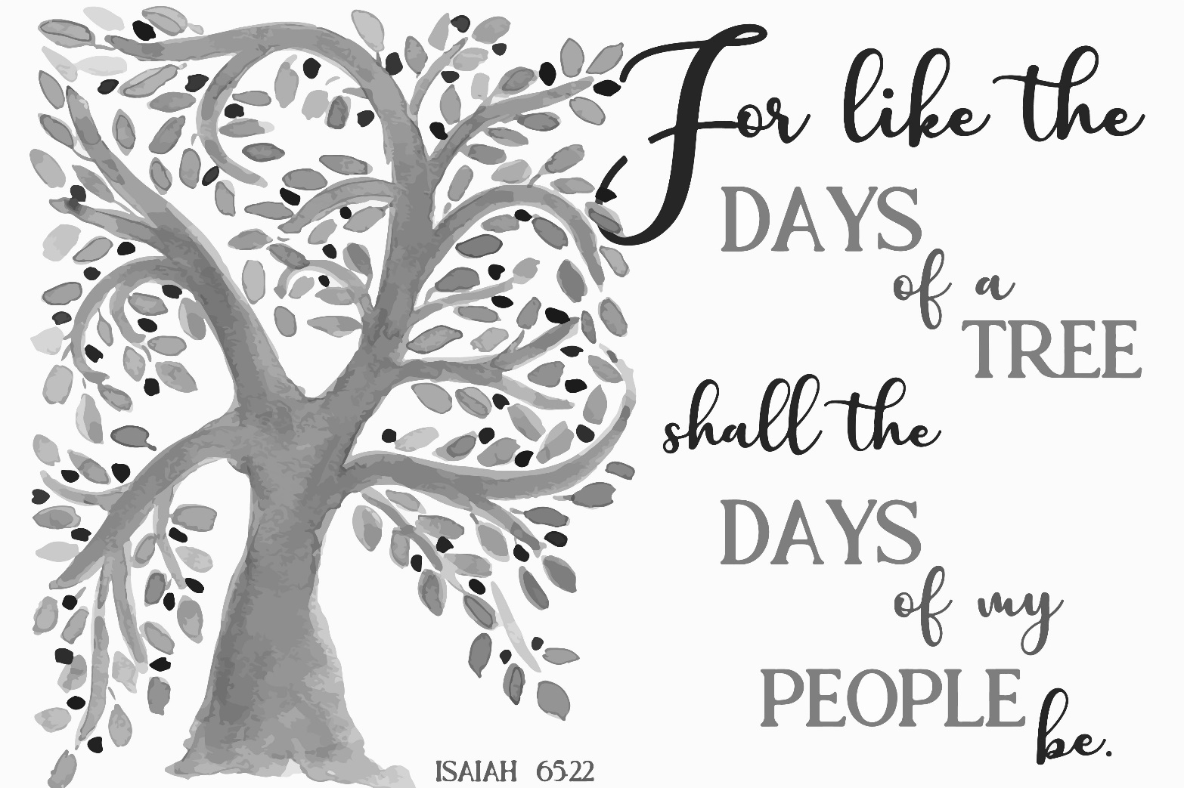

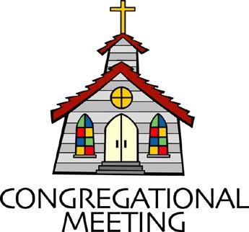
November 17, 2019 - 10:30 am

WELCOME VISITORS! We're glad you are here! Cards at the ends of each pew are for you to fill out and drop in the Offering Plate. Please let us know you are visiting, and join us for refreshments and fellowship following the service. The Sanctuary has an induction loop system to assist the hearing impaired. The system will also work on the telephone setting of hearing aids.

Springfield Presbyterian Church is rooted in the gospel of Jesus Christ, led by the Holy Spirit, and called to loving relationships through vibrant worship and service. Valuing all people, we are committed to developing disciples and fostering stewardship.
PREPARATION FOR THE WORD
(* those who are able are invited to stand)

PRELUDE

GATHERING OF THE PEOPLE

The Lord be with you! And also with you! (Greeting)

LIGHTING THE CHRIST CANDLE
Leader: Whenever we light this candle we proclaim:
People: Christ is the Light of the world and the center of our lives.

CALL TO WORSHIP [Psalm 98]
Leader: O sing to the Lord a new song, for He has done marvelous things! His right hand and His holy arm have gotten Him victory!
People: The Lord has made known His victory; He has revealed His vindication in the sight of the nations.
Leader: He has remembered His steadfast love and faithfulness to the house of Israel. All the ends of the earth have seen the glory of our God.
People: Make a joyful noise to the Lord, all the earth; break forth into joyous song and sing praises.
Leader: Sing praises to the Lord with the lyre, with the lyre and the sound of melody.
People: With trumpets and the sound of the horn, make a joyful noise before the King, the Lord.
Leader: Let the sea roar, and all that is in it; the world and those who live in it.
People: Let the floods clap their hands; let the hills sing together for joy at the presence of the Lord. He will judge the world with righteousness, and the peoples with equity.
ALL: Let us worship and praise our mighty and loving God!

* HYMN When Peace like a River

When peace like a river attendeth my way,
when sorrows like sea billows roll,
whatever my lot, thou hast taught me to say,
it is well, it is well with my soul.

Refrain:
It is well with my soul; it is well; it is well with my soul.

Though Satan should buffet, though trials should come,
let this blest assurance control,
that Christ hath regarded my helpless estate,
and hath shed his own blood for my soul. [Refrain]

He lives: O the bliss of this glorious thought.
My sin, not in part, but the whole,
is nailed to the cross and I bear it no more.
Praise the Lord, praise the Lord, O my soul! [Refrain]

Lord, hasten the day when our faith shall be sight,
the clouds be rolled back as a scroll,
the trumpet shall sound and the Lord shall descend;
even so it is well with my soul. [Refrain]

PRAYER OF CONFESSION
Generous God, we have been given images along the way of how you see the Kingdom at work and alive in this world. A world where none shall harm each other, where all will have a place to dwell, and manna in abundance for all to feast. We see your Kingdom, we hear your hopes and dreams alive in this world, yet we do not actively pursue your Kingdom. We get lost in the shuffle, our own busyness interferes with our call to serve you, and we fail to recognize with gratitude the new life you are calling us
into as your beloved children. Help us to make your Kingdom a reality: one where oppression ceases, one where there is a home for all, and there is sustenance in abundance. Forgive us, renew us, and restore us to the people you have called us to be in this world. Amen.

SILENT PRAYERS OF CONFESSION

RESPONSE Breathe on Me, Breath of God
Breathe on me, breath of God, until my heart is pure,
Until with thee I will one will, to do and to endure.

WORDS OF ASSURANCE [Isaiah 43:1, 19]
Leader: Do not fear, says the Lord, for I have redeemed you. I have called you by name; you are mine.
People: God is doing a new thing; now it springs forth! By the grace of Jesus Christ, we are forgiven! Thanks be to God! Amen.

* MUSICAL RESPONSE OF PRAISE O My Soul, Bless Your Redeemer
O my soul, bless your Redeemer; all within me bless God’s name;
Bless the Savior, and forget not all God’s mercies to proclaim.

* THE PEACE The peace of Christ be with you! And also with you!
(You may greet those around you.)

* RESPONSE Here I Am, Lord
Here I am, Lord, Is it I, Lord? I have heard you calling in the night.
I will go, Lord, if you lead me. I will hold your people in my heart.

THE PROCLAMATION OF THE WORD

PRAYER OF ILLUMINATION
Leader: Loving God, open our hearts and minds by the power of your Holy Spirit, that as the scriptures are read and your word is proclaimed, we may hear with joy what you say to us today. Amen.

FIRST SCRIPTURE LESSON Isaiah 12
You will say on that day: I will give thanks to you, O Lord, for though you were angry with me, your anger turned away, and you comforted me. ² Surely God is my salvation; I will trust, and will not be afraid, for the Lord God is my strength and my might; he has become my salvation. ³ With joy you will draw water from the wells of salvation. ⁴And you will say on that day: Give thanks to the Lord, call on his name;
make known his deeds among the nations; proclaim that his name is exalted. ⁵ Sing praises to the Lord, for he has done gloriously; let this be known in all the earth. ⁶ Shout aloud and sing for joy, O royal Zion, for great in your midst is the Holy One of Israel.

SECOND SCRIPTURE LESSON Isaiah 65:17-25
¹⁷ For I am about to create new heavens and a new earth; the former things shall not be remembered or come to mind. ¹⁸ But be glad and rejoice for ever in what I am creating; for I am about to create Jerusalem as a joy, and its people as a delight. ¹⁹ I will rejoice in Jerusalem, and delight in my people; no more shall the sound of weeping be heard in it, or the cry of distress. ²⁰ No more shall there be in it an infant that lives but a few days, or an old person who does not live out a lifetime; for one who dies at a hundred years will be considered a youth, and one who falls short of a hundred will be considered accursed. ²¹ They shall build houses and inhabit them; they shall plant vineyards and eat their fruit. ²² They shall not build and another inhabit; they shall not plant and another eat; for like the days of a tree shall the days of my people be, and my chosen shall long enjoy the work of their hands. ²³ They shall not labor in vain, or bear children for calamity; for they shall be offspring blessed by the Lord—
and their descendants as well. ²⁴ Before they call I will answer, while they are yet speaking I will hear. ²⁵ The wolf and the lamb shall feed

together, the lion shall eat straw like the ox; but the serpent—its food shall be dust! They shall not hurt or destroy on all my holy mountain,
says the Lord.

Leader: Hear what the Spirit is saying to the Church.
All: Thanks be to God.

TIME WITH YOUNG PEOPLE

A LITURGY OF MISSION
Leader: With thoughtfulness, prayer, and consideration, hands have crafted these garments. And so now, as a community, we bless these items for their purposes and bless those who receive them. For those who receive prayer shawls,
People: We pray that the fabric holds them close as your Spirit encourages them.
Leader: For those who will receive hats,
People: We pray that their heads are warm, and so may their hearts be, knowing that they are loved by you and this community of faith.
Leader: For those who receive blankets,
People: May they know the deep care and nurture of your loving hand, providing security and safety in a troubled world.
Leader: For all those works crafted by hand,
ALL: We send them into this community and this world to be a blessing, an active act of praise unto you, O God, and nurture for our neighbors near and far. Amen.

SERMON The Rings that Grow with Age Rev. Becca Crate

THE RESPONSE TO THE WORD

* HYMN Standing on the Promises

Standing on the promises of Christ my king,
through eternal ages let his praises ring;
glory in the highest, I will shout and sing,
standing on the promises of God.

Refrain:
Standing, standing, standing on the promises of God my Savior;
standing, standing, I’m standing on the promises of God.

Standing on the promises that cannot fail,
when the howling storms of doubt and fear assail,
by the living Word of God I shall prevail,
standing on the promises of God. [Refrain]

Standing on the promises of Christ the Lord,
bound to him eternally by love’s strong cord,
overcoming daily with the Spirit’s sword,
standing on the promises of God. [Refrain]

Standing on the promises I cannot fall,
listening every moment to the Spirit’s call,
resting in my Savior as my all in all,
standing on the promises of God. [Refrain]

PASTORAL PRAYER AND THE LORD’S PRAYER
“For this I pray to God.” / “For this I give thanks to God.”
Congregational Response: “Hear our prayer, O God.”

PRESENTATION OF TITHES AND OFFERINGS
OFFERTORY
* SONG OF THANKS We Give Thee but Thine Own
May we thy bounties thus as stewards true receive,
And gladly, as thou blessest us, to thee our first-fruits give.
* PRAYER OF DEDICATION

* HYMN Blessed Assurance
Blessed assurance, Jesus is mine! O what a fore-taste of glory divine!
Heir of salvation, purchase of God, born of his Spirit, washed in his blood.

Refrain:
This is my story; this is my song, praising my Savior all the day long;
This is my story, this is my song, praising my Savior all the day long.

Perfect submission, perfect delight, visions of rapture now burst on my sight;
Angels descending, bring from above echoes of mercy, whispers of love. [Refrain]

Perfect submission, all is at rest; I in my Savior am happy and blest,
Watching and waiting, looking above, filled with his goodness, lost in his love. [Refrain]

* CHARGE AND BENEDICTION
Leader: God is crafting a new thing, here and now.
People: A new heaven, a new earth, a new way of being.
Leader: And so we prepare our hearts, we open our minds,
People: We look towards a Kingdom where God’s love is evident in this world.
Leader: With the leading of the Spirit,
People: We welcome people into this new way, sharing with them the great story of God’s love.

* UNISON AMEN POSTLUDE
Sunday November 24 Lectionary
Jeremiah 23:1-6; Luke 1:68-79; Colossians 1:11-20; Luke 23:33-43

Assisting in Worship: We appreciate those who serve:

Today 11/17 Next Week 11/24
Sunday Opener Beth Oates Jennifer Wise
Greeters & Ushers Connie Robinson & Bob Rogers &
Martha Streaker Volunteer
Lay Leader Barbara Cornell Don Vasbinder
Sunday School Connie Robinson Connie Robinson
Fellowship Diana & Bob Steppling Barbara Cornell

Church Attendance: November 3 – 48 November 11 - 42

Church Cleaning: November 29 30 or December 1 – Lisa & Bob
Rogers

Happy Birthday! November 20 – Cathy White

Announcements

Stewardship: Many of you have turned in your pledge card for 2020, and we thank you! If you haven’t submitted yours yet, you may put it in the offering plate or send it to the Church Office at your earliest convenience. This will help us to prepare our budget for 2020.

Christmas Flowers: It’s time to order your Christmas flowers! If you would like to place flowers in the Sanctuary for Christmas, there are order forms in the Narthex or contact the Church Office. All flower orders are due by TOMORROW.

Youth/Children's Choir: I am hoping to have some of the young people in the congregation sing a few pieces through the year. The next time I have something planned is for the first week in December. I would love to have a group of the youth sing our introit for that morning We Look for the Star by Hal Hopson. This is a unison piece that we should be able to learn with just a little rehearsal. Brittany Rachin, a member of our congregation and choir, is also a music teacher in the school system and is interested in helping out with this endeavor. Please let me know if you are interested so we can work out a couple of times to practice before that first week in December. (Linda Caviglia - 410-746-1221 or linda@cavig5.net)

Expressions of appreciation were received this week from ESCAPE Ministries for the 82 lunches that were packed and delivered. You all made this possible with your donations of supplies and packing time. Another note was received from the Piney Ridge Elementary School counselor for the donation from our Noisy Offering of $81.61 to their Sunshine Fund. She noted that the need has greatly increased in the last two years and she appreciates being able to help with some of those 'extras' the students need. Thank you all for helping our reach into the community.

Shepherd’s Staff Festival of Trees (November 29 – December 1): Come join the fun! The Shepherd's Staff's Annual Festival of Trees will include a Silent Auction featuring over 30 decorated trees, an Ugly Sweater Contest, fun raffles, live music, baked goods, fun photo booth, children's craft table, and cash & carry gift baskets. For sponsorship opportunities, call 410-857-5944, email info@shepstaff.org, or online at http://www.shepstaff.org/events/festival-of-trees/
HOURS:
Fri. Nov. 29 : 10 a.m. - 5 p.m.; Sat. Nov. 30: 10 a.m. - 8 p.m.
Sun. Dec. 1: 10 a.m. - 2 p.m. Silent Auction ends at 2 p.m.
Newsletter Deadline: The deadline to submit information for the December newsletter is November 25. Please send your info to spc.office@verizon.net.

Blessing Bags are in the Narthex. Please feel free to pick up a few. Handing one out to someone in need gives you a very real way to meet their immediate needs by providing them with some basic supplies.

Weekly Announcements: If you have an announcement to include with next week’s bulletin, please call the Office at 410-795-6152 or email to spc.office@verizon.net by Wednesday each week.

Prayers & Thanksgivings

~ Prayers for Christ Memorial Presbyterian Church from our Ministry Group.

The Congregational Care team wants to know what YOU or someone you know needs...a visit...a call...a meal. Please contact Diana Steppling or Connie Robinson. If you are in need of pastoral care, please contact Pastor Becca at 410-795-6152 or springfieldpastor@gmail.com.

Today:
Sunday November 17
9:00 am Red Sea Parting Practice
10:30 am Worship
11:30 am Fellowship

This Week:
Monday November 18
4:30 pm C.I.A. Meeting (Manse)
Wednesday November 20
6:30 pm Bell Choir Practice
7:45 pm Adult Choir Practice

Looking Ahead:
Sunday November 24
10:30 am Worship
11:30 am Fellowship
Tuesday November 26
10:30 am Prayer Group (Manse)
Wednesday November 27
No Choir Practice

Office Hours: Tuesday, Wednesday, Friday 9:00 am - 3:00 pm

Springfield Presbyterian Church

10:30 am Worship & Sunday School
11:30 am Fellowship
Website: www.springfield-church.org Church Office: 410-795-6152
Like us on Facebook: www.facebook.com/SpringfieldPresbyterianChurch
Pastor: Rev. Becca Crate
Email: springfieldpastor@gmail.com
Clerk of Session: Sharon Pappas
Minister of Music: Linda Caviglia
Accompanist: Aaron Thacker Organist: Jennifer Wise
Youth Group Coordinators: Charles & Deb Sperling
Sunday School Coordinator: Connie Robinson
Administrative Assistant: Donna Mazer
e-mail: spc.office@verizon.net

