(Large Print)

Springfield Presbyterian Church (USA)
7300 Spout Hill Road, Sykesville, MD 21784 410-795-6152

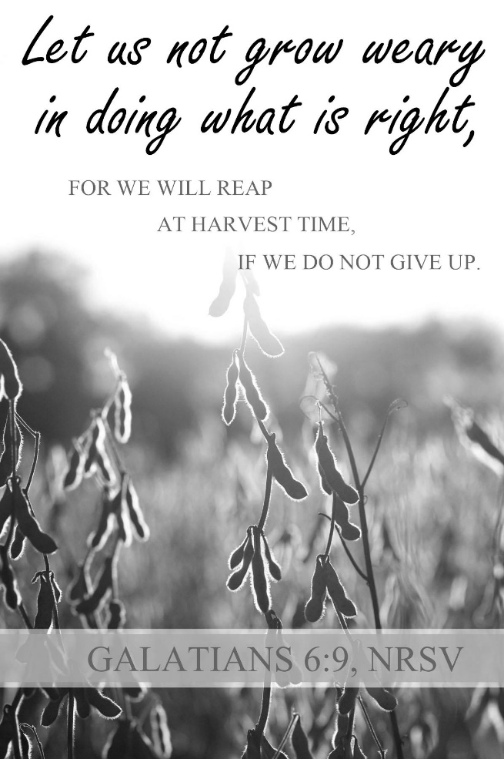

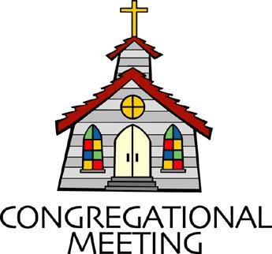
July 3, 2022 - 10:30 am

WELCOME VISITORS!
We're glad you are here! Cards at the ends of each pew are for you to fill out and drop in the Offering Plate. Please let us know you are visiting, and join us for refreshments and fellowship following the service. The Sanctuary has an induction loop system to assist the hearing impaired. The system will also work on the telephone setting of hearing aids.

Springfield Presbyterian Church is rooted in the gospel of Jesus Christ, led by the Holy Spirit, and called to loving relationships through vibrant worship and service. Valuing all people, we are committed to developing disciples and fostering stewardship.

PREPARATION FOR THE WORD
(* those who are able are invited to stand)
PRELUDE

GATHERING OF THE PEOPLE

The Lord be with you! And also with you! (Greeting)

LIGHTING THE CHRIST CANDLE
Leader: Whenever we light this candle we proclaim:
People: Christ is the Light of the world and the center of our lives.

CALL TO WORSHIP
Leader: As we cultivate our garden this summer season, we remember the seeds we need to sow:
People: Seeds of hope that bring light to the dark corners of our world.
Leader: Seeds of love that proclaim God’s love for all people everywhere.
People: Seeds of gentleness where words are chosen carefully and bravely.
Leader: Seeds of truth that articulate the realities of our world and the sin within in.
People: Seeds of community so that we remember we are not alone.
Leader: Seeds of generosity of time, talent, and energy.
People: Seeds of gratitude that acknowledge the wonders around us.
Leader: As we build this healthy and plentiful garden,
People: Let us praise our One and Holy God who charges us to sow all these things and rejoices at harvest time.

* HYMN Let Us Build a House GTG #301
Let us build a house where love can swell and all can safely live,
A place where saints and children tell how hears learn to forgive.
Built of hopes and dreams and visions, rock of faith and vault of grace; Here the love of Christ shall end divisions:

Refrain:
All are welcome; all are welcome; all are welcome in this place.

Let us build a house where prophets speak, and words are strong and true,
Where all God’s children dare to seek to dream God’s reign anew.
Here the cross shall stand as witness and as symbol of God’s grace;
Here as one we claim the faithful of Jesus: [Refrain]

Let us build a house where love is found in water, wine, and wheat;
A banquet hall on holy ground where peace and justice meet.
Here the love of God, through Jesus, is revealed in time and space;
As we share in Christ the feat that frees us: [Refrain]

Let us build a house where hands will reach beyond the wood and stone to heal and strengthen, serve and teach, and live the Word they’ve known.
Here the outcast and the stranger bear the image of God’s face;
Let us bring an end to fear and danger: [Refrain]

Let us build a house where all are named, their songs and visions heard, and loved and treasured, taught and claimed as words within the Word. Built of tears and cries and laughter, prayers of faith and songs of grace; let this house proclaim from floor to rafter: [Refrain]

CALL TO CONFESSION
Leader: When I was a child, I was told, “you reap what you sow.” These words in our vernacular come from Scripture where we are to understand that what we put in our hearts, minds, and bodies matters. When we sow those things that are harmful to ourselves and others, we reap harm. Yet, when we sow positivity, gentleness, kindness, love, and more into our lives, we will reap the same. As a people seeking to live out this concept, let us come to a time of confession together:

PRAYER OF CONFESSION
Generous God, we reap what we sow. We know this and yet we still embed negativity in our lives and wonder why the outcome is not positivity. For the times where we have sown harm or anger toward our neighbor or ourselves, forgive us. For the moments where we have been more in tune with the world than with your will, forgive us. For the places in which we could have done better, forgive us. Help us to realign ourselves with your Spirit of faithful sowing and restore us to be your people once again. Amen.

SILENT PRAYERS OF CONFESSION

RESPONSE The Woman Hiding in the Crowd Tune #178
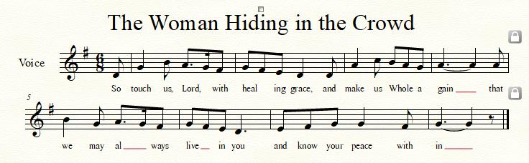

WORDS OF ASSURANCE [1 Tim. 1:15; 1 Peter 2:24]
Leader: The saying is sure and worthy of full acceptance, that Jesus Christ came into the world to save sinners. He himself bore our sins in his body on the cross, that we might be dead to sin, and alive to all that is good.
People: We declare that we are forgiven by the grace and mercy of Jesus Christ. Thanks be to God!

* MUSICAL RESPONSE OF PRAISE O My Soul, Bless Your Redeemer
Bless your Maker, all you creatures, ever under God’s control,
All throughout God’s vast dominion; bless the Lord of all, my soul!

* THE PEACE The peace of Christ be with you! And also with you!
(You may greet those around you.)

* RESPONSE Here I Am, Lord
Here I am, Lord, Is it I, Lord? I have heard you calling in the night.
I will go, Lord, if you lead me. I will hold your people in my heart.

THE PROCLAMATION OF THE WORD

PRAYER OF ILLUMINATION
Generous God, guide us by your Word and Spirit that in your light we may see light, in your truth find freedom, and in your will discover your peace; through Jesus Christ our Lord. Amen.

FIRST SCRIPTURE LESSON Psalm 30
¹ I will extol you, O Lord, for you have drawn me up, and did not let my foes rejoice over me. ² O Lord my God, I cried to you for help, and you have healed me. ³ O Lord, you brought up my soul from Sheol, restored me to life from among those gone down to the Pit. ⁴ Sing praises to the Lord, O you his faithful ones, and give thanks to his holy name. ⁵ For his anger is but for a moment; his favor is for a lifetime. Weeping may linger for the night, but joy comes with the morning. ⁶ As for me, I said in my prosperity, ‘I shall never be moved.’ ⁷ By your favor, O Lord, you had established me as a strong mountain; you hid your face; I was dismayed. ⁸ To you, O Lord, I cried, and to the Lord I made supplication:
⁹ ‘What profit is there in my death, if I go down to the Pit? Will the dust praise you? Will it tell of your faithfulness? ¹⁰ Hear, O Lord, and be gracious to me! O Lord, be my helper!’ ¹¹ You have turned my mourning into dancing; you have taken off my sackcloth and clothed me with joy, ¹² so that my soul may praise you and not be silent. O Lord my God, I will give thanks to you for ever.

SECOND SCRIPTURE LESSON Galatians 6:1-10
My friends, if anyone is detected in a transgression, you who have received the Spirit should restore such a one in a spirit of gentleness. Take care that you yourselves are not tempted. ²Bear one another’s burdens, and in this way you will fulfil the law of Christ. ³For if those who are nothing think they are something, they deceive themselves. ⁴All must test their own work; then that work, rather than their neighbor’s work, will become a cause for pride. ⁵For all must carry their own loads. ⁶Those who are taught the word must share in all good things with their teacher. ⁷Do not be deceived; God is not mocked, for you reap whatever you sow. ⁸If you sow to your own flesh, you will reap corruption from the flesh; but if you sow to the Spirit, you will reap eternal life from the Spirit. ⁹So let us not grow weary in doing what is right, for we will reap at harvest time, if we do not give up. ¹⁰So then, whenever we have an opportunity, let us work for the good of all, and especially for those of the family of faith.

Leader: Hear what the Spirit is saying to the Church.
All: Thanks be to God.

SERMON Faithful Gardening Rev. Becca Crate-Price

THE RESPONSE TO THE WORD

* HYMN Lord, You Have Come to the Lakeshore GTG #721
Lord, you have come to the lakeshore looking neither for wealthy nor wise ones; you only asked me to follow humbly.
Refrain:
O Lord, with your eyes you have searched me, and while smiling have spoken my name; now my boat’s left on the shoreline behind me. By your side I will seek other seas.

You know so well my possessions; my boat carries no gold and no weapons; you will find there my nets and labor. [Refrain]

You need my hands, full of caring, through my labors to give others rest and constant love that keeps on loving. [Refrain]

You, who have fished other oceans, ever longed for by souls who are waiting, my loving friend, as thus you call me. [Refrain]

THE COMMUNION OF THE PEOPLE

INVITATION

THE GREAT PRAYER OF THANKSGIVING
Leader: The Lord be with you.
People: And also with you.
Leader: Lift up your hearts.
People: We lift them up to the Lord.
Leader: Let us give thanks to the Lord our God.
People: It is right to give our thanks and praise.
[The Pastor continues… “…who forever sing to the glory of your name.”]

IN PRAISE OF GOD Tune #552
Holy, holy, holy, Lord, God of Power and might.
Heaven and earth are full of your glory, Hosanna in the highest!
Blessed is He who comes in the name of the Lord.
Hosanna in the highest, hosanna in the highest.
[The Pastor continues… “…proclaim the one crucified and risen.”]

IN PRAISE OF CHRIST Tune #553
Christ has died; Christ is risen; Christ will come again.
Christ has died; Christ is risen; Christ will come again.

PASTORAL PRAYER AND THE LORD’S PRAYER

WORDS OF INSTITUTION

SHARING OF THE MEAL

PRAYER OF DEDICATION (Unison)
Dear God, take us out to live as changed people because we have shared the living bread and cannot remain the same. Ask much of us, expect much from us, enable much by us, encourage many through us. So, Lord, may we live to your glory, both as inhabitants of the earth, and citizens of the commonwealth of Heaven. Through Christ, with Christ, in Christ, in the unity of the Holy Spirit, all glory and honor are yours, almighty God, now and forever. Amen.
OFFERTORY
SONG OF THANKS As Those of Old Their Firstfruits Brought #712
In gratitude and humble trust we bring our best today, to serve your cause and share your love with all along life’s way. O God who gave yourself to us in Jesus Christ your Son, help us to give ourselves each day until life’s work is done.
PRAYER OF DEDICATION

* HYMN Lord, Speak to Me That I May Speak GTG #722

Lord, speak to me that I may speak in living echoes of your tone.
As you have sought, so let me seek your erring children, lost and lone.

O lead me, Lord, that I may lead the wandering and the wavering feet.
O feed me, Lord, that I may feed your hungering ones with manna sweet.

O teach me, Lord, that I may teach the precious truths which you impart.
And wing my words that they may reach the hidden depths of many a heart.

O fill me with your fullness, Lord, until my very heart o'erflow
in kindling thought and glowing word, your love to tell, your praise to show.

O use me, Lord, use even me, just as you will, and when, and where
until your blessed face I see, your rest, your joy, your glory share.

* CHARGE AND BENEDICTION
Leader: We go into the world to garden,
People: To sow seeds of joy, hope, peace, and love in this world.
Leader: Through our words and actions,
People: May we be tender gardeners.
Leader: So that when it is time to yield,
People: We reap a plentiful harvest. Amen.

* UNISON AMEN

POSTLUDE

Sunday July 10, 2022 Lectionary
Deuteronomy 30:9-14; Psalm 25:1-10; Colossians 1:1-14; Luke 10:25-37
Assisting in Worship: We appreciate those who serve:

Today 7/3 Next Week 7/10
Sunday Opener Beth Oates Barbara Cornell
Ushers/Greeters Don Vasbinder Henry Halvorson
Elizabeth Meirowitz Bob Rogers
Lay Leader Tim Oates Sharon Pappas

Communion Servers Today:
1. Kathy Russ
2. Barbara Cornell

Happy Birthday! July 3 – Summer Carbaugh
July 8 – Tony Caviglia
July 8 – Sharon Pappas
July 8 – Cynthia Smith

Happy Anniversary! July 5 – Ron & Sue Holmes

Announcements

Lost & Found: If anyone lost a little pearl earring, please see Donna Mazer. It was found in the Noisy Offering bucket!

Mask Update: Due to the uptick in COVID-19 cases, the Session has decided to strongly encourage masking and social distancing. Though it is not a mandate, we seek to love one another by keeping each other as safe as possible. Thank you for your help in this endeavor.

Sunday School is back! On the 1st and 3rd Sundays of the month, we will be offering Sunday School! See Pastor Becca for details…
Pastor-Parish Committee: The Pastor-Parish Committee invites you to share your concerns, suggestions, and gratitude. We have a form in the Narthex and a lock-box that we will open weekly and we ask that you share your name and be specific. We look forward to reading your comments so that we can continue to grow into the body of Christ.

Springfield Membership: Are you interested in finding out more about our faith community and becoming a member? We would love to answer any questions you have. Please contact Pastor Becca at springfieldpastor@gmail.com for more information.

Congregational Care / Mission & Outreach: Do you know of a member or friend of our church family who is ill, needs prayers, would like call, a visit or a card, or might benefit from meal train? If so, please contact the Church Office (410-795-6152), Cathy Marsh (410-549-6916) or Diana Steppling (862-266-2242).

Fellowship Help Needed: If you are interested in helping with Fellowship, please contact Barbara Cornell (240-308-0035). A sign-up sheet will also be available.

Today:
Sunday July 3
10:30 am Worship
11:30 am Fellowship

This Week:
Thursday July 7
7:00 pm Session Meeting

Looking Ahead:
Sunday July 10
10:30 am Worship
11:30 am Fellowship

Office Hours: Tuesday, Wednesday & Friday
Springfield Presbyterian Church

10:30 am Worship
11:30 am Fellowship
Website: www.springfield-church.org Church Office: 410-795-6152
Like us on Facebook: www.facebook.com/SpringfieldPresbyterianChurch
Pastor: Rev. Becca Crate-Price
Email: springfieldpastor@gmail.com
Clerk of Session: Sharon Pappas
Minister of Music: Linda Caviglia
Accompanist/Organist: Aaron Thacker
Youth Group Coordinator: Dylan Vasbinder
Administrative Assistant: Donna Mazer e-mail: spc.office@verizon.net

